Balneário Camboriú, Santa Catarina, Brazil
Brazil's answer to Miami Beach — a wall of glass towers rising from white sand, anchored by a world-class cable car and some of South America's most energetic seafront promenades.
⚓ Pier/Tender (BC PORT + Barra Sul) · 🕒 Typical call: 8-10 hrs · 💵 Brazilian Real (BRL) · 🗣️ Portuguese
✍️ MY DAY IN PORT (FILL IN)
Ship / Date
In port | arrive ______ · all aboard ______
Booked excursion
Notes / meeting point
GETTING ASHORE
- Docking: BC PORT terminal (large ships) or tender to Atracadouro Barra Sul
- Walk to center: 5-15 min from pier to Praia Central
- Best For: Beach, skyline views, cable car, city buzz
- Don't Miss: Unipraias Park cable car over Morro da Aguada
GETTING AROUND
- 🚕 Taxi: BRL 25–65 — Taxis are available near the port with a base fare around BRL 7 plus ~BRL 10/km. An 8 km ride across town runs approxima
- 📱 Rideshare: ✅ Uber, 99
TOP THINGS TO DO
- Unipraias Park Cable Car — The only cable car in the world connecting two beaches — ride from Praia Central over Morro da Aguada to Laranjeiras Beach with…
- Praia Central & Laranjeiras Beach — Spend your shore day on Balneário Camboriú's postcard-worthy beaches.
- Cristo Luz Monument & City Views — A towering Christ statue atop a hill illuminates the city at night, but daytime visits offer panoramic views over the coast.
- Oceanic Aquarium Balneário Camboriú — One of Brazil's finest aquariums, with sharks, rays, penguins, and a range of Atlantic species.
- Beto Carrero World Theme Park — Latin America's largest theme park sits about 30 km north near Penha.
BEST WALKS
- Avenida Atlântica Beachfront Stroll: 2-3 km | Easy | 30-45 min — Walk Balneário Camboriú's main seaside boulevard from the pier area along Praia Central's full…
- Pontal Norte Pier & Skyline Views: 1 km | Easy | 20 min — Stroll out along Pontal Norte pier for the best full-skyline shot of Balneário Camboriú.
WEATHER · DAYLIGHT · MONEY
Month | High °F | Low °F | Rainy days
May | 73 | 62 | 13
Jul | 69 | 57 | 8
Sep | 72 | 62 | 13
Daylight: May 6:47AM–5:34PM · Jul 7:02AM–5:38PM · Sep 6:12AM–6:07PM
cruiseports.org/balneario-camboriu · Confirm terminal & all-aboard time with your ship

Balneário Camboriú, Santa Catarina, Brazil — Port Map
Red = walkable sights · Amber = excursions farther out · P = cruise terminal
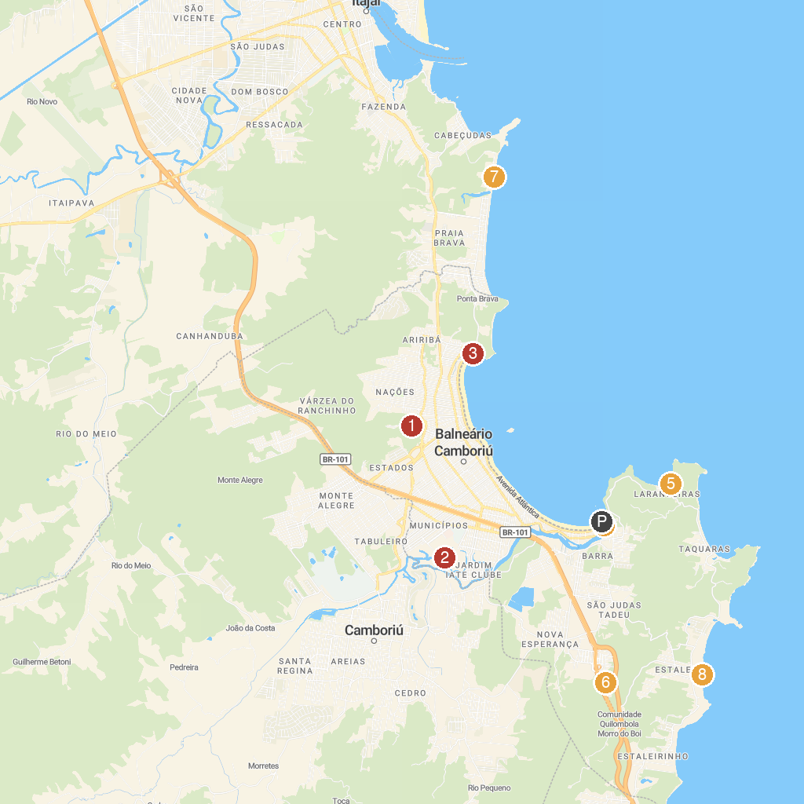
MAP KEY
1. Cristo Luz | 5. Barco Pirata-Trapiche da Praia das Laranjeiras
2. Parque Ecológico Raimundo Gonçález Malta | 6. Music Speedway Park
3. Deck do Pontal Norte | 7. North Brava beach
4. Parque Unipraias | 8. Praia do Estaleiro
P. Cruise port / terminal
Map © MapTiler © OpenStreetMap contributors · cruiseports.org

