Balikpapan, East Kalimantan, Indonesia
Gateway to the Bornean jungle, Balikpapan pairs urban polish with rare wildlife encounters — from sun bears to wild orangutans — all on a single shore day.
⚓ Docked (Semayang Port) · 🕒 Typical call: 8-10 hrs · 💵 Indonesian Rupiah (IDR) · 🗣️ Indonesian (Bahasa) · 🌿 Jungle & wildlife hub
✍️ MY DAY IN PORT (FILL IN)
Ship / Date
In port | arrive ______ · all aboard ______
Booked excursion
Notes / meeting point
GETTING ASHORE
- Docking: Semayang Port; cruise ships berth dockside, no tendering required
- To City Center: ~10 min by Grab/Gojek or Blue Bird taxi; not walkable
- Best For: Orangutan & sun bear encounters, mangrove tours, beaches
- Don't Miss: BOSF Samboja Lestari orangutan sanctuary (~1 hr from port)
GETTING AROUND
- 🚕 Taxi: Rp 67,000–80,000 — Metered Blue Bird taxis serve Semayang Port area with a Rp 20,000 minimum fare. Best to call ahead rather than hail on t
- 📱 Rideshare: ✅ Grab, Gojek
TOP THINGS TO DO
- Samboja Lestari Orangutan Sanctuary — Visit the Borneo Orangutan Survival Foundation's Samboja Lestari site, about 1 hour from port, to see rescued orangutans and sun…
- Bukit Bangkirai Canopy Bridge — Swing across suspension bridges strung between 40-meter dipterocarp trees at Bukit Bangkirai eco-forest, about 1.5 hours from port.
- Margomulyo Mangrove Center — Explore the Margomulyo Mangrove Center on an 800-meter boardwalk and by boat through dense mangrove forest in West Balikpapan.
- Kemala Beach — A popular city beach with pale sand, calm bay waters, and seaside warungs (food stalls) serving fresh grilled fish.
- Balikpapan City Highlights — Hit the Monpera independence monument, stroll Taman Bekapai city park, and browse Pasar Klandasan wet market for local spices and…
BEST WALKS
- Balikpapan Downtown Stroll: ~2 km · Flat · 45 min — From Taman Bekapai city park, walk along Jalan Ahmad Yani past the Monpera monument and toward…
WEATHER · DAYLIGHT · MONEY
Month | High °F | Low °F | Rainy days
May | 84 | 76 | 29
Jul | 82 | 76 | 25
Sep | 83 | 76 | 20
Daylight: May 6:07AM–6:10PM · Jul 6:17AM–6:20PM · Sep 6:05AM–6:10PM
cruiseports.org/balikpapan · Confirm terminal & all-aboard time with your ship

Balikpapan, East Kalimantan, Indonesia — Port Map
Red = walkable sights · Amber = excursions farther out · P = cruise terminal
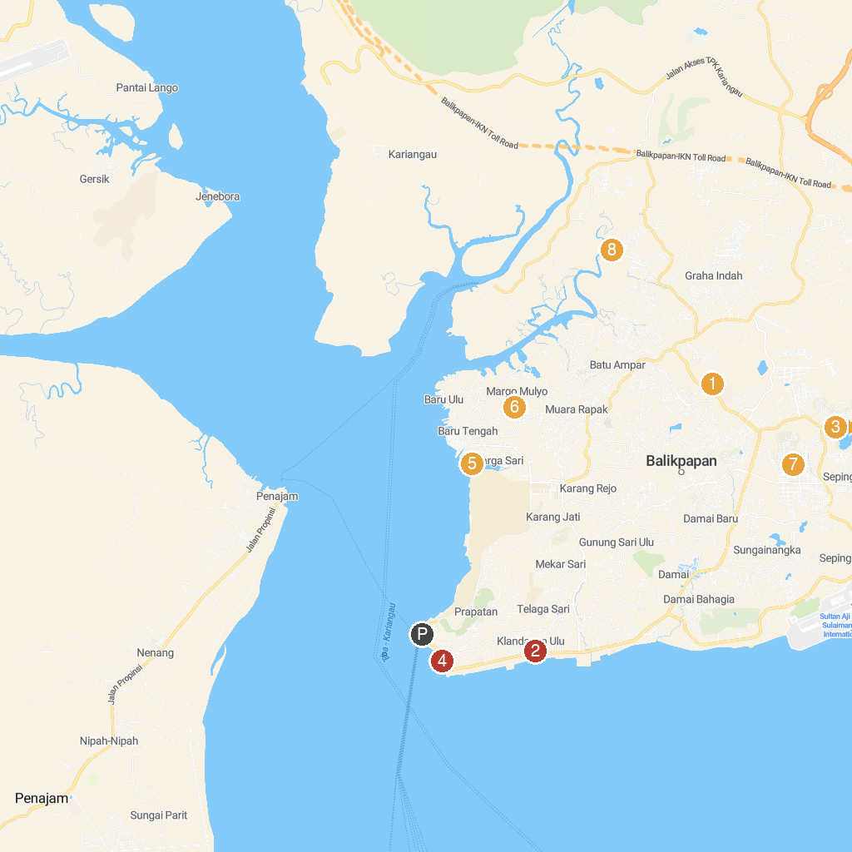
MAP KEY
1. Mahavihara Buddhamanggala | 5. Kawasan Kampung Atas Air
2. Masjid Agung At-Taqwa Balikpapan | 6. Mangrove Margo Mulyo
3. Caribbean Island Water Park | 7. Balikpapan Islamic Center
4. Melawai Beach | 8. Mangrove Center Graha Indah
P. Cruise port / terminal
Map © MapTiler © OpenStreetMap contributors · cruiseports.org

