Balestrand, Vestland, Norway
A storybook fjord village on Europe's longest waterway — where wooden churches echo Disney's Frozen and glaciers loom just a boat ride away.
⚓ Docked (pier) · 🕒 Typical call: 6-8 hrs · 💵 Norwegian Krone (NOK) · 🗣️ Norwegian
✍️ MY DAY IN PORT (FILL IN)
Ship / Date
In port | arrive ______ · all aboard ______
Booked excursion
Notes / meeting point
GETTING ASHORE
- Docking: Ships berth at the Balestrand quay, directly in the village center
- Walk to center: Under 5 minutes — the quay and village are one and the same
- Best For: Fjord scenery, glacier day trips, and quiet Norwegian village charm
- Don't Miss: Fjord & Glacier Tour to Fjærland and the Bøyabreen glacier
GETTING AROUND
- 🚕 Taxi: Metered; short local fares not published — Use Balestrand Taxi/LokalTaxi for mobility needs or point-to-point trips outside the village. Pre-book if timing matters
TOP THINGS TO DO
- Fjord & Glacier Tour to Fjærland — The classic Balestrand excursion: a scenic boat ride up the narrow Fjærlandsfjord, then a bus to the Norwegian Glacier Museum and…
- RIB Boat Safari on the Sognefjord — Speed through the secluded Finnafjord arm of the Sognefjord on a rigid inflatable boat, taking in sheer mountain walls…
- Cider Tasting at Ciderhuset — The Sognefjord region has centuries of fruit-growing history.
- Norwegian Museum of Travel & Tourism — Carved into solid rock above the village, this interactive museum charts how the English, Germans, and Norwegians 'discovered'…
- Village Walking Tour — Churches, Kings & Kviknes — A self-guided loop takes in St.
BEST WALKS
- Village Heritage Loop: 1.5 km · 30 min · Easy — From the quay, stroll south along the waterfront past the Kviknes Hotel to the King Bele Viking…
- Dragsvik Ferry Stroll: 8 km · 2-2.5 hrs · Easy — Take the small passenger ferry across the Esefjord to Dragsvik, then follow the quiet old country…
WEATHER · DAYLIGHT · MONEY
Month | High °F | Low °F | Rainy days
May | 57 | 44 | 16
Jul | 68 | 56 | 18
Sep | 60 | 49 | 18
Daylight: May 4:47AM–10:15PM · Jul 4:26AM–10:51PM · Sep 7:01AM–7:55PM
cruiseports.org/balestrand · Confirm terminal & all-aboard time with your ship

Balestrand, Vestland, Norway — Port Map
Red = walkable sights · Amber = excursions farther out · P = cruise terminal
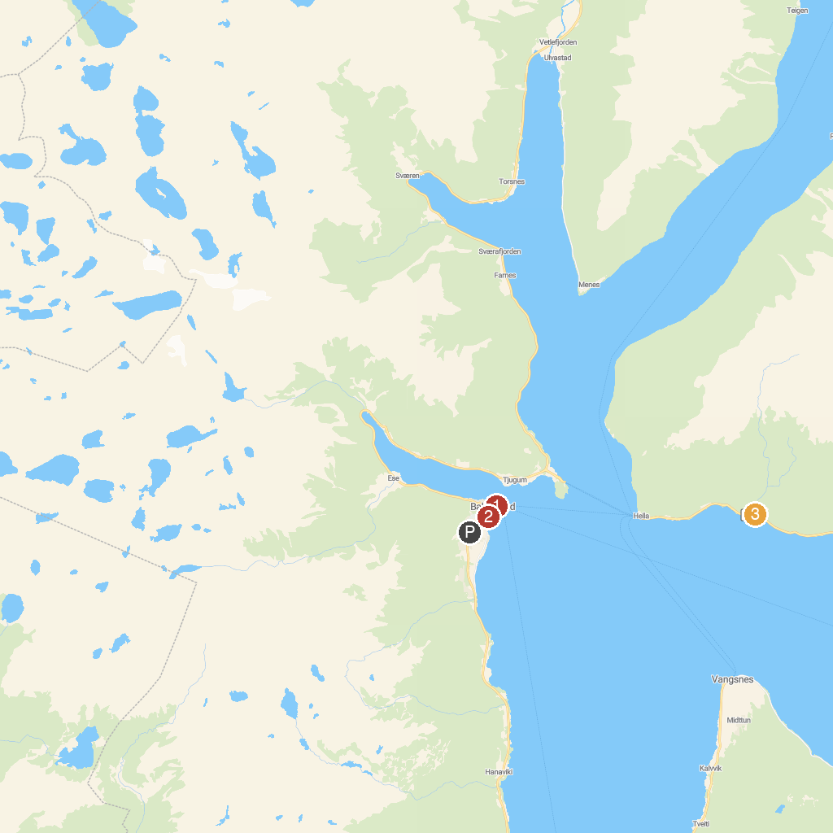
MAP KEY
1. Norwegian Travel Museum | 3. Woman Waterfall
2. St. Olafs kirke
P. Cruise port / terminal
Map © MapTiler © OpenStreetMap contributors · cruiseports.org

