Bakkagerði, East Iceland, Iceland
A tiny fjord hamlet cradled by jagged rhyolite mountains, Bakkagerði draws expedition ships with its world-class puffin colony, elf folklore, and some of Iceland's most dramatic hiking.
⚓ Tender only (Zodiac/tender boat) · 🕒 Typical call: 5-7 hrs · 💵 Icelandic Króna (ISK) / cards widely accepted · 🗣️ Icelandic (English spoken by most locals) · 🐦 Best May–Aug for puffins
✍️ MY DAY IN PORT (FILL IN)
Ship / Date
In port | arrive ______ · all aboard ______
Booked excursion
Notes / meeting point
GETTING ASHORE
- Docking: Tender port — ships anchor offshore; Zodiacs/tenders to the small harbor quay
- Walk to center: Tenders land at Hafnarhólmi marina (puffin islet 5-min walk); village center is ~5 km / 3 mi away
- Best For: Puffin watching, hiking Stórurð & Víknaslóðir trails, elf folklore
- Don't Miss: Hafnarhólmi puffin platforms and Álfaborg (Elf Rock) viewpoint
GETTING AROUND
- 📱 Rideshare: ❌ not available
TOP THINGS TO DO
- Puffin Watching at Hafnarhólmi — A wooden walkway leads to a small islet where thousands of Atlantic puffins nest May–August.
- Stórurð — The Giant Boulders — A dramatic hike to a glacial boulder field surrounded by vivid rhyolite peaks and a turquoise lake.
- Víknaslóðir — Abandoned Fjord Trails — Multi-stage hiking routes across once-inhabited fjords now returned to wilderness.
- Álfaborg Elf Rock & Village Walk — Climb the easy trail up Álfaborg — a basalt rock said to house the Elf Queen — for panoramic views, then explore the village…
- RIB Boat Safari — Seabirds & Seals — Zodiac or RIB tours around the fjord offer views of puffins from the water, plus chances to spot harbour seals, harlequin ducks…
BEST WALKS
- Harbor to Hafnarhólmi Puffin Islet: Easy · ~20 min return · flat path — From the tender landing at the harbor, follow the path north along the waterfront to Hafnarhólmi.
- Village to Álfaborg (Elf Rock): Easy · ~45 min return · gentle trail — Walk from the village center to Álfaborg, a prominent basalt rock formation.
WEATHER · DAYLIGHT · MONEY
Month | High °F | Low °F | Rainy days
May | 44 | 36 | 15
Jul | 53 | 47 | 16
Sep | 51 | 44 | 18
Daylight: Sep 6:17AM–7:21PM
cruiseports.org/bakkargerdi · Confirm terminal & all-aboard time with your ship

Bakkagerði, East Iceland, Iceland — Port Map
Red = walkable sights · Amber = excursions farther out · P = cruise terminal
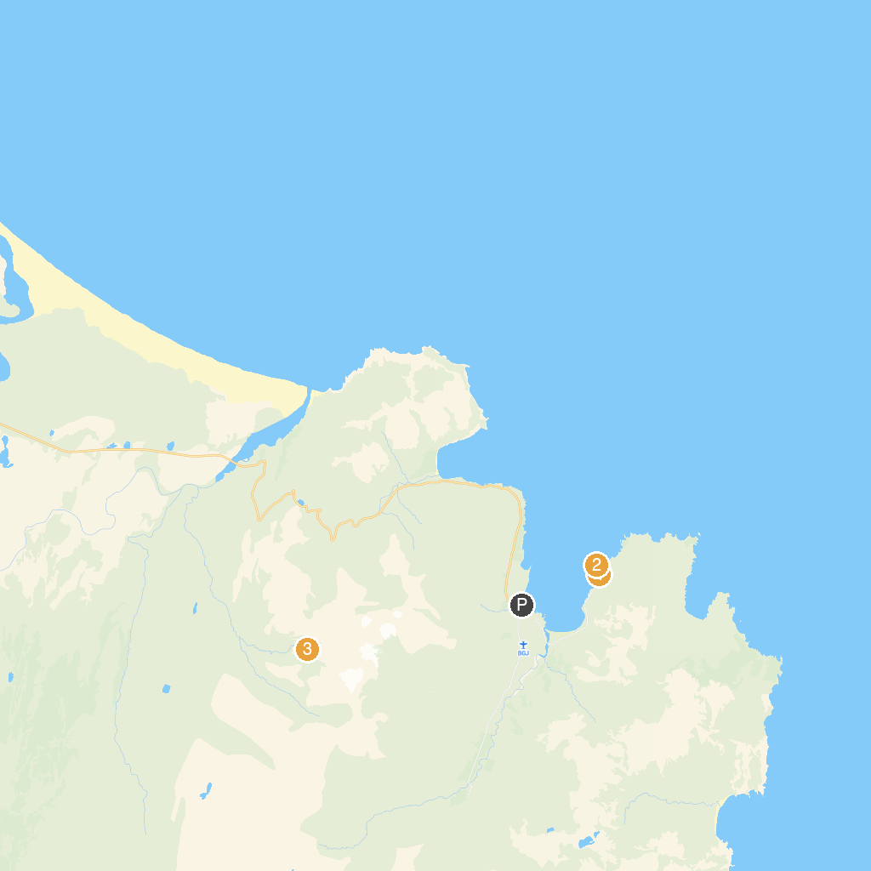
MAP KEY
1. Puffin Adventures | 3. Stórurð
2. Hafnarhólmi
P. Cruise port / terminal
Map © MapTiler © OpenStreetMap contributors · cruiseports.org

