Baie-Comeau, Quebec, Canada
A working port town punching above its weight — the St. Lawrence here is prime whale habitat, the church frescoes rival anything in Italy, and the Manicouagan hydroelectric complex is one of North America's great engineering feats.
⚓ Docked (deep-water pier) · 🕒 Typical call: 7-9 hrs · 💵 Canadian Dollar (CAD) · 🗣️ French (English spoken in tourism)
✍️ MY DAY IN PORT (FILL IN)
Ship / Date
In port | arrive ______ · all aboard ______
Booked excursion
Notes / meeting point
GETTING ASHORE
- Docking: Deep-water pier; ~1.5 km (20-min walk) to downtown. Free shuttle buses from terminal.
- Walk to Center: 20 min along Pioneer Promenade; flat and easy.
- Best For: Whale watching, dam tours, Sainte-Amélie frescoes, boreal nature.
- Don't Miss: Sainte-Amélie Church — a vast ceiling fresco by Florentine-trained master Guido Nincheri.
GETTING AROUND
- 🚕 Taxi: CAD $10–15 — Taxis meet ships at the dock. Short ride to city center; confirm fare before departing as not all cabs use meters.
TOP THINGS TO DO
- St. Lawrence Whale Watching — The confluence of the St.
- Sainte-Amélie Church Fresco Tour — This Baie-Comeau landmark is crowned by one of North America's largest church frescoes — a roughly 1,500 m² ceiling work by…
- Manic-5 Daniel-Johnson Dam Tour — The world's largest multiple-arch-and-buttress dam sits 214 km north of town (2.5-hour drive).
- Boisé de la Pointe-St.-Gilles Park — A 432-acre urban forest right in town with groomed and wild hiking trails.
- Gardens of the Glaciers (Jardin des Glaciers) — An immersive multimedia attraction retracing the last ice age — glacier simulations, geological exhibits, and the story of how…
BEST WALKS
- Pioneer Promenade to Downtown: 1.5 km · 20 min · Flat — Follow the waterfront Pioneer Promenade from the cruise pier to Pioneer Park, then continue into…
- Church Walk: St. Andrew's to Sainte-Amélie: 1 km · 15 min · Flat — Start at St.
WEATHER · DAYLIGHT · MONEY
Month | High °F | Low °F | Rainy days
May | 53 | 39 | 12
Jul | 71 | 58 | 15
Sep | 61 | 50 | 12
Daylight: May 4:49AM–8:09PM · Jul 4:44AM–8:32PM · Sep 6:09AM–6:44PM
cruiseports.org/baie-comeau · Confirm terminal & all-aboard time with your ship

Baie-Comeau, Quebec, Canada — Port Map
Red = walkable sights · Amber = excursions farther out · P = cruise terminal
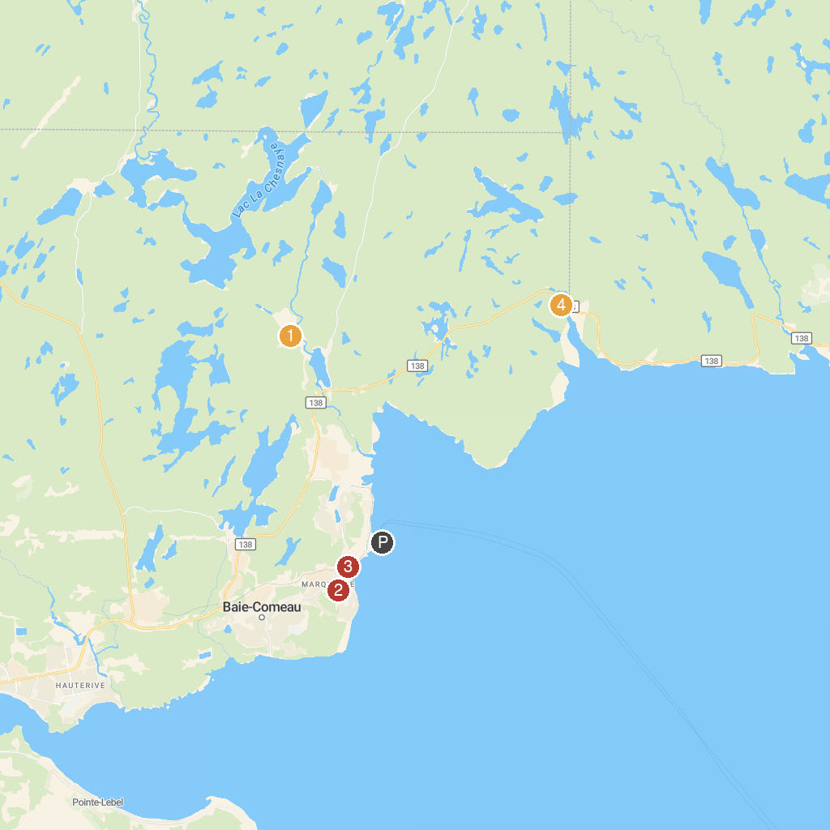
MAP KEY
1. Mont Ti-Basse | 3. Pionniers Park
2. Ancienne Église catholique Sainte-Amélie à Baie-Comeau | 4. Belvédère Baie St-Pancrace
P. Cruise port / terminal
Map © MapTiler © OpenStreetMap contributors · cruiseports.org

