Bad Wimpfen, Baden-Württemberg, Germany
One of Germany's most intact medieval towns, Bad Wimpfen rises above the Neckar River in two distinct layers — the bustling lower town by the dock and the atmospheric upper town crowned by the ruins of a Hohenstaufen Imperial Palace. It's history you can walk through in an afternoon.
⚓ River dock (Schiffsanlegestelle) · 🕒 Typical call: 4-6 hrs · 💶 Euro (EUR) · 🗣️ German
✍️ MY DAY IN PORT (FILL IN)
Ship / Date
In port | arrive ______ · all aboard ______
Booked excursion
Notes / meeting point
GETTING ASHORE
- Docking: River dock at Wimpfen im Tal; ships berth directly on the Neckar bank
- Walk to center: 7-10 min on foot up to the Altstadt (Wimpfen am Berg)
- Best For: Medieval history, half-timbered streets, Neckar Valley cycling
- Don't Miss: Blauer Turm (Blue Tower) for panoramic views over the river valley
GETTING AROUND
- 🚕 Taxi: ~€5–10 — Local taxis cover the short uphill ride to the old town. Base fare is ~€4.90 with €2.50–€3.20/km; useful for passengers
TOP THINGS TO DO
- Staufer Imperial Palace & Blue Tower — The Kaiserpfalz was once the largest imperial palace north of the Alps.
- Altstadt Walking Tour — Wander the medieval lanes of Wimpfen am Berg past half-timbered houses, the 13th-century Stadtkirche (remarkable stained glass…
- Ritterstiftskirche St. Peter (Wimpfen im Tal) — Down in the lower town near the dock, this collegiate church dates from the 10th–13th centuries and features impressive German…
- Neckartal Cycle Path — The Neckar valley cycle route passes right through town on a mostly flat riverside path.
- Burg Guttenberg Day Trip — A short drive or taxi from Bad Wimpfen, Burg Guttenberg is a living medieval hilltop castle continuously inhabited for nearly 800…
BEST WALKS
- Altstadt & Imperial Palace Loop: 1.5 km · ~45 min · gentle uphill — From the dock, walk up Hauptstraße to the Marktplatz, continue to the Kaiserpfalz ruins and Blue…
- Riverside Stroll — Lower Town: 1 km · ~20 min · flat — Stay riverside and walk from the dock along the Neckar bank past the Ritterstiftskirche St.
WEATHER · DAYLIGHT · MONEY
Month | High °F | Low °F | Rainy days
May | 66 | 49 | 12
Jul | 78 | 60 | 11
Sep | 70 | 53 | 8
Daylight: May 5:40AM–8:59PM · Jul 5:34AM–9:23PM · Sep 7:00AM–7:35PM
cruiseports.org/bad-wimpfen · Confirm terminal & all-aboard time with your ship

Bad Wimpfen, Baden-Württemberg, Germany — Port Map
Red = walkable sights · Amber = excursions farther out · P = cruise terminal
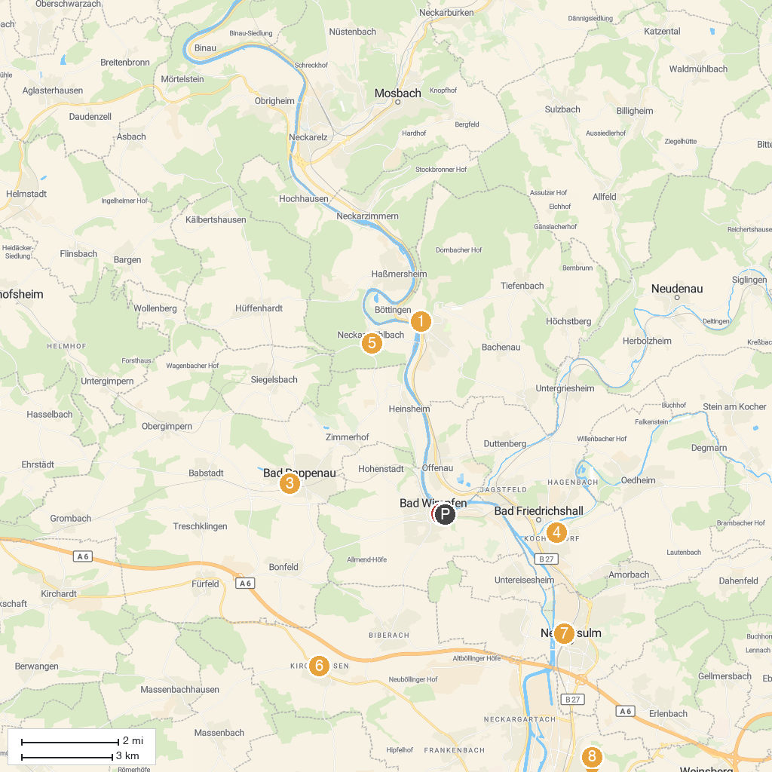
MAP KEY
1. Transylvanian Museum | 5. Burg Guttenberg
2. Roter Turm | 6. Deutschordensschloss Heilbronn - Kirchhausen
3. Kunstverein Wasserschloss Bad Rappenau e.V. | 7. Audi Forum Neckarsulm
4. Grecken Castle Bad Friedrichshall | 8. Botanical Fruit Garden Heilbronn
P. Cruise port / terminal
Map © MapTiler © OpenStreetMap contributors · cruiseports.org

