Bad Schandau, Saxony, Germany
Perched on the Elbe in the heart of Saxon Switzerland National Park, Bad Schandau pairs a charming spa-town center with breathtaking sandstone landscapes just minutes from the dock.
⚓ Docked (riverside quay) · 🕒 Typical call: 8–10 hrs · 💶 Currency: Euro (€) · 🗣️ Language: German · 🏞️ National park gateway
✍️ MY DAY IN PORT (FILL IN)
Ship / Date
In port | arrive ______ · all aboard ______
Booked excursion
Notes / meeting point
GETTING ASHORE
- Docking: Riverside quay in town center; ships dock directly — no tender
- Walk to center: Under 5 min — town is right at the dock
- Best For: Hiking, dramatic scenery, Bastei Bridge day trip, wellness
- Don't Miss: Bastei Bridge rock formation and Königstein Fortress
GETTING AROUND
- 🚕 Taxi: €9–15 short trips — Local taxis are available for rides to outlying sights like Königstein Fortress or trailheads. Base fare is ~€4.50 plus
TOP THINGS TO DO
- Bastei Bridge & Rock Formations — The region's star attraction — a 19th-century stone bridge spanning dramatic sandstone pillars 194 m above the Elbe Valley.
- Königstein Fortress — One of Europe's largest hilltop fortresses, perched on a flat-topped sandstone mesa above the Elbe.
- Kirnitzschtal Tram & Lichtenhain Waterfall — Board the historic narrow-gauge tram (since 1898) from town and ride through the wooded Kirnitzsch Valley to the Lichtenhain…
- Malerweg Hiking Trail — Section of the famous 'Painter's Way' long-distance route that inspired Romantic-era artists.
- Toskana Therme Spa — Bad Schandau's modern wellness center features thermal pools, a liquid-sound pool with underwater music and light, sauna worlds…
BEST WALKS
- Elbe Promenade & Town Stroll: 1–2 km · Flat · 30–45 min — Walk the riverside promenade from the dock past the ferry landing, through the Marktplatz, and up…
- Ostrauer Scheibe Viewpoint via Personenaufzug: 2–3 km · Moderate · 1.5–2 hrs — Ride the historic iron elevator up to the Ostrau plateau, then walk the short trail to the Ostrauer…
WEATHER · DAYLIGHT · MONEY
Month | High °F | Low °F | Rainy days
May | 66 | 49 | 11
Jul | 77 | 60 | 13
Sep | 69 | 54 | 11
Daylight: May 5:14AM–8:46PM · Jul 5:07AM–9:10PM · Sep 6:39AM–7:16PM
cruiseports.org/bad-schandau · Confirm terminal & all-aboard time with your ship

Bad Schandau, Saxony, Germany — Port Map
Red = walkable sights · Amber = excursions farther out · P = cruise terminal
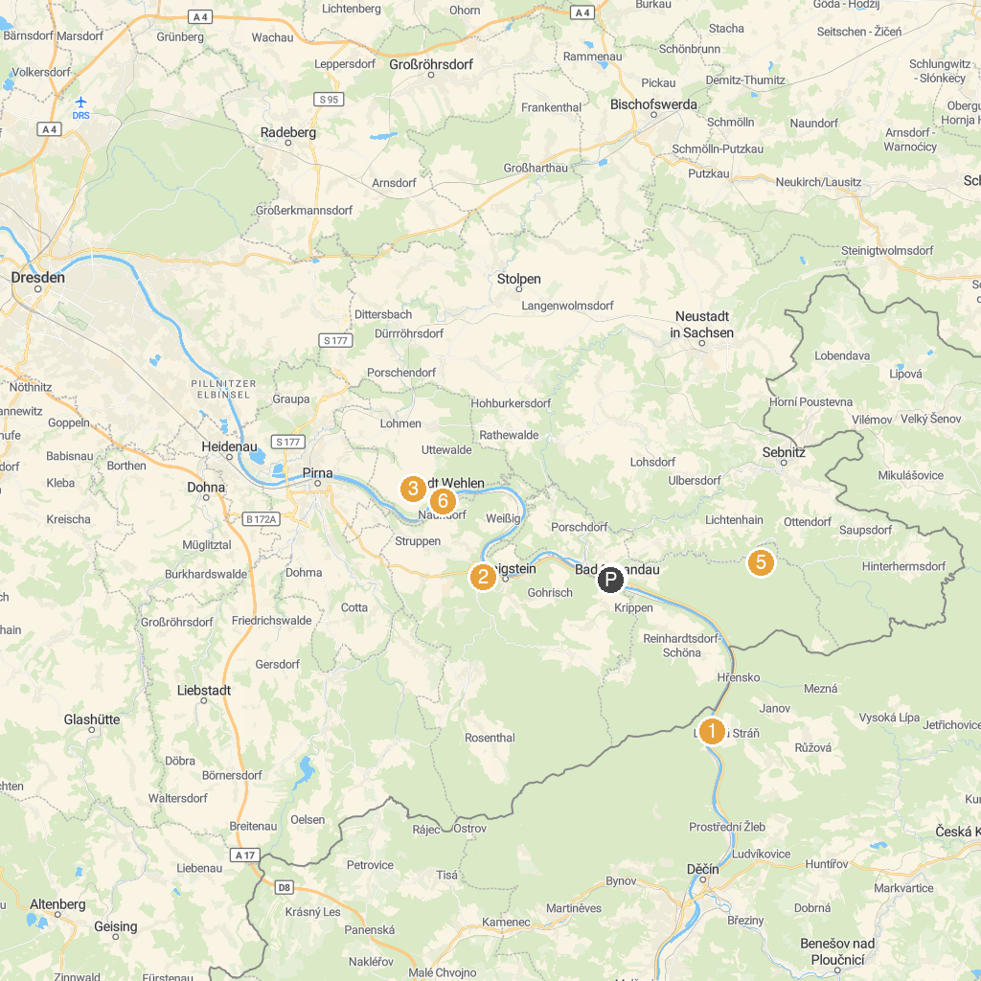
MAP KEY
1. Belvedere Viewpoint | 5. Kleine Sächsische Schweiz
2. Malá Pravčická brána | 6. National Park Center Saxon Switzerland
3. Šaunštejn / Schauenstein Castle | 7. Felsentor 'Kuhstall'
4. Königstein Fortress | 8. Freibad Stadt Wehlen
P. Cruise port / terminal
Map © MapTiler © OpenStreetMap contributors · cruiseports.org

