Bacharach, Rhineland-Palatinate, Germany
One of the Rhine Gorge's most photogenic stops, Bacharach packs a medieval castle, Gothic chapel ruins, half-timbered lanes, and legendary Riesling into a compact old town you can explore entirely on foot.
⚓ Docked (riverside quay) · 🕒 Typical call: 4–7 hrs · 💶 Euro (€) · 🗣️ German
✍️ MY DAY IN PORT (FILL IN)
Ship / Date
In port | arrive ______ · all aboard ______
Booked excursion
Notes / meeting point
GETTING ASHORE
- Docking: KD landing stage on the Rhine riverfront, Leinpfad — steps from the old town gate
- Walk to center: 2 min on foot from the pier to the Marktplatz
- Best For: Medieval architecture, Riesling wine tasting, Rhine scenery, castle hikes
- Don't Miss: Burg Stahleck for panoramic Rhine views and Wernerkapelle Gothic ruins
GETTING AROUND
- 🚕 Taxi: Minimal (short distances) — Local taxis and Uber are available, though rarely necessary given the compact town layout. Useful for reaching hillside
- 📱 Rideshare: ✅ Uber
TOP THINGS TO DO
- Burg Stahleck Castle — The 12th-century castle above town offers sweeping Rhine Valley views.
- Wernerkapelle Gothic Ruins — The roofless 13th-century Werner Chapel sits on the hillside above town.
- Riesling Wine Tasting — The Bacharacher Riesling is world-class.
- Rhine Gorge River Cruise — Board a KD or Bingen-Rüdesheimer day boat for a scenic stretch of the Rhine Gorge toward the Loreley Rock and St.
- Vineyard & Town Wall Walk — The Stadtmauer-Rundweg follows Bacharach's intact medieval walls and towers (Marktturm, Postenturm) through the surrounding…
BEST WALKS
- Old Town & Town Walls Loop: 1 hr | Easy–Moderate | Medieval streets and ramparts — Start at the KD quay and walk through the Markttor (beneath the Marktturm) into the old town.
- Castle & Chapel Hike: 1.5–2 hrs | Moderate | Castle ruins and panoramic Rhine views — From Marktplatz, follow vineyard paths uphill to the Wernerkapelle Gothic ruins, then continue to…
WEATHER · DAYLIGHT · MONEY
Month | High °F | Low °F | Rainy days
May | 66 | 50 | 11
Jul | 78 | 61 | 11
Sep | 70 | 55 | 8
Daylight: May 5:42AM–9:08PM · Jul 5:36AM–9:32PM · Sep 7:05AM–7:41PM
cruiseports.org/bacharach · Confirm terminal & all-aboard time with your ship

Bacharach, Rhineland-Palatinate, Germany — Port Map
Red = walkable sights · Amber = excursions farther out · P = cruise terminal
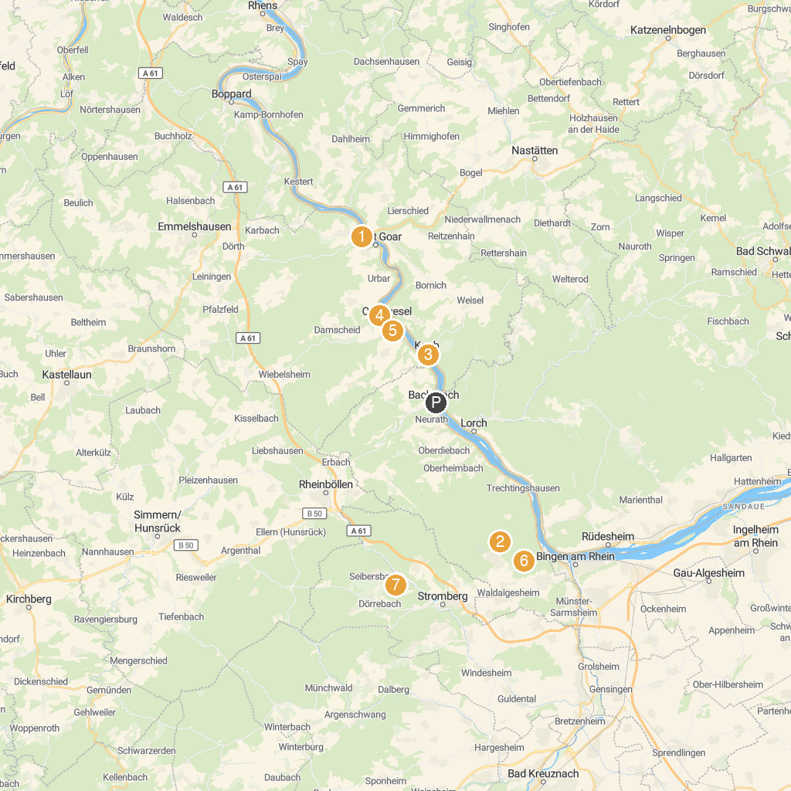
MAP KEY
1. Rheinfels Castle | 5. St. Martinskirche
2. Mouse Tower | 6. Turmmuseum auf Schönburg (Tower Museum)
3. Steckeschlääfer-Klamm | 7. Hängebrücke im Binger Wald
4. Blüchermuseum Kaub | 8. Hunsrück llamas llama trekking in the Hunsrück
P. Cruise port / terminal
Map © MapTiler © OpenStreetMap contributors · cruiseports.org

