Awendaw, South Carolina, USA
A rare expedition stop where cypress-draped swamps meet barrier island wilderness — Awendaw gives small-ship passengers a genuine Lowcountry wild immersion, not a tourist circuit.
⚓ Expedition / Zodiac landing · 🕒 Typical call: 6-8 hrs · 💵 US Dollar (USD) · 🗣️ English · 🌿 Nature & Wildlife focus
✍️ MY DAY IN PORT (FILL IN)
Ship / Date
In port | arrive ______ · all aboard ______
Booked excursion
Notes / meeting point
GETTING ASHORE
- Docking: No cruise pier — expedition ships use Zodiacs or anchor off Garris Landing
- Walk to center: No town center to walk to; activities require a short transfer or guided shuttle
- Best For: Wildlife, birding, kayaking, barrier-island hiking
- Don't Miss: Bulls Island Boneyard Beach and the Cape Romain NWR ferry
GETTING AROUND
- 🚕 Taxi: ~$85–120 to Charleston — Charleston-based car services and taxis can be arranged in advance to pick up at Garris Landing Rd. Contact your ship or
- 📱 Rideshare: ✅ Uber
TOP THINGS TO DO
- Bulls Island & Boneyard Beach — Take the ferry from Garris Landing to Bulls Island, a largely undeveloped barrier island inside Cape Romain National Wildlife…
- Palmetto Trail — Awendaw Passage — A 7.1-mile trail through Francis Marion National Forest weaving between longleaf pine forest and salt marsh.
- Lowcountry Swamp Kayak Tour — Paddle through the blackwater creeks and bottomland hardwood forest of Francis Marion National Forest with guides from Coastal…
- Center for Birds of Prey — A short drive from Garris Landing, this acclaimed center houses nearly 50 raptor species — eagles, falcons, hawks, owls — with…
- Sewee Shell Ring & Visitor Center — Walk the one-mile Sewee Shell Ring Trail to a 4,000-year-old Native American oyster-shell mound, one of the oldest surviving…
BEST WALKS
- Sewee Shell Ring Trail: 1 mile | Easy | Francis Marion National Forest — A flat, self-guided loop through longleaf pine scrub to a 4,000-year-old pre-Columbian shell mound.
- I'on Swamp Trail: ~2 miles | Easy | Francis Marion National Forest — A historic 1700s-era trail through wet pine flatwoods and swamp edges.
WEATHER · DAYLIGHT · MONEY
Month | High °F | Low °F | Rainy days
May | 79 | 66 | 11
Jul | 87 | 76 | 19
Sep | 82 | 71 | 15
Daylight: May 6:19AM–8:11PM · Jul 6:21AM–8:27PM · Sep 7:02AM–7:24PM
cruiseports.org/awendaw-sc · Confirm terminal & all-aboard time with your ship

Awendaw, South Carolina, USA — Port Map
Red = walkable sights · Amber = excursions farther out · P = cruise terminal
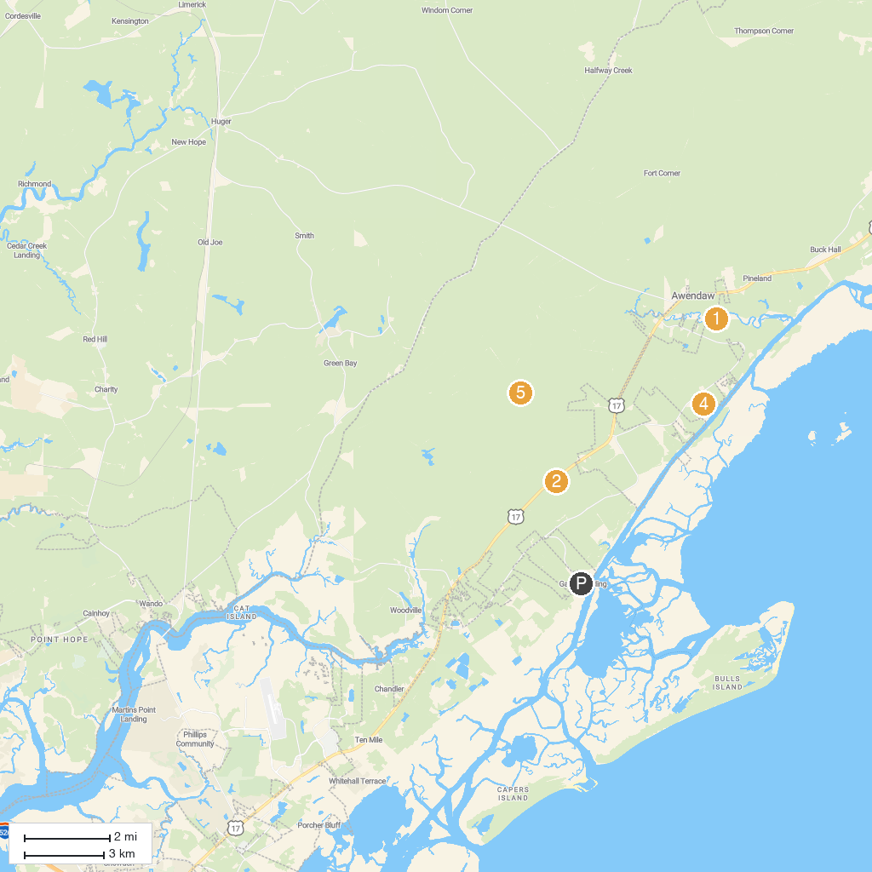
MAP KEY
1. Francis Marion National Forest | 5. Sewee Shell Ring
2. Awendaw Passage- Palmetto Trail | 6. I'on Swamp Interpretive Trail
3. Sewee Visitor & Environmental Education Center | 7. Charleston Adventure Forest
4. Garris Landing Public Boat Ramp
P. Cruise port / terminal
Map © MapTiler © OpenStreetMap contributors · cruiseports.org

