Avignon, Provence, France
Where medieval popes built Europe's largest Gothic palace — and where a famous song put a half-finished bridge on every traveller's bucket list. Avignon's walled city is a UNESCO World Heritage site you can walk end-to-end in a morning.
⚓ Docked (river quay, Rhône) · 🕒 Typical call: 8-10 hrs · 💶 Currency: Euro (€) · 🗣️ Language: French · 🏛️ UNESCO World Heritage city
✍️ MY DAY IN PORT (FILL IN)
Ship / Date
In port | arrive ______ · all aboard ______
Booked excursion
Notes / meeting point
GETTING ASHORE
- Docking: River quay on the Rhône, steps from Pont Saint-Bénézet — no tender needed
- Walk to centre: 5-10 min on foot through the Porte de l'Oulle into the old city
- Best For: History, Provençal food, wine tasting, and scenic walks inside the ramparts
- Don't Miss: Palais des Papes interior and the view from Rocher des Doms garden
GETTING AROUND
- 🚕 Taxi: €8–15 — Metered taxis available at the port. Day rate: €8 base fare (first 2.3 km) + €2.46/km. Night/Sunday rate is higher. Most
- 📱 Rideshare: ✅ Uber, Bolt
- 🚌 Hop-on hop-off: ✅ · from 12
TOP THINGS TO DO
- Palais des Papes & Old City Walking Tour — Europe's largest Gothic palace dominated Christendom for 70 years when the papacy relocated from Rome in 1309.
- Pont Saint-Bénézet (Pont d'Avignon) — The 12th-century bridge that inspired the French nursery rhyme extended 22 arches across the Rhône — floods destroyed most of it…
- Châteauneuf-du-Pape Wine Tour — The papal vineyards 15 km north produce some of France's most celebrated reds.
- Pont du Gard Roman Aqueduct — A UNESCO-listed Roman engineering marvel built around 50 AD to carry water 50 km to Nîmes — its three tiers soar 49 m above the…
- Hilltop Villages — Gordes, Roussillon & Les Baux — Provence's limestone country east and south of Avignon is studded with impossibly pretty hilltop villages.
BEST WALKS
- Quay to Palais des Papes Heritage Loop: 2.5 km · 1.5 hrs · Easy — Start at the ship, visit Pont Saint-Bénézet, pass through Porte de l'Oulle, cross Place du Palais…
- Ramparts & Market Walk: 3 km · 1.5 hrs · Easy — Follow the inside of the 14th-century fortification walls south from Porte de l'Oulle, passing…
WEATHER · DAYLIGHT · MONEY
Month | High °F | Low °F | Rainy days
May | 74 | 55 | 8
Jul | 89 | 69 | 3
Sep | 79 | 61 | 6
Daylight: May 6:15AM–8:59PM · Jul 6:12AM–9:20PM · Sep 7:20AM–7:50PM
cruiseports.org/avignon · Confirm terminal & all-aboard time with your ship

Avignon, Provence, France — Port Map
Red = walkable sights · Amber = excursions farther out · P = cruise terminal
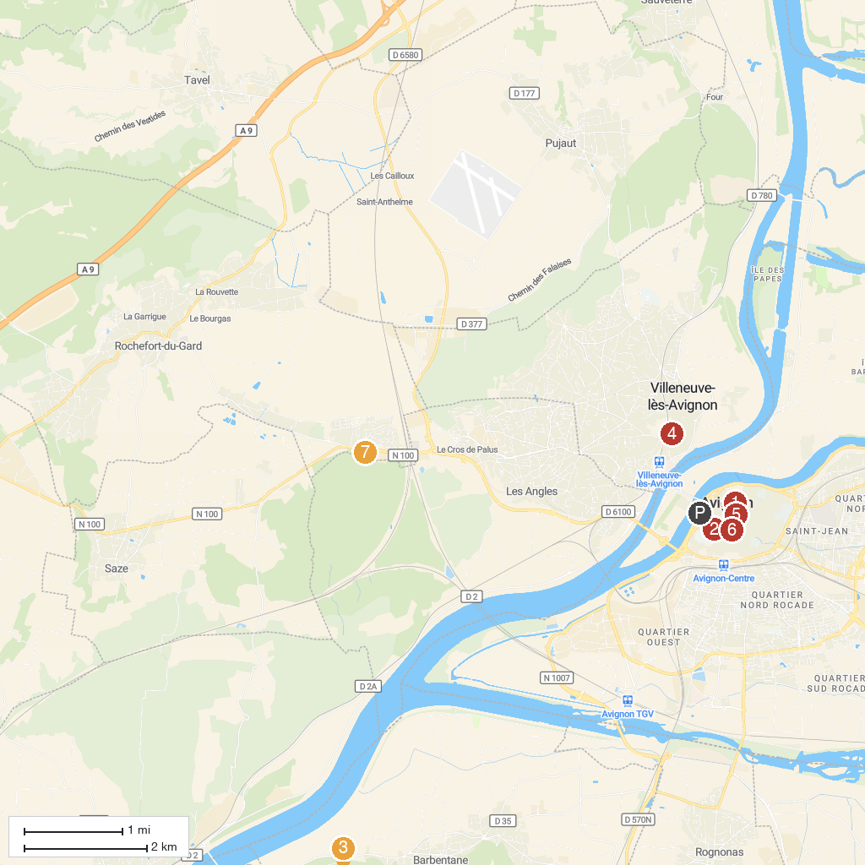
MAP KEY
1. Palais des Papes | 5. Basilique Saint-Pierre
2. Musée Calvet | 6. Église Saint Didier
3. Frigolet Abbey | 7. Piratland
4. The Hill of Mourgues | 8. Jardin Romain
P. Cruise port / terminal
Map © MapTiler © OpenStreetMap contributors · cruiseports.org

