Auckland, North Island, New Zealand
The City of Sails docks you right in the heart of the waterfront CBD — volcanic islands, world-class wineries, and Maori culture are all within easy reach of the pier.
⚓ Docked (CBD piers) · 🕒 Typical call: 8-12 hrs · 💵 NZD (New Zealand Dollar) · 🗣️ English & Māori
✍️ MY DAY IN PORT (FILL IN)
Ship / Date
In port | arrive ______ · all aboard ______
Booked excursion
Notes / meeting point
GETTING ASHORE
- Docking: Princes Wharf or Queens Wharf — both in the CBD, steps from shops and transport
- Walk to center: 5 min to Queen Street; ferry terminal and Britomart train hub are adjacent
- Best For: Waiheke Island wine tours, Sky Tower, Rangitoto volcano, Maori culture
- Don't Miss: A ferry to Waiheke Island or Rangitoto — Auckland's harbour is the star
GETTING AROUND
- 🚕 Taxi: NZD $10–$20 — Taxis are available at the wharf. Given the port is essentially in the city centre, fares to most central hotels and att
- 📱 Rideshare: ✅ Uber, Bolt
- 🚌 Hop-on hop-off: ✅ Auckland Explorer Bus
TOP THINGS TO DO
- Waiheke Island Wine Tour — A 35-minute ferry ride delivers you to Waiheke Island's world-class vineyards.
- Rangitoto Island Summit Hike — Catch the ferry to Rangitoto, Auckland's youngest and largest volcano.
- Maori Culture & Auckland Museum — The Auckland War Memorial Museum on the Domain holds one of the world's finest collections of Maori and Pacific taonga (treasures).
- Sky Tower & Harbour Bridge Climb — Auckland's two signature adrenaline experiences: the Sky Tower offers a glass-floor observation deck (328 m) and a SkyJump; the…
- Hobbiton Movie Set (Full Day) — Two hours south of Auckland in the Waikato, the Shire set from Peter Jackson's films is fully preserved for guided tours.
BEST WALKS
- CBD Waterfront & Viaduct Walk: 2 km · Flat · 30-45 min · No guide needed — Turn right off the pier to explore the Viaduct Harbour — Auckland's America's Cup hub, now filled…
- Queen Street to Sky Tower: 1.5 km · Gentle uphill · 20 min walk — Walk up Queen Street — Auckland's main shopping spine — through the CBD to the base of the Sky Tower.
- Mount Eden Summit: 6 km round trip from CBD · Allow 2-3 hrs · Moderate — Auckland's most accessible volcanic summit offers sweeping 360° views of the harbour, city, and…
WEATHER · DAYLIGHT · MONEY
Month | High °F | Low °F | Rainy days
May | 63 | 55 | 12
Jul | 58 | 50 | 14
Sep | 60 | 51 | 16
Daylight: May 7:12AM–5:22PM · Jul 7:31AM–5:22PM · Sep 6:21AM–6:11PM
cruiseports.org/auckland · Confirm terminal & all-aboard time with your ship

Auckland, North Island, New Zealand — Port Map
Red = walkable sights · Amber = excursions farther out · P = cruise terminal
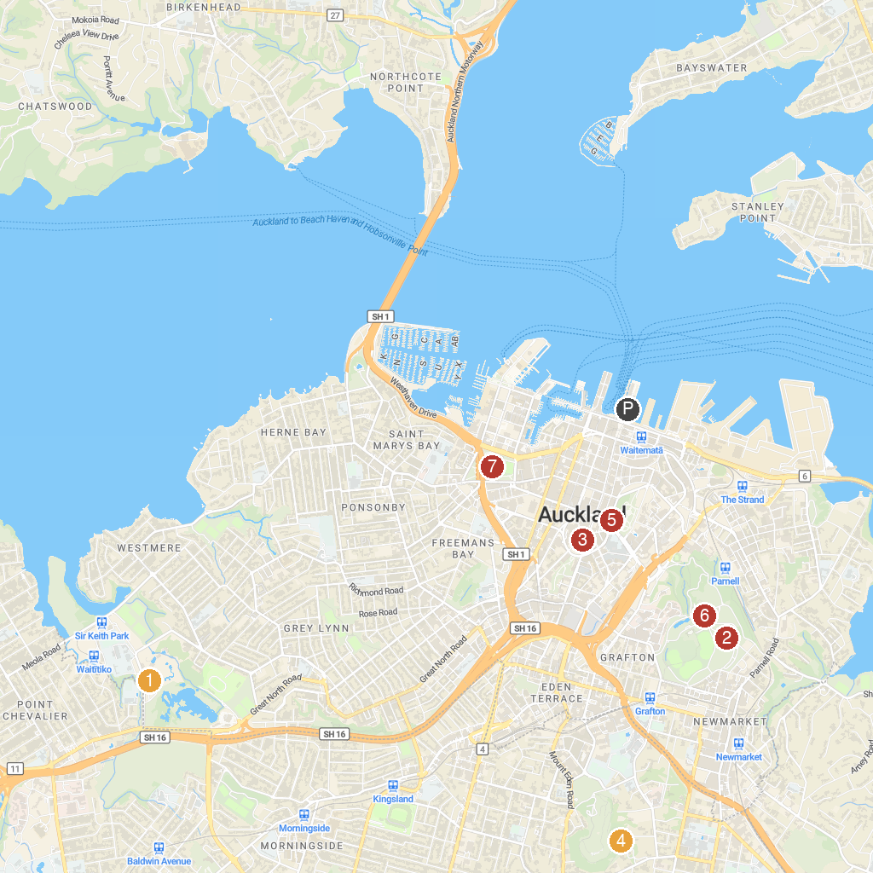
MAP KEY
1. Auckland Zoo | 5. Auckland Art Gallery
2. Auckland Museum | 6. Auckland Domain
3. Auckland Town Hall | 7. Victoria Park
4. Eden Garden
P. Cruise port / terminal
Map © MapTiler © OpenStreetMap contributors · cruiseports.org

