Asyut, Upper Egypt, Egypt
A lesser-visited gem of the Nile Valley, Asyut blends ancient pharaonic tombs, fortress-like Coptic monasteries sacred to the Holy Family, and the buzz of a real Egyptian city untouched by mass tourism.
⚓ Docked (Nile riverbank pier) · 🕒 Typical call: 6-8 hrs · 💵 Egyptian Pound (EGP) · 🗣️ Arabic
✍️ MY DAY IN PORT (FILL IN)
Ship / Date
In port | arrive ______ · all aboard ______
Booked excursion
Notes / meeting point
GETTING ASHORE
- Docking: Nile riverbank pier near city center; most ships moor on the Corniche
- Walk to center: 5-10 min on foot from the Corniche pier to the old market
- Best For: Coptic Christian heritage, pharaonic tombs, off-the-beaten-path Egypt
- Don't Miss: Deir Dronka monastery and the Asyut Barrage (completed 1902)
GETTING AROUND
- 🚕 Taxi: $2–5 USD — Taxis wait near the Nile cruise dock and are the most common way into the city. Agree on a fare before you go — meters a
- 📱 Rideshare: ✅ Careem
TOP THINGS TO DO
- Deir Dronka — Monastery of the Virgin Mary — Perched on a cliffside 10 km southwest of Asyut, this sprawling Coptic complex is built around a cave where the Holy Family is…
- Al-Muharraq Monastery — One of the oldest and holiest Christian monasteries in Egypt, Al-Muharraq is a fortress-like complex 50 km north where tradition…
- Asyut Barrage — This early-20th-century engineering marvel, completed in 1902, spans the full width of the Nile and was originally built to…
- Tombs of the Nomarchs & Necropolis of Meir — Carved into Gebel Asyut al-Gharbi, the rock-cut Tombs of the Nomarchs (the Siut tombs of Khety and Iti-ibi) date to the First…
- Asyut Old Market & Corniche Walk — The bustling souq along the Nile riverbank is one of Upper Egypt's liveliest.
BEST WALKS
- Corniche & Old Market Walk: 1.5 km · 30-40 min · Flat & easy — From the ship's berth on the Corniche, head north along the riverfront promenade to the old souq.
WEATHER · DAYLIGHT · MONEY
Month | High °F | Low °F | Rainy days
May | 98 | 70 | 0
Jul | 103 | 77 | 0
Sep | 99 | 74 | 0
Daylight: May 6:07AM–7:36PM · Jul 6:10AM–7:51PM · Sep 6:40AM–6:59PM
cruiseports.org/asyut · Confirm terminal & all-aboard time with your ship

Asyut, Upper Egypt, Egypt — Port Map
Red = walkable sights · Amber = excursions farther out · P = cruise terminal
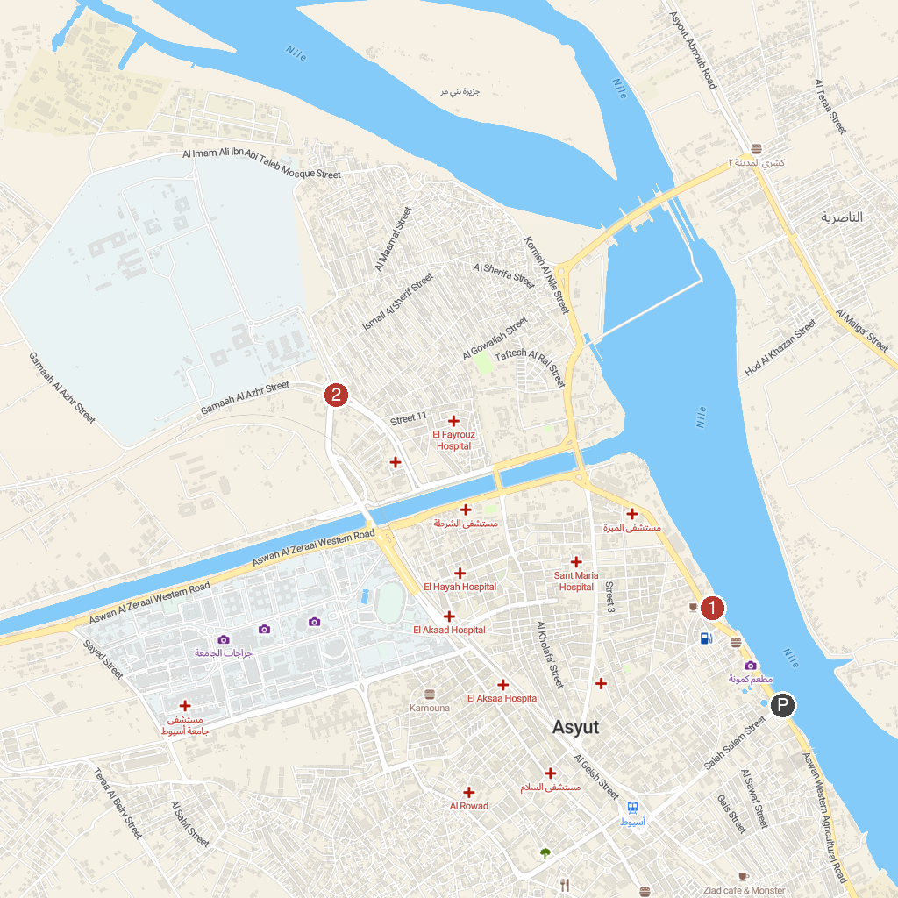
MAP KEY
1. Alexan Pasha Palace, Asyut | 2. ميدان أسماء الله الحسنى
P. Cruise port / terminal
Map © MapTiler © OpenStreetMap contributors · cruiseports.org

