Aswan, Upper Egypt, Egypt
Where the Nile narrows between granite boulders and ancient Nubian temples rise from rescued islands, Aswan is the soul of Upper Egypt — unhurried, golden, and genuinely spectacular.
⚓ Docked (Nile riverbank quay) · 🕒 Typical call: 1–2 days · 💵 Egyptian Pound (EGP) · 🗣️ Arabic (English widely spoken in tourism)
✍️ MY DAY IN PORT (FILL IN)
Ship / Date
In port | arrive ______ · all aboard ______
Booked excursion
Notes / meeting point
GETTING ASHORE
- Docking: Riverside quay along the Nile, central Aswan — ships berth directly to the bank
- Walk to center: The Corniche promenade starts right at the quay; Aswan souk is a 10-min walk
- Best For: Ancient temples, Nubian culture, felucca rides, Abu Simbel day trips
- Don't Miss: Philae Temple at golden hour — arrive by boat from Shellal dock for the best views
GETTING AROUND
- 🚕 Taxi: $2–$5 local / $20–$25 port transfer — Metered taxis are rare in Aswan — fares are negotiated. Agree on a price before boarding; short city hops run the equiva
- 📱 Rideshare: ✅ inDrive
TOP THINGS TO DO
- Philae Temple & Motorboat Crossing — Dedicated to the goddess Isis and relocated stone-by-stone to Agilkia Island after the High Dam flooded its original site, Philae…
- Abu Simbel Temples Day Trip — Ramses II carved these colossal temples into a Nubian cliff face around 1264 BC.
- Aswan High Dam & Unfinished Obelisk — The 1970 High Dam tamed the Nile and created Lake Nasser — a modern marvel worth seeing.
- Nubian Village Visit — Cross the Nile by motorboat to the west bank or Elephantine Island for a vivid Nubian village: brightly painted houses, crocodile…
- Felucca Sail at Sunset — Hire a traditional wooden felucca for a slow tack around Elephantine Island as the sun drops behind the dunes.
BEST WALKS
- Corniche & Aswan Souk Walk: 2.5 km · 45 min · Easy · Flat paved promenade — From the cruise quay, follow the Corniche el-Nil north past the Ferial Gardens and the landmark Old…
- Elephantine Island Stroll: 1.5 km on island · 1 hr · Easy · Public ferry or felucca — Take the public ferry (a few EGP) from the Corniche to Elephantine Island.
WEATHER · DAYLIGHT · MONEY
Month | High °F | Low °F | Rainy days
May | 103 | 76 | 0
Jul | 106 | 81 | 0
Sep | 104 | 78 | 0
Daylight: May 6:05AM–7:23PM · Jul 6:10AM–7:38PM · Sep 6:34AM–6:51PM
cruiseports.org/aswan · Confirm terminal & all-aboard time with your ship

Aswan, Upper Egypt, Egypt — Port Map
Red = walkable sights · Amber = excursions farther out · P = cruise terminal
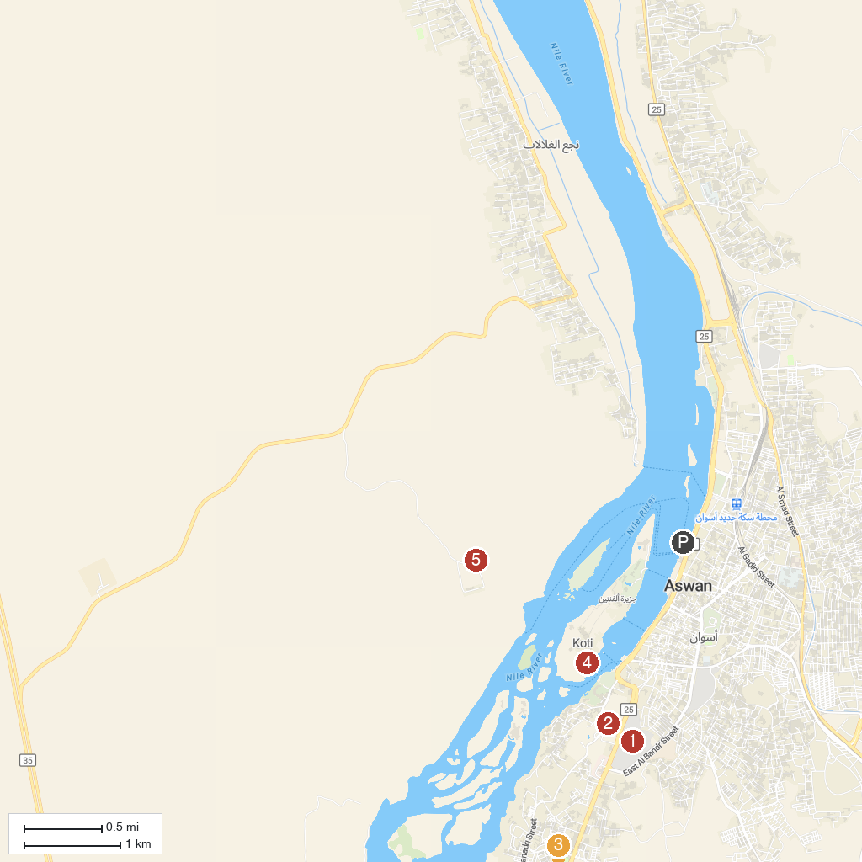
MAP KEY
1. Kalabsha Temple | 5. Nubian Museum
2. Beit el-Wali | 6. Philae Temple
3. Assuão-The High Dam | 7. Aswan Museum
4. Fatimid Cemetery | 8. Monastery of St. Simeon
P. Cruise port / terminal
Map © MapTiler © OpenStreetMap contributors · cruiseports.org

