Astoria, Oregon, USA
Where the Columbia River meets the Pacific, Astoria mixes genuine maritime history — Lewis & Clark, the Graveyard of the Pacific, Victorian mansions — with a walkable craft-beer downtown and sweeping views from a 125-foot hilltop column.
⚓ Docked — Pier 1 · 🕒 Typical call: 8-10 hrs · 💵 USD (no Oregon sales tax) · 🗣️ English
✍️ MY DAY IN PORT (FILL IN)
Ship / Date
In port | arrive ______ · all aboard ______
Booked excursion
Notes / meeting point
GETTING ASHORE
- Docking: Pier 1, western edge of historic downtown — no tendering
- Walk to center: 5-10 min along the Riverwalk to Commercial St shops
- Best For: History buffs, craft-beer lovers, scenic photography
- Don't Miss: Astoria Column views + Columbia River Maritime Museum
GETTING AROUND
- 🚕 Taxi: $10–$15 to city center — Local taxis charge ~$5.50 drop + $3.40/mile. The pier is 1.5–2.5 miles from downtown; roughly 7–8 cabs typically availab
- 📱 Rideshare: ✅ Uber
- 🚌 Hop-on hop-off: ✅
TOP THINGS TO DO
- Astoria Column — Climb 164 spiral steps inside this 125-foot hilltop tower to panoramic views of the Columbia River, Pacific Ocean, and Cascade…
- Columbia River Maritime Museum — One of the best maritime museums on the West Coast, sitting right on the waterfront.
- Fort Clatsop / Lewis & Clark National Historical Park — A replica of the fort where Lewis & Clark and the Corps of Discovery spent the winter of 1805-06 before returning east.
- Fort Stevens & Peter Iredale Shipwreck — The rusting skeleton of the 1906 four-masted steel barque Peter Iredale is one of the most photogenic shipwrecks on the Pacific…
- Craft Brewery Tour — Astoria has an outsized craft brewing scene.
BEST WALKS
- Astoria Riverwalk: 1.5 miles one-way · Flat · 30-40 min — Follow the old railroad bed along the Columbia River from Pier 1 through downtown to the east end.
- Historic Downtown Astoria: 0.5 miles · Flat · 1-2 hrs with stops — Head up 14th Street from the Riverwalk to the Flavel House Museum (stunning 1885 Queen Anne…
WEATHER · DAYLIGHT · MONEY
Month | High °F | Low °F | Rainy days
May | 70 | 53 | 11
Jul | 85 | 69 | 12
Sep | 77 | 62 | 10
Daylight: May 5:38AM–8:06PM · Jul 5:37AM–8:25PM · Sep 6:36AM–7:03PM
cruiseports.org/astoria-or · Confirm terminal & all-aboard time with your ship

Astoria, Oregon, USA — Port Map
Red = walkable sights · Amber = excursions farther out · P = cruise terminal
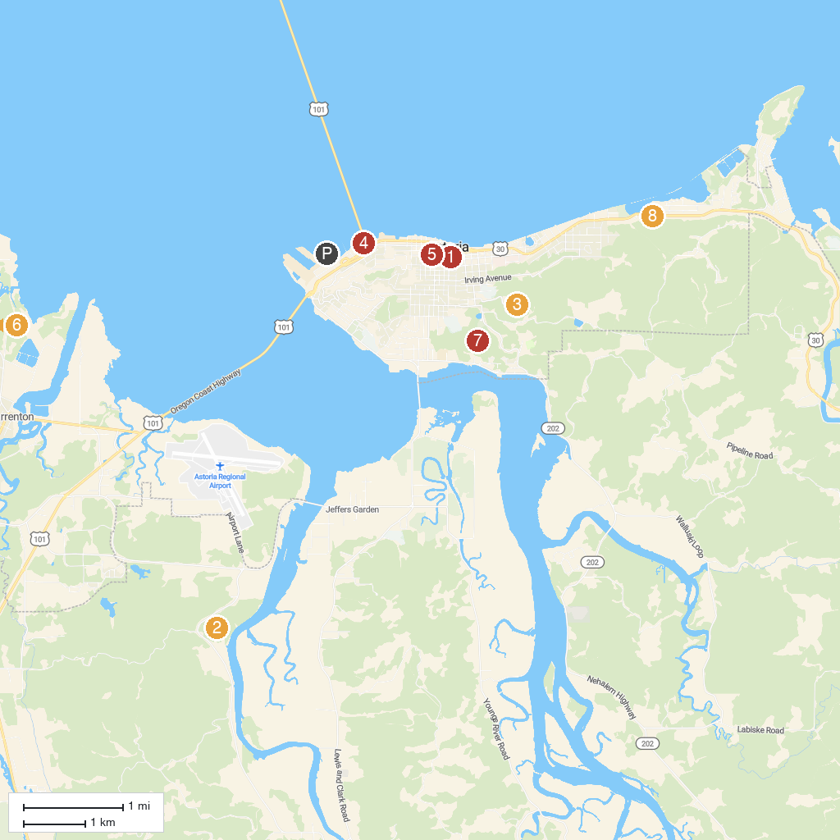
MAP KEY
1. Garden of Surging Waves - HERITAGE SQUARE | 5. Oregon Film Museum
2. Lewis and Clark National Historical Park | 6. Wreck of the Peter Iredale
3. The Astoria Column | 7. Shively Park
4. Maritime Memorial | 8. Alderbrook Park
P. Cruise port / terminal
Map © MapTiler © OpenStreetMap contributors · cruiseports.org

