Ashdod, Southern District, Israel
Israel's busiest port and your launchpad into the Holy Land — Jerusalem is just an hour away, the Dead Sea a little more. Few ports in the world deliver this much history in a single day.
⚓ Docked (cruise pier) · 🕒 Typical call: 9-11 hrs · 💵 Israeli Shekel (ILS) · 🗣️ Hebrew / English widely spoken · 🕌 Religious sites require modest dress
✍️ MY DAY IN PORT (FILL IN)
Ship / Date
In port | arrive ______ · all aboard ______
Booked excursion
Notes / meeting point
GETTING ASHORE
- Docking: Cruise ships dock at the dedicated passenger pier; air-conditioned shuttles transfer passengers to the terminal building
- Walk to center: Ashdod city center ~4 km from port; most passengers join excursions rather than walking into town
- Best For: Jerusalem & Bethlehem, Dead Sea floating, Masada fortress, Tel Aviv & Jaffa
- Don't Miss: The Western Wall and Old City of Jerusalem — even a half-day visit is life-changing
GETTING AROUND
- 🚕 Taxi: ₪30–₪40 (~$10–13 USD) — Metered taxis wait at the port exit (walking inside the port is prohibited). The city center is about 5 km away; the rid
- 📱 Rideshare: ✅ Gett, Yango
TOP THINGS TO DO
- Jerusalem Old City & Western Wall — The undisputed highlight of any Ashdod call.
- Jerusalem & Bethlehem Combined — Add Bethlehem's Church of the Nativity to a Jerusalem day.
- Masada & the Dead Sea — Ride a cable car to the mountaintop fortress of Masada, then float effortlessly in the mineral-rich Dead Sea — the lowest point…
- Tel Aviv & Old Jaffa — Israel's modern cosmopolitan city pairs beautifully with ancient Jaffa's winding alleys and clifftop views.
- Caesarea Roman Ruins — Herod the Great's ancient port city features a stunning Roman amphitheatre, aqueduct, hippodrome, and Crusader fortifications…
BEST WALKS
- Ashdod Marina & Beach Promenade: 1-2 hrs | Easy | Flat — A relaxed walk for those staying close to port.
- Old Jaffa Self-Guided Walk: 2-3 hrs | Easy | Mostly flat — Take the train or taxi to Tel Aviv and walk into ancient Jaffa.
WEATHER · DAYLIGHT · MONEY
Month | High °F | Low °F | Rainy days
May | 79 | 63 | 2
Jul | 87 | 73 | 0
Sep | 86 | 73 | 1
Daylight: May 5:44AM–7:31PM · Jul 5:46AM–7:47PM · Sep 6:25AM–6:47PM
cruiseports.org/ashdod · Confirm terminal & all-aboard time with your ship

Ashdod, Southern District, Israel — Port Map
Red = walkable sights · Amber = excursions farther out · P = cruise terminal
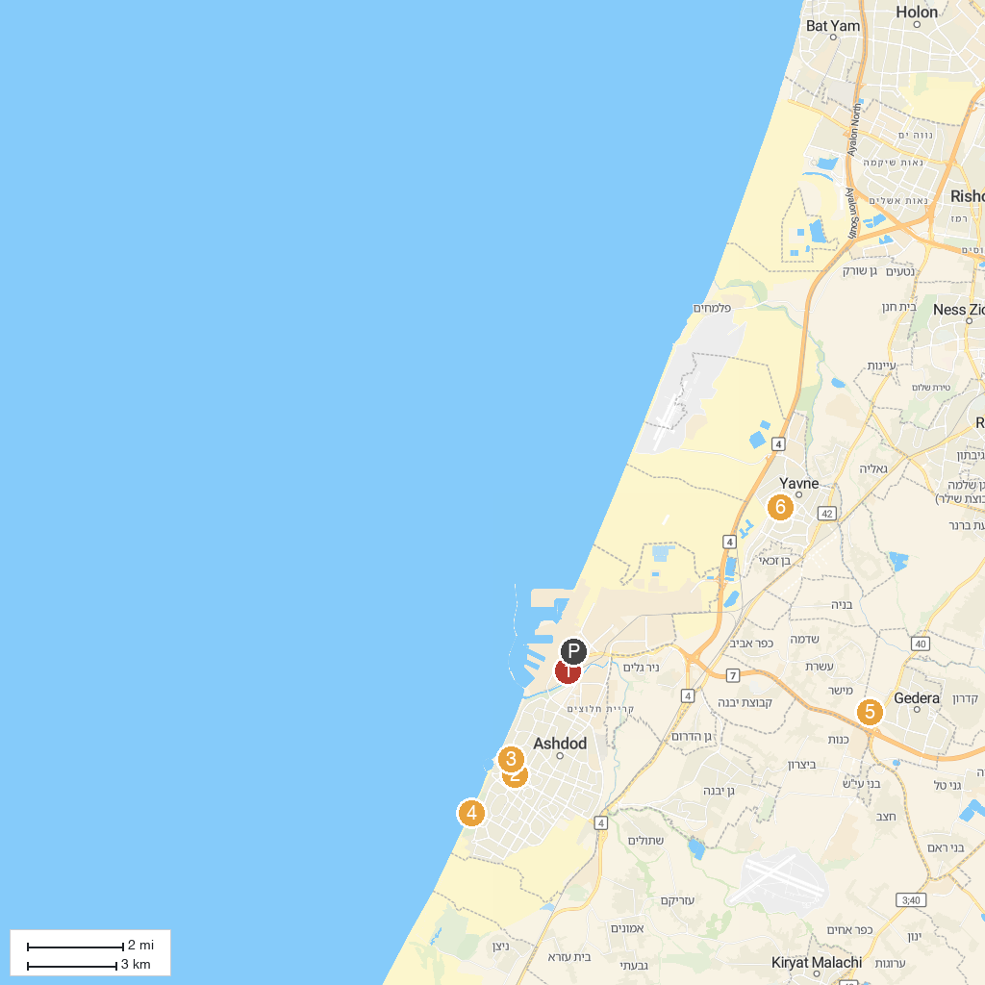
MAP KEY
1. Tel Mor | 5. אגרונן - קטיף עצמי
2. Ashdod Museum of Art | 6. Yavne Water Park
3. פארק אשדוד ים | 7. משק בגבעה - קטיף עצמי בגדרה
4. Ashdod Yam Fort | 8. Tom and Tomer hill
P. Cruise port / terminal
Map © MapTiler © OpenStreetMap contributors · cruiseports.org

