Aschaffenburg, Bavaria, Germany
Called the "Bavarian Nice" for its mild climate and Mediterranean gardens, Aschaffenburg packs a Renaissance palace, a Roman villa, and a medieval Altstadt into one compact, walkable riverbank stop.
⚓ Docked (riverside pier) · 🕒 Typical call: 6–8 hrs · 💶 Euro (€) · 🗣️ German
✍️ MY DAY IN PORT (FILL IN)
Ship / Date
In port | arrive ______ · all aboard ______
Booked excursion
Notes / meeting point
GETTING ASHORE
- Docking: Alongside on the Main River — bayernhafen pier or Floßhafen municipal pier, both near center
- Walk to center: 5–10 min on foot to Johannisburg Palace and Old Town
- Best For: History, architecture, riverside strolling, German cuisine
- Don't Miss: Schloss Johannisburg and the Pompejanum side by side on the riverbank
GETTING AROUND
- 🚕 Taxi: €6–12 to center — Taxis queue near the pier and charge a base fare of ~€3.80 plus ~€2.30/km. The short hop to the palace or old town typic
- 📱 Rideshare: ✅ Uber
TOP THINGS TO DO
- Schloss Johannisburg — This imposing red-sandstone Renaissance palace (1605–1614) was the seat of the prince-bishops of Mainz.
- Pompejanum — A full-scale replica of a Pompeian villa commissioned by King Ludwig I of Bavaria, perched above the Main with a Mediterranean…
- Stiftsbasilika St. Peter und Alexander — Aschaffenburg's collegiate church dates to the 10th century and blends Romanesque and Gothic styles.
- Schönbusch Palace & Park — Bavaria's oldest English-style landscaped park (est.
- Aschaffenburg Old Town (Altstadt) — Wander cobbled lanes past half-timbered houses from around 1600, the Baroque Church of Our Lady, the municipal theatre, and…
BEST WALKS
- Palace & Riverfront Stroll: 2 km · 30–40 min · flat — From the pier, walk upriver to Johannisburg Palace, then continue through the Schlossgarten to the…
- Altstadt Loop: 2.5 km · 40–50 min · flat — Head into the Old Town from the pier past the Stiftsbasilika, explore Dalbergstraße and the market…
WEATHER · DAYLIGHT · MONEY
Month | High °F | Low °F | Rainy days
May | 66 | 49 | 12
Jul | 78 | 60 | 11
Sep | 69 | 53 | 9
Daylight: May 5:37AM–9:02PM · Jul 5:31AM–9:26PM · Sep 6:59AM–7:36PM
cruiseports.org/aschaffenburg · Confirm terminal & all-aboard time with your ship

Aschaffenburg, Bavaria, Germany — Port Map
Red = walkable sights · Amber = excursions farther out · P = cruise terminal
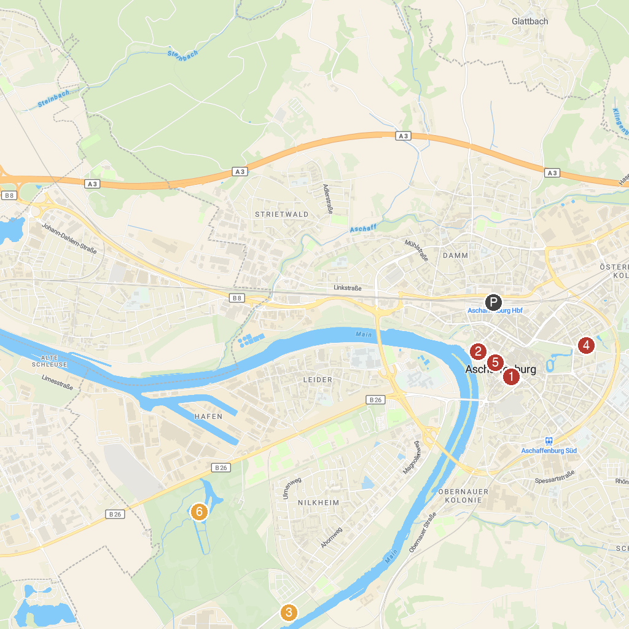
MAP KEY
1. Stiftsmuseum | 4. Ludwigsbrunnen
2. Schloss Johannisburg | 5. Christian Schad Museum
3. Nilkheimer Park | 6. Schönbusch
P. Cruise port / terminal
Map © MapTiler © OpenStreetMap contributors · cruiseports.org

