Arromanches-les-Bains, Normandy, France
The concrete caissons of Port Winston still sit in the sea off Gold Beach, a silent testament to the greatest amphibious operation in history. Arromanches-les-Bains is hallowed ground — small, walkable, and profoundly moving.
⚓ Tender port (expedition ships only) · 🕒 Typical call: 5–7 hrs · 💶 Currency: Euro (EUR) · 🗣️ Language: French · 🎖️ D-Day / WWII history
✍️ MY DAY IN PORT (FILL IN)
Ship / Date
In port | arrive ______ · all aboard ______
Booked excursion
Notes / meeting point
GETTING ASHORE
- Docking: Tender only — expedition ships anchor offshore; large cruise ships visit via shore excursion from Le Havre or Cherbourg
- Walk to centre: Tender lands at the seafront, beach and museum within 5 min walk
- Best For: WWII history, D-Day beaches, sombre reflection, coastal walks
- Don't Miss: Mulberry Harbour remains at low tide and Arromanches 360 Circular Cinema
GETTING AROUND
- 🚕 Taxi: €21–€50 — Local taxis serve day-trip destinations: Bayeux (~10 km) runs €21–€26; the Normandy American Cemetery (~20 km) runs €40–
- 📱 Rideshare: ✅ Uber
TOP THINGS TO DO
- Musée du Débarquement (D-Day Landing Museum) — The museum sits right on the seafront and tells the story of the Mulberry B harbour through scale models, original equipment, and…
- Mulberry Harbour Remains (Port Winston) — The concrete caissons (Phoenix units) of the Allied artificial harbour are still visible in the bay and on the beach.
- Arromanches 360 Circular Cinema — A 360° panoramic cinema screens 'The 100 Days of Normandy', blending archival D-Day footage with modern shots of the same…
- Omaha Beach & Normandy American Cemetery — A 20-minute drive west brings you to Omaha Beach and the Colleville-sur-Mer cemetery, where nearly 10,000 American servicemen are…
- Pointe du Hoc Ranger Memorial — The cliff-top promontory where U.S.
BEST WALKS
- Seafront to Mulberry Harbour Walk: 1.5 km • Easy • 30–45 min — From the tender pier, walk east along the promenade past the Musée du Débarquement, then continue…
- Seafront to Arromanches 360: 0.5 km • Short uphill • 10 min — From the seafront, follow Rue du Lieutenant Colonel Hewitt uphill to the Arromanches 360 Circular…
WEATHER · DAYLIGHT · MONEY
Month | High °F | Low °F | Rainy days
May | 61 | 50 | 11
Jul | 71 | 59 | 10
Sep | 68 | 56 | 10
Daylight: May 6:19AM–9:39PM · Jul 6:13AM–10:02PM · Sep 7:39AM–8:15PM
cruiseports.org/arromanches-les-bains · Confirm terminal & all-aboard time with your ship

Arromanches-les-Bains, Normandy, France — Port Map
Red = walkable sights · Amber = excursions farther out · P = cruise terminal
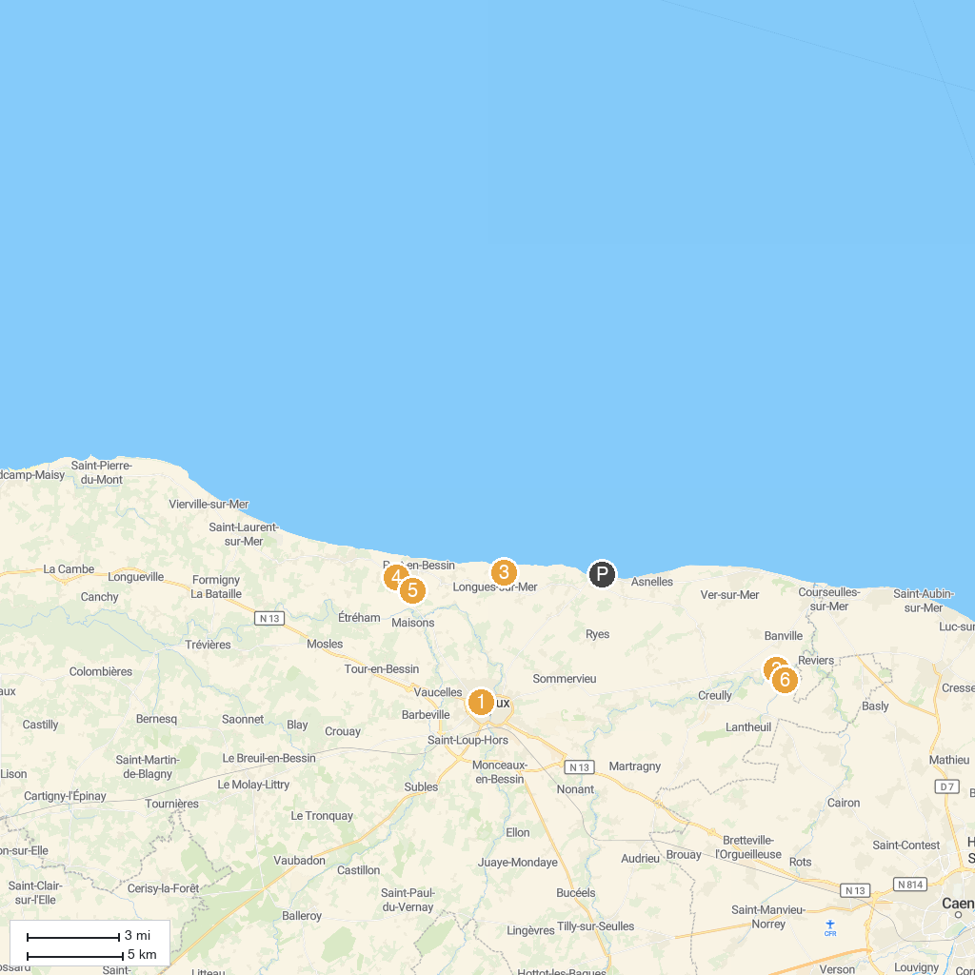
MAP KEY
1. Saint-Patrice Church of Bayeux | 5. Omaha Beach Golf
2. Tumulus de Colombiers-sur-Seulles | 6. Musée des épaves sous-marines du débarquement. DD Wrecks
3. Old St. Peter's Church | 7. Jardin Des Marettes
4. Longues-sur-Mer battery | 8. Parc de l'Édit
P. Cruise port / terminal
Map © MapTiler © OpenStreetMap contributors · cruiseports.org

