Arrecife, Lanzarote
Volcanic Capital of the Atlantic
🚢 Port City · 🌋 Volcanic Terrain · ⚪ White Architecture · 🇪🇸 Spanish Culture
✍️ MY DAY IN PORT (FILL IN)
Ship / Date
In port | arrive ______ · all aboard ______
Booked excursion
Notes / meeting point
GETTING ASHORE
- Currency: Euro (€)
- Language: Spanish
- Time Zone: UTC+0 / UTC+1
- Vibe: Authentic Canarian Town
GETTING AROUND
- 🚕 Taxi: €5–€10 — Taxis queue at both docks. Muelle de los Mármoles (further dock) is ~€8–€10 to city center; La Boca de Puerto Naos (clos
- 📱 Rideshare: ❌ not available
- 🚌 Hop-on hop-off: ✅
TOP THINGS TO DO
- Timanfaya National Park — Explore the 'Mountains of Fire' in an open-top bus, witnessing the lunar-like volcanic landscapes and geothermal heat.
- Jameos del Agua — A stunning subterranean cave transformed into a gallery and concert hall by artist César Manrique, featuring a lake with blind…
- La Geria Vineyards — Visit the unique volcanic vineyards where grapes are grown in pits of volcanic ash (lapilli) to protect them from wind.
- Mirador del Río — A breathtaking viewpoint overlooking the neighboring island of La Graciosa, designed by César Manrique.
BEST WALKS
- Charco de San Ginés: Lagoon Walk — Walk from the port to this natural lagoon, where you can enjoy the white-washed houses and…
- The Old Town: Cultural Walk — Explore the narrow streets, visit the local market, and enjoy a coffee at a traditional cafe.
- The Waterfront: Waterfront Walk — Stroll along the harbor, watching the fishing boats and the blue ocean.
WEATHER · DAYLIGHT · MONEY
Month | High °F | Low °F | Rainy days
May | 72 | 64 | 1
Jul | 77 | 69 | 0
Sep | 78 | 70 | 1
Daylight: May 7:02AM–8:38PM · Jul 7:05AM–8:54PM · Sep 7:39AM–7:58PM
cruiseports.org/arrecife · Confirm terminal & all-aboard time with your ship

Arrecife, Lanzarote — Port Map
Red = walkable sights · Amber = excursions farther out · P = cruise terminal
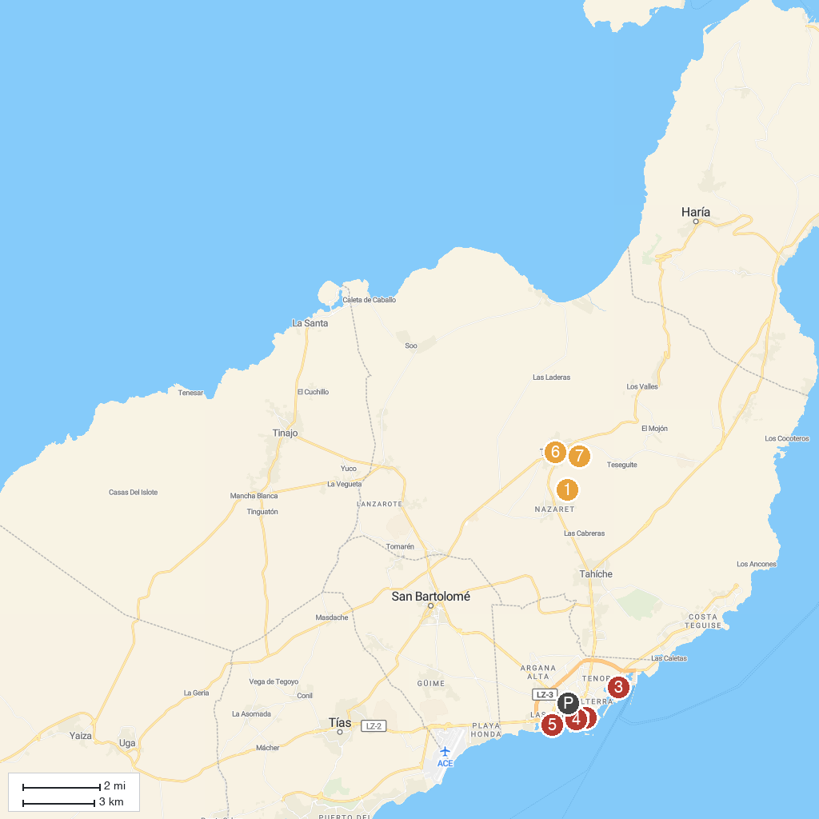
MAP KEY
1. Museo Lagomar | 5. Parque Temático
2. Parroquia de San Ginés | 6. Casa Museo Palacio Spínola
3. MIAC - International Museum of Contemporary Art, San José Castle | 7. Castillo de Santa Bárbara
4. Centro de Innovación Cultural "El Almacén"
P. Cruise port / terminal
Map © MapTiler © OpenStreetMap contributors · cruiseports.org

