Arkhangelsk, Arkhangelsk Oblast, Russia
Russia's gateway to the Arctic, Arkhangelsk sits where the Northern Dvina meets the White Sea — a city of weathered wooden streets, Pomor seafaring tradition, and some of the finest open-air architecture museums in Europe.
⚓ Docked (Solombala pier) · 🕒 Typical call: 8-10 hrs · 💵 Russian Ruble (cash only — international cards blocked) · 🗣️ Russian · 🌤️ Best season: Jun–Aug
✍️ MY DAY IN PORT (FILL IN)
Ship / Date
In port | arrive ______ · all aboard ______
Booked excursion
Notes / meeting point
GETTING ASHORE
- Docking: Ships berth at Solombala district pier, a short taxi or ferry hop from the city center
- Walk to center: ~2 km via the Kuznechevsky Bridge from Solombala to the Dvina Embankment
- Best For: Northern Russian history, wooden architecture, White Sea culture, Arctic heritage
- Don't Miss: Malye Korely open-air museum — 25 km away, Europe's largest collection of wooden northern buildings
GETTING AROUND
- 🚕 Taxi: Varies — confirm rate before boarding — Local taxis are available but metered pricing and English-language service are not guaranteed. Pre-arrange through your
- 📱 Rideshare: ❌ not available
TOP THINGS TO DO
- Malye Korely Open-Air Museum — Europe's largest open-air museum of northern Russian wooden architecture sits 25 km from the city on the Dvina riverbank.
- Chumbarovka Avenue & City Center Walk — Arkhangelsk's pedestrian showpiece: a preserved 19th-century wooden streetscape with painted facades, craft shops, and the 'Bird…
- Northern Maritime Museum — Dedicated to the Pomor people — the Arctic seafarers who navigated the White Sea centuries before European explorers reached the…
- Northern Dvina River Cruise — Summer boat trips depart from the embankment to nearby river islands — Kegostrov and Konetsdvorye — offering a glimpse of island…
- Arkhangelsk Regional Museum & Gostiny Dvor — One of Russia's oldest regional museums occupies the Gostiny Dvor — the city's oldest stone building, built in the 17th century…
BEST WALKS
- Dvina Embankment to Chumbarovka: 3 km · 1-1.5 hrs · Easy — Start at the Northern Maritime Museum on the Dvina Embankment and walk south along the river…
- Solombala Island Historic Loop: 2 km · 45 min · Easy — Explore the island district where Peter the Great founded Russia's first state shipyard in 1693.
WEATHER · DAYLIGHT · MONEY
Month | High °F | Low °F | Rainy days
May | 55 | 37 | 11
Jul | 70 | 54 | 13
Sep | 55 | 44 | 13
Daylight: Sep 5:40AM–6:43PM
cruiseports.org/arkhangelsk · Confirm terminal & all-aboard time with your ship

Arkhangelsk, Arkhangelsk Oblast, Russia — Port Map
Red = walkable sights · Amber = excursions farther out · P = cruise terminal
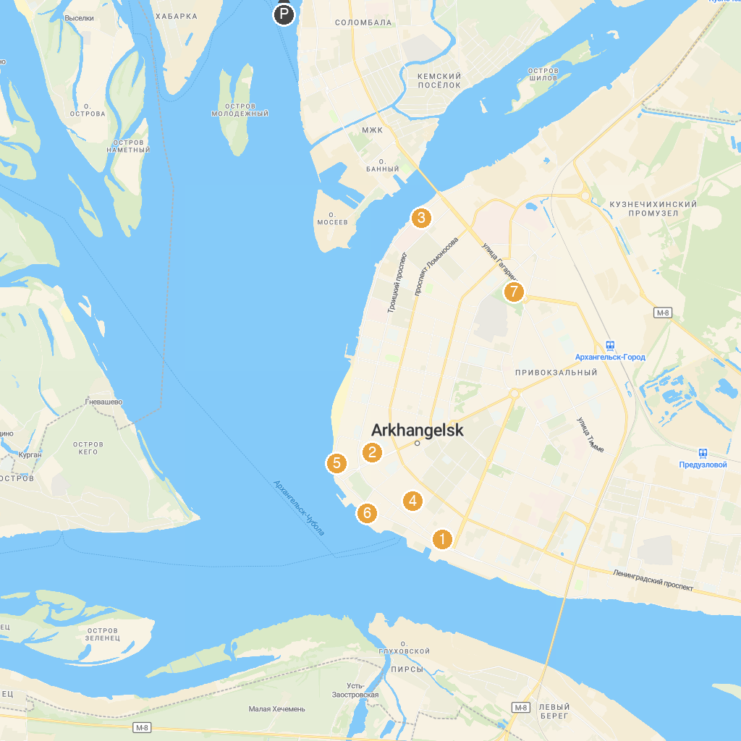
MAP KEY
1. Monument to heroic defenders of the Soviet north | 5. Arkhangelsk Regional History Museum
2. Art Museum | 6. Northern Maritime Museum
3. Svyato-Troitskiy Khram | 7. Monument to victims of political repression
4. Museum of Arkhangelsk Gingerbread, Kozuli
P. Cruise port / terminal
Map © MapTiler © OpenStreetMap contributors · cruiseports.org

