Aride Island, Seychelles
The 'Seabird Fortress of the Indian Ocean' — a pristine 71-hectare reserve hosting hundreds of thousands of breeding seabirds, endemic reptiles, and nesting sea turtles. No shops, no terminals, no crowds: just wild Seychelles as it was meant to be.
⚓ Tender / wet beach landing · 🕒 Typical call: 4-6 hrs · 💵 Seychellois Rupee (SCR) · 🗣️ Seychellois Creole / English · 🚫 Expedition & small ships only
✍️ MY DAY IN PORT (FILL IN)
Ship / Date
In port | arrive ______ · all aboard ______
Booked excursion
Notes / meeting point
GETTING ASHORE
- Docking: Wet beach landing on La Cour Beach (south side) via reserve boats; no pier or terminal
- Walk to centre: No town — guided 2 km loop from beach is the entire island experience
- Best For: Birdwatchers, wildlife photographers, nature lovers, eco-tourism
- Don't Miss: Hilltop viewpoint (Gros La Tête, 134 m) and the Wright's Gardenia — found nowhere else on Earth
GETTING AROUND
- 📱 Rideshare: ❌ not available
TOP THINGS TO DO
- Guided Island Nature Walk — The signature 2 km guided loop through the reserve.
- Hilltop Viewpoint (Gros La Tête) — Hike 135 m to the island's high point for sweeping panoramas of the Indian Ocean and neighboring islands including Praslin, La…
- Seabird Colony Watch — Aride hosts the world's largest colony of lesser noddies and Seychelles' biggest roseate tern population.
- Endemic Flora Discovery — Spot Wright's Gardenia (Rothmannia annae) — a shrub found only on Aride Island.
- La Cour Beach Stroll — After the guided walk, relax on the pristine south beach.
BEST WALKS
- Island Nature Loop: 2 km · ~2 hrs · guided only · moderate — The reserve's mandatory guided walk leads from the landing beach past the historic Cadbury Lodge…
WEATHER · DAYLIGHT · MONEY
Month | High °F | Low °F | Rainy days
May | 82 | 79 | 22
Jul | 78 | 76 | 16
Sep | 79 | 77 | 17
Daylight: May 6:16AM–6:11PM · Jul 6:26AM–6:20PM · Sep 6:10AM–6:14PM
cruiseports.org/aride-island-seychelles · Confirm terminal & all-aboard time with your ship

Aride Island, Seychelles — Port Map
Red = walkable sights · Amber = excursions farther out · P = cruise terminal
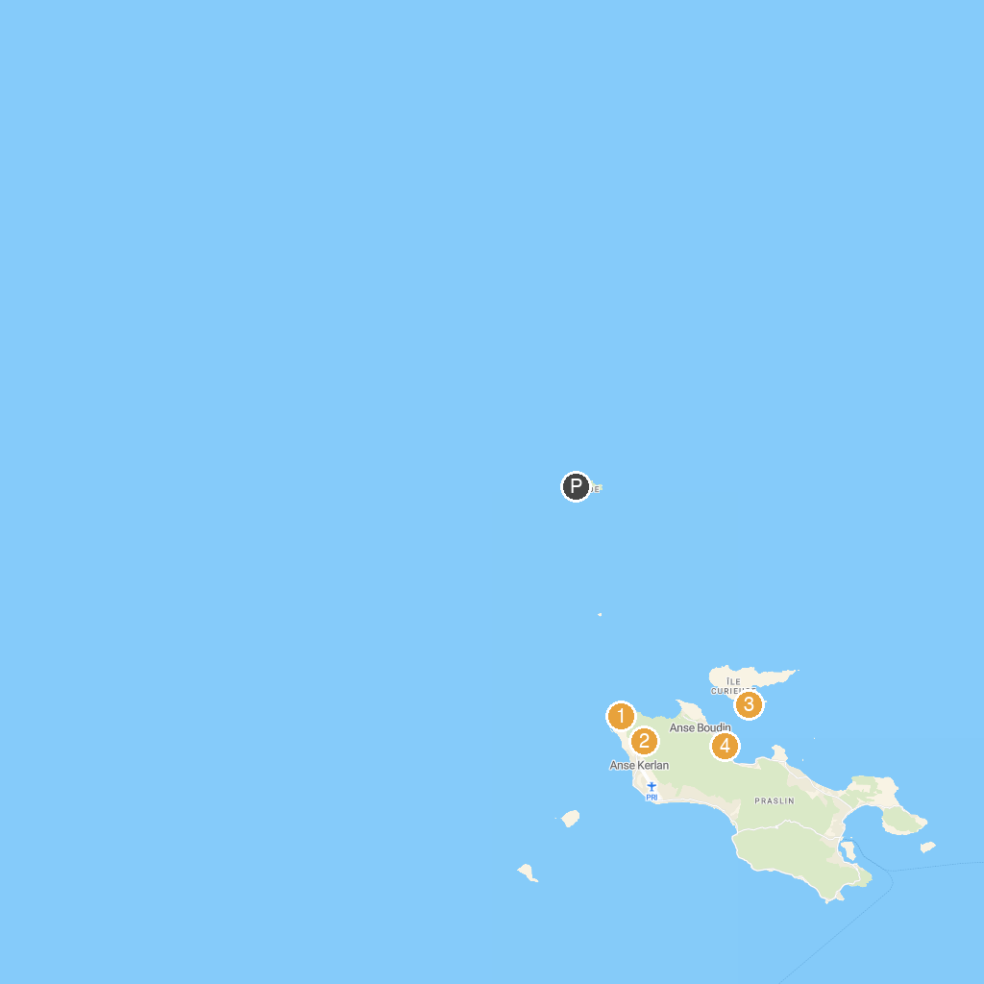
MAP KEY
1. Geoli Charters - Group Tours, Private Charters & Glass Bottom Boat | 5. Anse Takamaka
2. Anse Georgette | 6. Grand Anse Beach
3. Mont Plaisir to Anse Georgette Nature Trail | 7. Snorkeling St.Pierre
4. Anse St. Jose | 8. Gallery Passerose’s horizontal palm tree
P. Cruise port / terminal
Map © MapTiler © OpenStreetMap contributors · cruiseports.org

