Arica, Chile
Arica, Chile
Port City · Desert Coast · Eternal Spring · Archaeology
✍️ MY DAY IN PORT (FILL IN)
Ship / Date
In port | arrive ______ · all aboard ______
Booked excursion
Notes / meeting point
GETTING ASHORE
- Currency: Chilean Peso (CLP)
- Language: Spanish
- Climate: Arid/Desert
- Time Zone: GMT-4
GETTING AROUND
- 🚕 Taxi: 3,000–4,000 CLP (~$4–5 USD) — Taxis wait at the pier and are metered or fixed-rate for short city hops. Cash in Chilean Pesos recommended.
- 📱 Rideshare: ✅ Uber
TOP THINGS TO DO
- The Mummies of the Chinchorro — Visit the San Miguel de Azapa Archaeological Museum to see the world's oldest artificially mummified remains, predating the…
- El Morro de Arica — Ascend the coastal cliff for panoramic views of the city and the Pacific Ocean.
- Playa Chinchorro Promenade — Stroll the revitalized seaside promenade at Playa Chinchorro, enjoying ocean views, local seafood, and artisan markets along the…
- Azapa Valley — Explore the fertile green oasis of the Azapa Valley, known for its agriculture and local markets selling fresh olives and…
BEST WALKS
- City Center Stroll: City Center, Plaza de Armas, Local Markets — Walk from the port to the Plaza de Armas, exploring the local shops and the colonial architecture…
- El Morro Walk: El Morro, Coastal Cliff — Walk from the port to the base of El Morro and climb the stairs to the top for a view of the…
- Arica Port: Terminal Portuario de Arica — The main hub for cruise passengers, providing easy access to the city's main attractions.
WEATHER · DAYLIGHT · MONEY
Month | High °F | Low °F | Rainy days
May | 69 | 60 | 5
Jul | 64 | 55 | 4
Sep | 66 | 56 | 1
Daylight: May 7:00AM–6:14PM · Jul 7:13AM–6:20PM · Sep 7:36AM–7:35PM
cruiseports.org/arica · Confirm terminal & all-aboard time with your ship

Arica, Chile — Port Map
Red = walkable sights · Amber = excursions farther out · P = cruise terminal
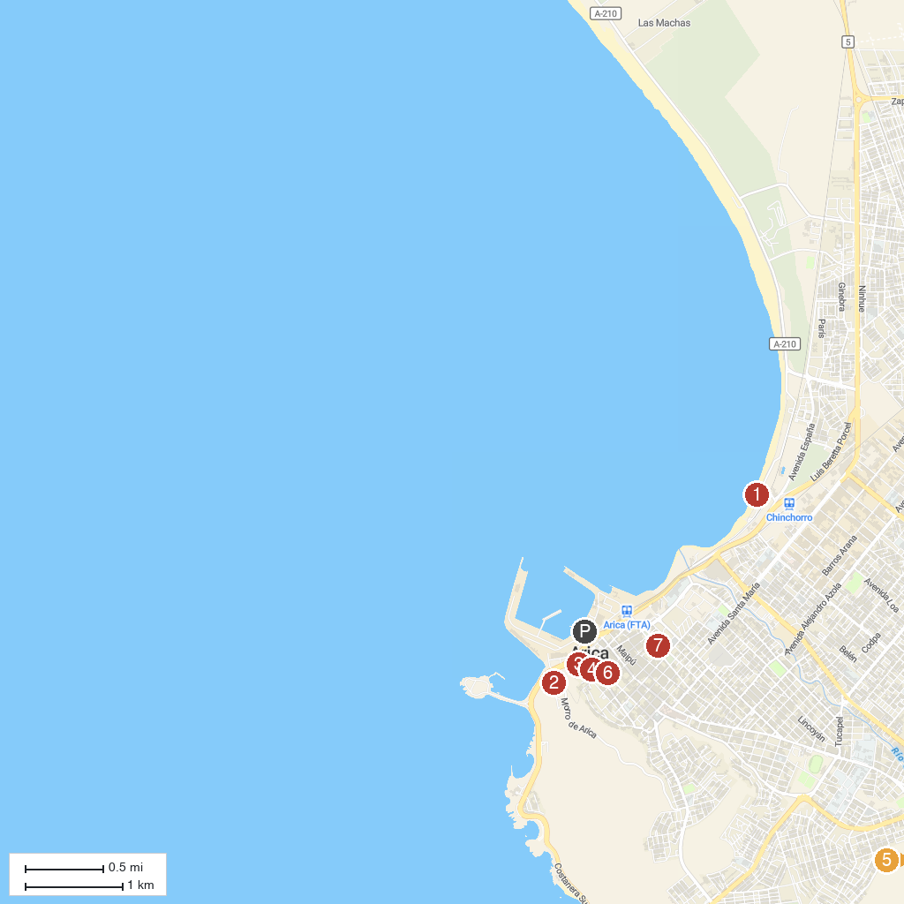
MAP KEY
1. Playa Chinchorro | 5. St. Mark's Cathedral, Arica
2. Museum of History and Weapon | 6. Terminal ASOCAPEC
3. Vicuña Mackenna Square | 7. Museo del Mar de Arica
4. Archaeology Museum San Miguel de Azapa | 8. Carlos Ibañez Del Campo Park
P. Cruise port / terminal
Map © MapTiler © OpenStreetMap contributors · cruiseports.org

