Argens-Minervois, Aude, France
A charming medieval village straddling the UNESCO-listed Canal du Midi, Argens-Minervois is the gateway to Languedoc's vineyards, Cathar history, and some of the smoothest canal cruising in France.
⚓ Canal mooring (Port d'Occitanie) · 🕒 Typical call: full day or overnight · 💶 Currency: Euro · 🗣️ Language: French
✍️ MY DAY IN PORT (FILL IN)
Ship / Date
In port | arrive ______ · all aboard ______
Booked excursion
Notes / meeting point
GETTING ASHORE
- Docking: Canal mooring at Port d'Occitanie on the Canal du Midi
- Walk to centre: 5 min from the canal port to the village centre
- Best For: Wine tasting, cycling the towpath, Cathar history, slow travel
- Don't Miss: The start of the Grand Bief — a 54 km lock-free stretch of the Canal du Midi
GETTING AROUND
- 🚕 Taxi: €10–20 in village; €45–60 to Narbonne; €75–95 to Carcassonne — Taxi du Minervois (+33 6 75 01 79 69) and Azur Taxi serve the area. Pre-book for day trips to Narbonne (~23 km) or Carca
TOP THINGS TO DO
- Carcassonne — Medieval Citadel — The spectacular walled city of Carcassonne is just 33 km away.
- Minerve — A Village Perché in the Gorge — Rated one of France's Most Beautiful Villages, Minerve is a dramatic Cathar stronghold perched on a rocky spur above the Cesse…
- Minervois Wine Tasting — The surrounding Minervois AOC produces excellent reds and rosés.
- Narbonne — Roman City & Cathedral — Narbonne, about 35 km away, was once the capital of Roman Gaul.
- Cycle the Canal du Midi Towpath — The Canal du Midi towpath is flat, shaded by centuries-old plane trees, and ideal for cycling.
BEST WALKS
- Village & Canal Locks Loop: 45 min · Flat · Canal towpath & village streets — Start at Port d'Occitanie, walk the towpath past the Écluses d'Argens, then climb into the medieval…
- Towpath to Lac des Aiguilles: 1.5 hr round trip · Flat · Canal towpath & lakeside path — Follow the canal towpath south from Port d'Occitanie then branch off to Lac des Aiguilles for a…
WEATHER · DAYLIGHT · MONEY
Month | High °F | Low °F | Rainy days
May | 71 | 55 | 8
Jul | 86 | 67 | 4
Sep | 78 | 61 | 7
Daylight: May 6:25AM–9:06PM · Jul 6:23AM–9:26PM · Sep 7:28AM–7:58PM
cruiseports.org/argens-minervois · Confirm terminal & all-aboard time with your ship

Argens-Minervois, Aude, France — Port Map
Red = walkable sights · Amber = excursions farther out · P = cruise terminal
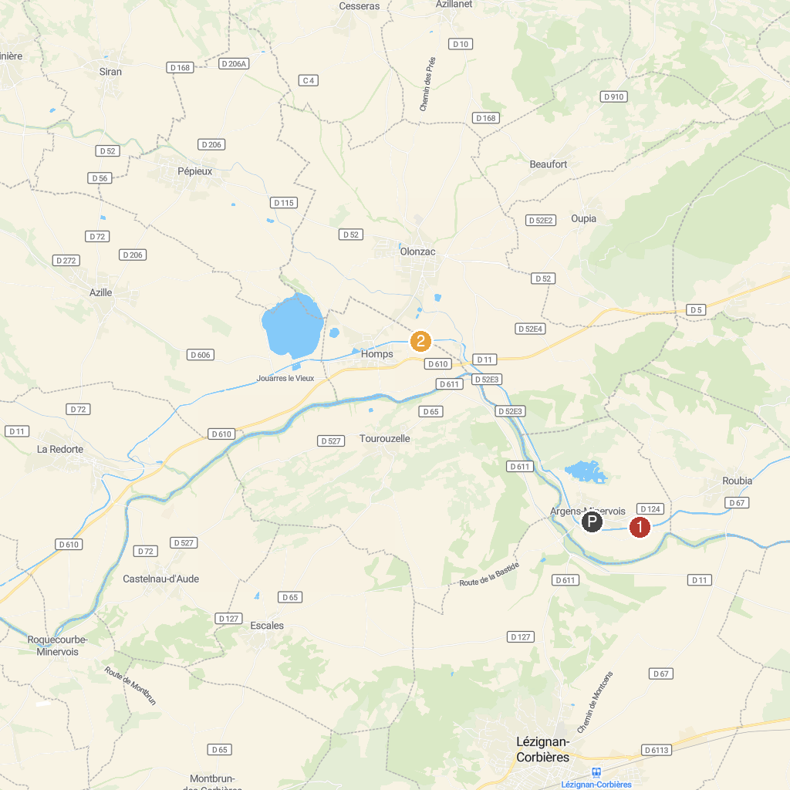
MAP KEY
1. Écluse d'Argens | 2. Écluse d'Homps
P. Cruise port / terminal
Map © MapTiler © OpenStreetMap contributors · cruiseports.org

