Arendal, Aust-Agder, Norway
Billed as the 'Venice of the North', Arendal wraps a handsome 18th-century old town around a lively inner harbour — most ships dock right in the thick of it, leaving you free to wander islands, eat shrimp by the quay, and be home before dinner.
⚓ Docked (Batterikaien or Hotelkaien pier) · 🕒 Typical call: 6–8 hrs · 💵 Norwegian Krone (NOK) — cards widely accepted · 🗣️ Norwegian; English spoken everywhere
✍️ MY DAY IN PORT (FILL IN)
Ship / Date
In port | arrive ______ · all aboard ______
Booked excursion
Notes / meeting point
GETTING ASHORE
- Docking: Ships berth at Batterikaien or Hotelkaien in the inner harbour; very large vessels may anchor and tender to Pollen quay
- Walk to centre: 2–5 min on foot from either pier to Pollen promenade and Tyholmen old town
- Best for: Historic wooden architecture, island hopping, kayaking, local seafood
- Don't miss: Tyholmen old town, a shrimp lunch at Pollen, and the ferry to car-free Merdø island
GETTING AROUND
- 🚕 Taxi: NOK 100–200 — Taxis available at the port. Fares are metered; the compact city means most rides are short and affordable.
- 📱 Rideshare: ✅ Uber, Bolt
TOP THINGS TO DO
- Tyholmen Old Town Walk — Tyholmen is Arendal's historic island district, packed with immaculately preserved 18th- and 19th-century white wooden houses.
- Ferry to Merdø Island — A short Merdøferga ferry hop from Pollen quay reaches car-free Merdø — sandy beaches, the 18th-century Merdøgaard Museum (a…
- Kayaking the Archipelago — Paddle through the sheltered skerries around Arendal, including within Raet National Park.
- KUBEN Museum (Aust-Agder Museum) — Arendal's main cultural history museum covers Viking-age artefacts, maritime heritage, and 19th-century local life.
- Glass Lift & Panorama Views — The Glass Lift connects the Market Square (Torget) to the hillside above, giving sweeping views over Galtesund strait and the…
BEST WALKS
- Tyholmen & Pollen Harbour Loop: 1.5 km · 30–45 min · Easy — From the pier, walk to Pollen promenade, cross to Tyholmen island via the short bridge, and loop…
- Market Square to the Glass Lift: 0.5 km · 20 min · Easy — Walk from Pollen up to Torget (Market Square) and take the Glass Lift up to the hill for panoramic…
WEATHER · DAYLIGHT · MONEY
Month | High °F | Low °F | Rainy days
May | 58 | 45 | 10
Jul | 68 | 56 | 12
Sep | 61 | 52 | 14
Daylight: May 4:57AM–9:46PM · Jul 4:42AM–10:18PM · Sep 6:54AM–7:43PM
cruiseports.org/arendal · Confirm terminal & all-aboard time with your ship

Arendal, Aust-Agder, Norway — Port Map
Red = walkable sights · Amber = excursions farther out · P = cruise terminal
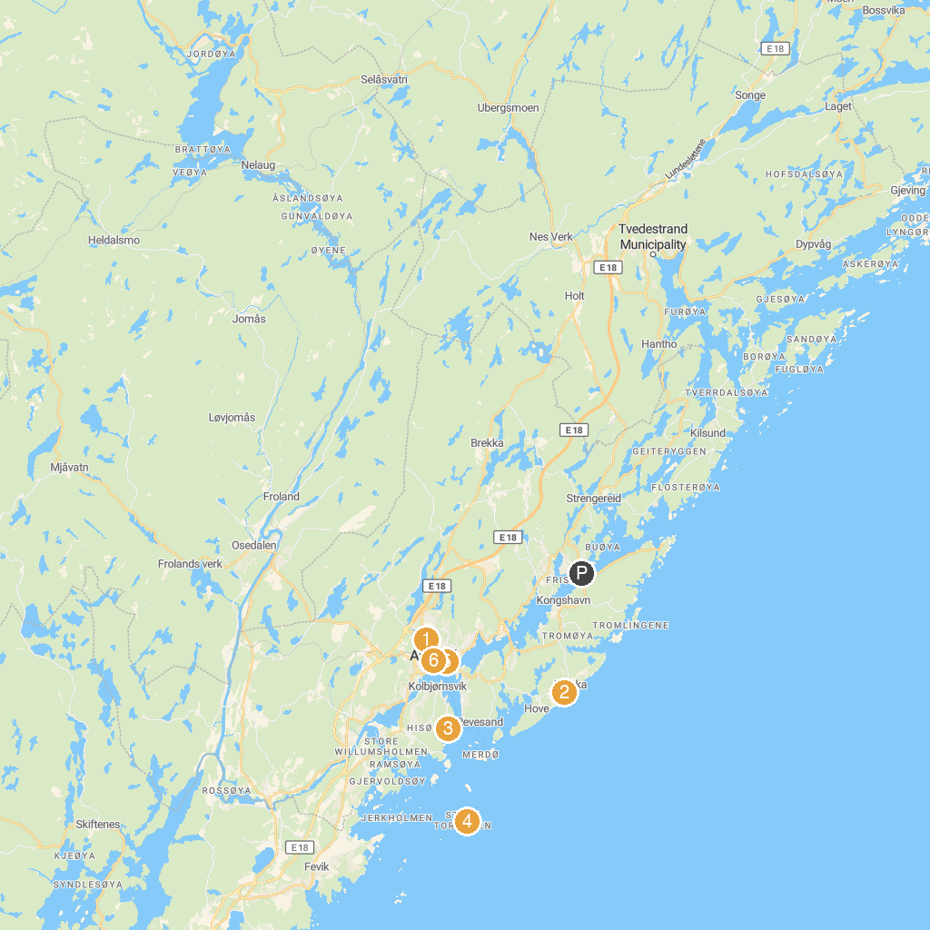
MAP KEY
1. KUBEN, Aust-Agder museum og arkiv | 4. Store Torungen Lighthouse
2. Tromøy Church | 5. Parc Barbu
3. Sandviken Fort | 6. Glassheisen til Fløyheia
P. Cruise port / terminal
Map © MapTiler © OpenStreetMap contributors · cruiseports.org

