Arcachon, Nouvelle-Aquitaine, France
A shimmering Atlantic bay backed by Europe's tallest sand dune — Arcachon rewards curious cruisers with oysters straight from the water, stilt-house islands, and Belle Époque villas hidden in a pine forest.
⚓ Tender port · 🕒 Typical call: 7-9 hrs · 💶 Currency: Euro · 🗣️ Language: French · 🦪 Famous for: oysters & Dune du Pilat
✍️ MY DAY IN PORT (FILL IN)
Ship / Date
In port | arrive ______ · all aboard ______
Booked excursion
Notes / meeting point
GETTING ASHORE
- Docking: Tender — ships anchor offshore; tenders land at Jetée Thiers
- Walk to center: Immediate — Jetée Thiers is in the heart of the waterfront
- Best For: Nature, seafood, scenic hikes, coastal walks
- Don't Miss: Climbing Dune du Pilat for Atlantic panoramas
GETTING AROUND
- 🚕 Taxi: €10–€20 — Multiple local taxi companies serve Arcachon with metered fares (~€5 flag fall, ~€1.80/km). The city center and train st
- 📱 Rideshare: ✅ Uber
TOP THINGS TO DO
- Dune du Pilat — Climb Europe's tallest sand dune (110 m) for sweeping views of the Atlantic, the Landes pine forest, and the mouth of Arcachon Bay.
- Arcachon Bay Boat Tour — Traditional pinasse boats cruise to Île aux Oiseaux and its iconic Cabanes Tchanquées stilt huts, a protected salt-meadow island…
- Oyster Farm Visit & Tasting — Arcachon Bay is one of France's premier oyster-farming regions.
- Ville d'Hiver Walking Tour — Arcachon's hillside 'Winter City' is a labyrinth of extravagant 19th-century Belle Époque villas built for wealthy Bordelais…
- Cap Ferret Day Trip — Take a ferry across the bay to the Cap Ferret peninsula — pine-backed Atlantic beaches, the Cap Ferret lighthouse with 180°…
BEST WALKS
- Waterfront to Ville d'Hiver: 2.5 km · 1.5 hrs · Easy (elevator available for uphill section) — Start at Jetée Thiers, stroll west along the promenade past Plage Pereire, then take the elevator…
- Town Center & Market Stroll: 1 km · 45 min · Easy — From Jetée Thiers walk into the Ville d'Été (summer city) centre.
WEATHER · DAYLIGHT · MONEY
Month | High °F | Low °F | Rainy days
May | 67 | 55 | 11
Jul | 77 | 64 | 8
Sep | 75 | 61 | 9
Daylight: May 6:36AM–9:25PM · Jul 6:33AM–9:47PM · Sep 7:43AM–8:14PM
cruiseports.org/arcachon · Confirm terminal & all-aboard time with your ship

Arcachon, Nouvelle-Aquitaine, France — Port Map
Red = walkable sights · Amber = excursions farther out · P = cruise terminal
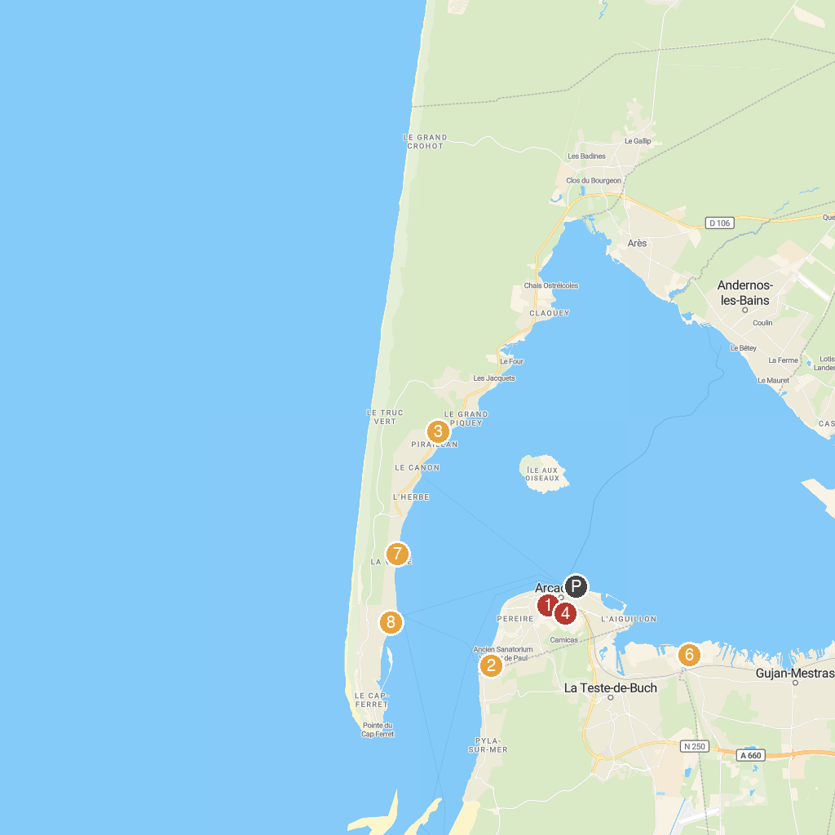
MAP KEY
1. Observatoire Sainte-Cécile | 5. Union des Bateliers Arcachonnais : point de vente Jetée Eyrac
2. Église catholique Notre-Dame-des-Passes d'Arcachon | 6. Plage de La Hume
3. Réservoirs de Piraillan | 7. Plage de la Vigne
4. Le Quartier de la Ville d'Hiver | 8. Eglise Notre Dame des Flots
P. Cruise port / terminal
Map © MapTiler © OpenStreetMap contributors · cruiseports.org

