Aran Islands, Connacht, Ireland
Perched on the edge of Galway Bay, Inis Mór is the largest of the three Aran Islands — a wind-sculpted limestone world of ancient forts, drystone walls, and an Irish language still very much alive. Most cruise ships tender into Kilronan Pier, where ponies, bikes, and minibuses wait to whisk you to one of Europe's most dramatic prehistoric sites.
⚓ Tender port · 🕒 Typical call: 6–8 hrs · 💶 Currency: Euro (EUR) · 🗣️ Irish & English spoken · 🌿 Best May–September
✍️ MY DAY IN PORT (FILL IN)
Ship / Date
In port | arrive ______ · all aboard ______
Booked excursion
Notes / meeting point
GETTING ASHORE
- Docking: Tender to Kilronan Pier (Inis Mór); ships anchor in Kilronan Bay
- Walk to centre: Tender lands at the pier — Kilronan village is steps away
- Best For: Prehistoric forts, cycling, Atlantic landscapes, Celtic culture
- Don't Miss: Dún Aonghasa — Bronze Age fort on a 100 m sea cliff
GETTING AROUND
- 🚕 Taxi: Negotiated with driver — A small number of local van/minibus taxis operate on Inis Mór. Private cars are not permitted on the islands, so taxis a
- 📱 Rideshare: ❌ not available
TOP THINGS TO DO
- Dún Aonghasa — Cliff-Edge Prehistoric Fort — The island's unmissable sight: a massive semicircular stone fort from around 1100 BC, balanced on the rim of a near-100-metre sea…
- Cycle Inis Mór — Hire a bike at Kilronan Pier and follow the island's main road westward through a patchwork of drystone walls.
- The Wormhole (Poll na bPéist) — A perfectly rectangular tidal pool carved by nature into the black limestone near Gort na gCapall — a geological oddity that…
- Grey Seal Colony — Near Kilmurvey Beach, a signposted viewing point on the road to Dún Aonghasa overlooks a resident colony of Atlantic grey seals.
- Pony-and-Trap Island Tour — The most traditional way to see Inis Mór: a local driver narrates the island's history, folklore, and daily life from the seat of…
BEST WALKS
- Kilronan to Dún Aonghasa on Foot: 6 km each way | ~2 hrs one way | Moderate — Walk the main island road west through Kilmurvey village to the Dún Aonghasa visitor centre, then…
- Lúb Dún Eochla Looped Walk: 10 km loop | ~3 hrs | Easy–moderate — A waymarked looped trail starting from Kilronan that climbs to Dún Eochla, a circular early…
WEATHER · DAYLIGHT · MONEY
Month | High °F | Low °F | Rainy days
May | 54 | 50 | 14
Jul | 61 | 58 | 17
Sep | 60 | 57 | 16
Daylight: May 5:39AM–9:31PM · Jul 5:31AM–9:57PM · Sep 7:13AM–7:53PM
cruiseports.org/aran-islands-ireland · Confirm terminal & all-aboard time with your ship

Aran Islands, Connacht, Ireland — Port Map
Red = walkable sights · Amber = excursions farther out · P = cruise terminal
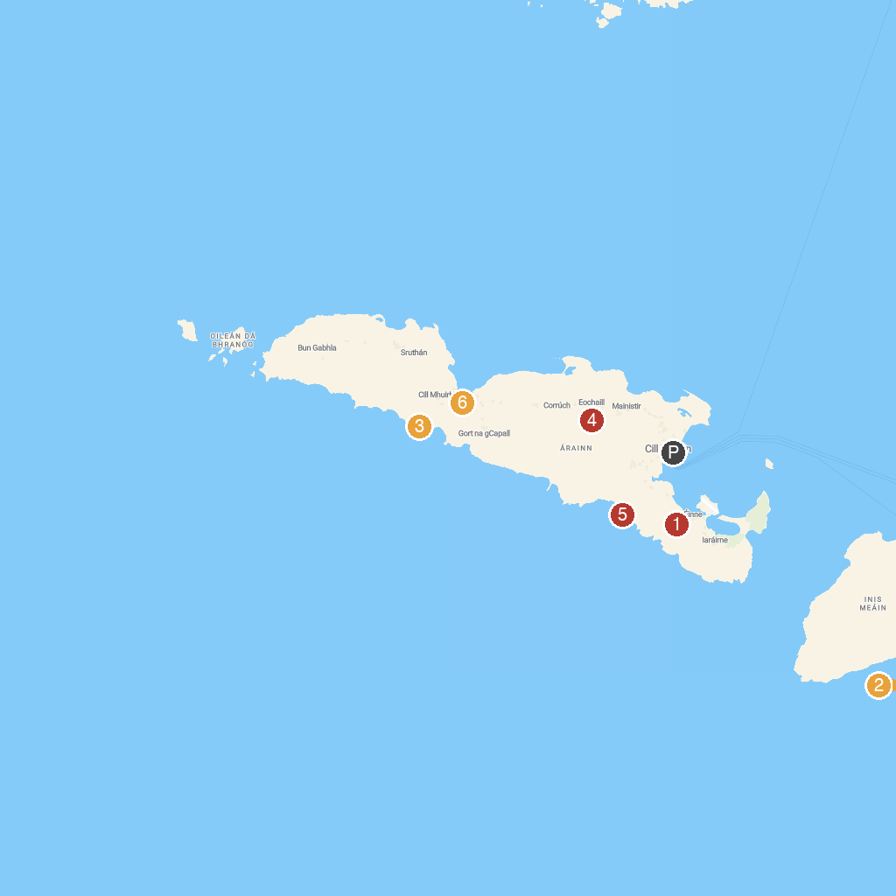
MAP KEY
1. Plassey Shipwreck | 5. Ionad Oidhreachta Leitir Mealláin (Heritage Centre)
2. Teampall Bheanáin | 6. Dún Eochla
3. Áras Éanna Arts Centre | 7. Dún Dúchathair (Black Fort)
4. Dún Aonghasa | 8. Kilmurvey Beach
P. Cruise port / terminal
Map © MapTiler © OpenStreetMap contributors · cruiseports.org

