Aqaba, Aqaba Governorate, Jordan
Jordan's only sea port sits where four countries meet at the tip of the Red Sea. From this compact resort city you can reach Petra's rose-red ruins and Wadi Rum's otherworldly desert — or simply snorkel pristine coral reefs steps from the shore.
⚓ Docked (cruise pier) · 🕒 Typical call: 8-12 hrs · 💵 Jordanian Dinar (JOD) · 🗣️ Arabic (English widely spoken) · 🌡️ Hot & dry — bring water and sunscreen
✍️ MY DAY IN PORT (FILL IN)
Ship / Date
In port | arrive ______ · all aboard ______
Booked excursion
Notes / meeting point
GETTING ASHORE
- Docking: Docked at Aqaba Cruise Terminal, ~4 km south of city center; no walking through port — shuttle bus required
- Walk to center: Not walkable from pier; free cruise-line shuttle to downtown, ~10 min
- Best For: Petra day trip, Wadi Rum desert, Red Sea snorkeling & diving
- Don't Miss: The Treasury at Petra, a Bedouin 4x4 in Wadi Rum, or snorkeling the South Beach coral reefs
GETTING AROUND
- 🚕 Taxi: 5–15 JOD (~$7–21) — Taxis are readily available at the port. The city center is roughly 4–8 km away — always agree on a fare before getting
- 📱 Rideshare: ✅ Bolt
- 🚌 Hop-on hop-off: ✅
TOP THINGS TO DO
- Petra — the Rose-Red City — Walk the Siq gorge to emerge before the Treasury facade, then explore Royal Tombs, the Roman Theatre and Qasr Al Bint.
- Wadi Rum Desert 4x4 Safari — A Bedouin driver takes you through the 'Valley of the Moon' — towering sandstone pillars, Lawrence's Spring, Al-Khazali Canyon…
- Petra + Wadi Rum Combo — A full-day express hitting both UNESCO sites.
- Red Sea Snorkeling — South Beach Reefs — Aqaba's southern coast has pristine coral reefs often just metres from the waterline.
- Aqaba City & Fort Walk — Downtown Aqaba is walkable once the shuttle drops you off.
BEST WALKS
- Aqaba Historic Core Loop: ~2 km · 1-1.5 hrs · Easy · Mostly flat — From Arab Revolt Square, walk to the Great Arab Revolt Plaza flagpole, then to Aqaba Fort (Mamluk…
- Old Souk Wander: ~1 km · 30-60 mins · Easy — Dive into the back streets behind Arab Revolt Square for Aqaba's traditional market — spices…
WEATHER · DAYLIGHT · MONEY
Month | High °F | Low °F | Rainy days
May | 95 | 71 | 0
Jul | 103 | 79 | 0
Sep | 98 | 76 | 0
Daylight: May 5:47AM–7:25PM · Jul 5:50AM–7:41PM · Sep 6:24AM–6:44PM
cruiseports.org/aqaba · Confirm terminal & all-aboard time with your ship

Aqaba, Aqaba Governorate, Jordan — Port Map
Red = walkable sights · Amber = excursions farther out · P = cruise terminal
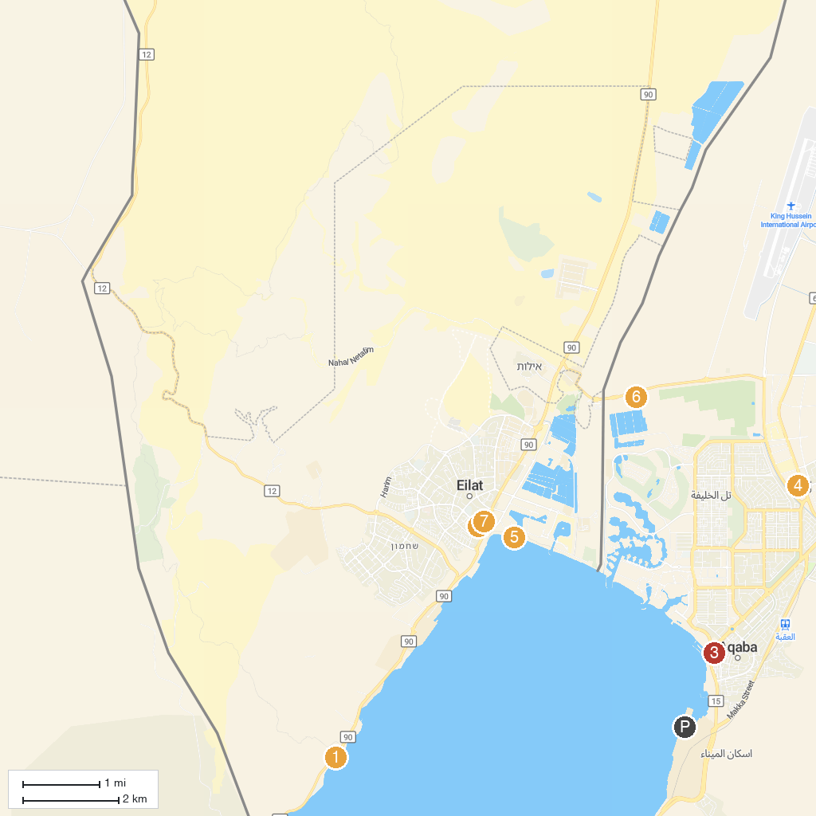
MAP KEY
1. Gai Avud | 5. Aqaba Special Economic Zone Authority
2. שמורת טבע חוף האלמוגים | 6. Hananya Beach - חוף חנניה ספורט ימי ושייט
3. Nightmare Horror Maze | 7. Aqaba Bird Observatory
4. Sharif Hussein bin Ali Mosque | 8. Musical Fountain Eilat
P. Cruise port / terminal
Map © MapTiler © OpenStreetMap contributors · cruiseports.org

