Aomori City, Aomori Prefecture, Japan
Northern Japan's festival city packs UNESCO prehistory, giant illuminated parade floats, and the world's best apple cider into a single shore day — most of it within easy walking distance of the pier.
⚓ Docked (Shin-Chuo or Okidate Wharf) · 🕒 Typical call: 8-10 hrs · 💴 Currency: Japanese Yen (JPY) · 🗣️ Language: Japanese · 🍎 Famous for: Nebuta Festival & apples
✍️ MY DAY IN PORT (FILL IN)
Ship / Date
In port | arrive ______ · all aboard ______
Booked excursion
Notes / meeting point
GETTING ASHORE
- Docking: Shin-Chuo Wharf (central, walkable) or Okidate Wharf (~3 km, taxi needed)
- Walk to center: 5-10 min from Shin-Chuo; 15 min to Aomori Station
- Best For: Culture, history, local food, scenic day trips
- Don't Miss: Nebuta Museum Wa Rasse and a Nokkedon seafood bowl at Furukawa Market
GETTING AROUND
- 🚕 Taxi: ¥800–¥2,400 — Okidate Wharf to city center runs about ¥2,200; Shin-Chuo to Fish Market around ¥800. Most taxis accept credit cards and
- 📱 Rideshare: ✅ Uber
TOP THINGS TO DO
- Nebuta Museum Wa Rasse — Five enormous illuminated parade floats — the kind that roll through August's Nebuta Festival — are on permanent display inside…
- Nokkedon at Furukawa Fish Market — Buy a strip of tickets at Aomori Gyosai Center (Furukawa Market), then spend them at individual stalls piling tuna, sea urchin…
- Sannai-Maruyama Jomon Site — A UNESCO World Heritage archaeological site preserving a 5,500-year-old village from Japan's Jomon period.
- Hirosaki Castle & Park — About an hour southwest of Aomori, Hirosaki Castle is one of Japan's original surviving castle keeps, set in a 120-acre…
- Hakkoda Mountains & Ropeway — Ride the Hakkoda Ropeway to 1,324 m for sweeping views over the Tsugaru Strait toward Hokkaido.
BEST WALKS
- Waterfront Highlights Walk: 1.5 km · ~30 min · flat · no hills — Start at Shin-Chuo Wharf and walk east along the bay promenade.
- City Center & Market Loop: 2.5 km · ~45 min · flat — From the pier, head south along the bay to Aomori Station, then inland to Furukawa Fish Market…
cruiseports.org/aomori-city · Confirm terminal & all-aboard time with your ship

Aomori City, Aomori Prefecture, Japan — Port Map
Red = walkable sights · Amber = excursions farther out · P = cruise terminal
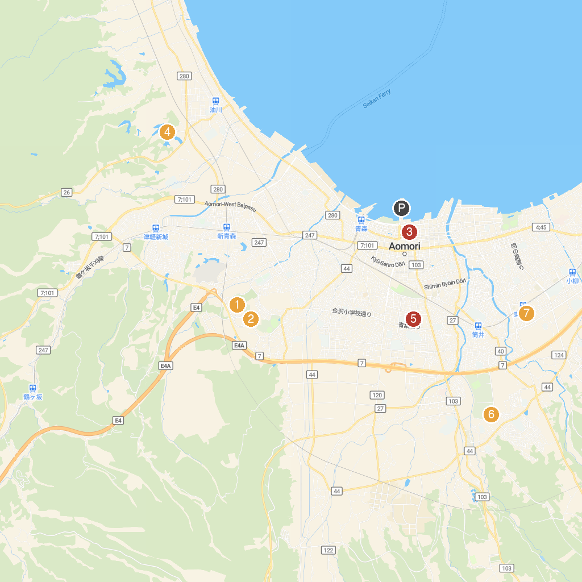
MAP KEY
1. Sannai Maruyama Site | 5. Nogiwa Park
2. Aomori Museum of Art | 6. Okuno Central Park
3. Aomori kenritsu kyōdo-kan Prefectural Museum | 7. Aomori City Sports Park Waku Waku Square
4. Aquarium Asamushi | 8. Hamadate Park
P. Cruise port / terminal
Map © MapTiler © OpenStreetMap contributors · cruiseports.org

