Antsiranana, Diana, Madagascar
Perched at Madagascar's northern tip on one of the world's great natural harbors, Antsiranana — still called Diego Suarez by locals — mixes crumbling French colonial charm with access to some of the most otherworldly landscapes on Earth: red sculpted tsingy, emerald lagoons, and rainforest alive with lemurs.
⚓ Mixed: pier or tender · 🕒 Typical call: 6-8 hrs · 💵 Malagasy Ariary (MGA); euros/USD sometimes accepted · 🗣️ Malagasy & French; limited English · 🦎 Wildlife destination
✍️ MY DAY IN PORT (FILL IN)
Ship / Date
In port | arrive ______ · all aboard ______
Booked excursion
Notes / meeting point
GETTING ASHORE
- Docking: Most cruise ships tender to the Port de Plaisance landing; only occasionally do smaller vessels berth at the commercial pier.
- Walk to center: ~1.5 km (15-20 min on foot) or a quick tuk-tuk ride from the pier gate.
- Best For: Unique geology (Red Tsingy), wildlife (lemurs, chameleons), colonial city walks, pristine beaches.
- Don't Miss: Tsingy Rouge for its Martian red rock formations, or the Emerald Sea (Mer d'Émeraude) for snorkeling.
GETTING AROUND
- 🚕 Taxi: $2–5 USD — Traditional taxis available at the tender landing. Slightly more comfortable than tuk-tuks; fares are negotiated, not me
- 📱 Rideshare: ❌ not available
TOP THINGS TO DO
- Red Tsingy (Tsingy Rouge) — The star attraction near Antsiranana: towering spires of red laterite rock sculpted by erosion into an alien landscape.
- Three Bays Tour (Les Trois Baies) — A scenic half-day looping Sakalava Bay (kitesurfing capital), Pigeon Bay, and Dunes Bay — white sand, turquoise water, and a stop…
- Montagne d'Ambre National Park — A lush volcanic massif blanketed in rainforest, threaded with waterfalls and crater lakes.
- Emerald Sea (Mer d'Émeraude) — A sheltered lagoon of vivid emerald-green water accessible only by traditional Malagasy pirogue or small boat.
- City Tour & Antsiranana Market — Walk the colonial-era streets around Place Joffre, browse the lively central market for spices and vanilla, and see the…
BEST WALKS
- Colonial City Center Stroll: 1.5 km · Easy · 30–45 min — From the pier gate, walk north along the waterfront to Place Joffre, the old French colonial square.
- Ramena Beach Walk: Taxi to Ramena (~20 min) · Easy · Beach walk — Take a taxi or organized transfer to Ramena village, a fishing settlement east of the city with a…
WEATHER · DAYLIGHT · MONEY
Month | High °F | Low °F | Rainy days
May | 85 | 74 | 3
Jul | 82 | 70 | 2
Sep | 83 | 71 | 2
Daylight: May 5:52AM–5:25PM · Jul 6:05AM–5:32PM · Sep 5:37AM–5:38PM
cruiseports.org/antsiranana · Confirm terminal & all-aboard time with your ship

Antsiranana, Diana, Madagascar — Port Map
Red = walkable sights · Amber = excursions farther out · P = cruise terminal
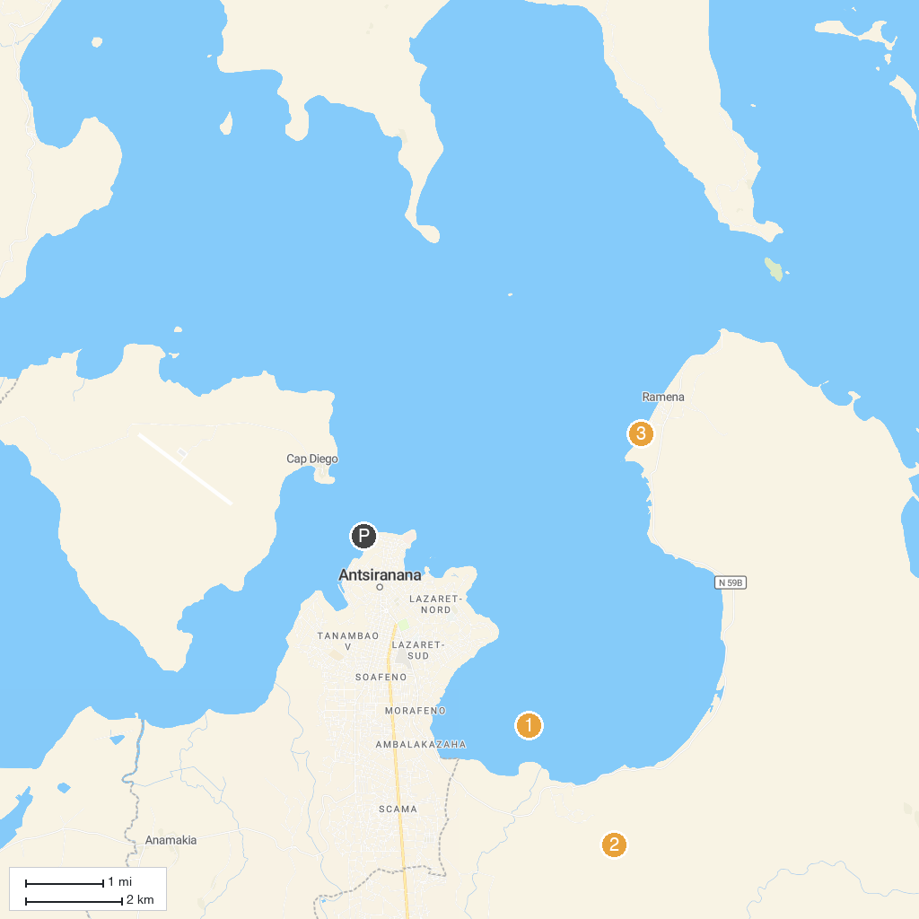
MAP KEY
1. Nosy Lonjo (Sugar Loaf) | 3. Ramena Beach
2. Montagne des Français | 4. Emerald Sea (Mer d'Émeraude)
P. Cruise port / terminal
Map © MapTiler © OpenStreetMap contributors · cruiseports.org

