Antoing, Wallonia, Belgium
A sleepy Wallonian town where a medieval castle lords over the Nimy-Blaton-Peronnes Canal. River cruisers dock at Peronnes-lez-Antoing, a short walk from cobbled streets and one of Belgium's finest ancestral châteaux.
⚓ Docked (canal quay) · 🕒 Typical call: 4–7 hrs · 💵 Euro (€) · 🗣️ French
✍️ MY DAY IN PORT (FILL IN)
Ship / Date
In port | arrive ______ · all aboard ______
Booked excursion
Notes / meeting point
GETTING ASHORE
- Docking: Canal quay at Peronnes-lez-Antoing; ships tie up alongside — no tender needed
- Walk to center: ~15 min on foot from quay to Antoing town center and château
- Best For: Castle history, peaceful canal scenery, day trip to Tournai
- Don't Miss: Guided tour of Château d'Antoing (book ahead — limited slots)
GETTING AROUND
- 🚕 Taxi: €16–€20 to Tournai — Taxi ATP serves the Antoing area. The 5-minute ride to Tournai costs roughly €16–€20. Pre-booking recommended as this is
TOP THINGS TO DO
- Château d'Antoing Tour — The ancestral home of the Princes of Ligne, this 12th-century castle was redesigned by Viollet-le-Duc in the 19th century.
- Tournai Day Trip — Just 7 km north, Tournai is one of Belgium's oldest cities.
- Bon-Secours Forest & Basilica — On the Franco-Belgian border about 12 km away, 2,000 hectares of forest surround the neo-Gothic Basilica of Notre-Dame de…
- Mont-Saint-Aubert Ride or Walk — A beloved local summit popular with cyclists and runners, Mont-Saint-Aubert offers winding low-traffic roads and a satisfying…
BEST WALKS
- Quay to Château Loop: 1.5 km · ~25 min · Easy — From the canal quay, walk north along the towpath to Antoing town center.
- Canal Towpath Stroll: 2 km · ~30 min · Easy — A relaxing out-and-back along the Nimy-Blaton-Peronnes Canal.
WEATHER · DAYLIGHT · MONEY
Month | High °F | Low °F | Rainy days
May | 64 | 48 | 12
Jul | 74 | 58 | 10
Sep | 68 | 54 | 10
Daylight: May 5:58AM–9:27PM · Jul 5:51AM–9:52PM · Sep 7:22AM–7:59PM
cruiseports.org/antoing · Confirm terminal & all-aboard time with your ship

Antoing, Wallonia, Belgium — Port Map
Red = walkable sights · Amber = excursions farther out · P = cruise terminal
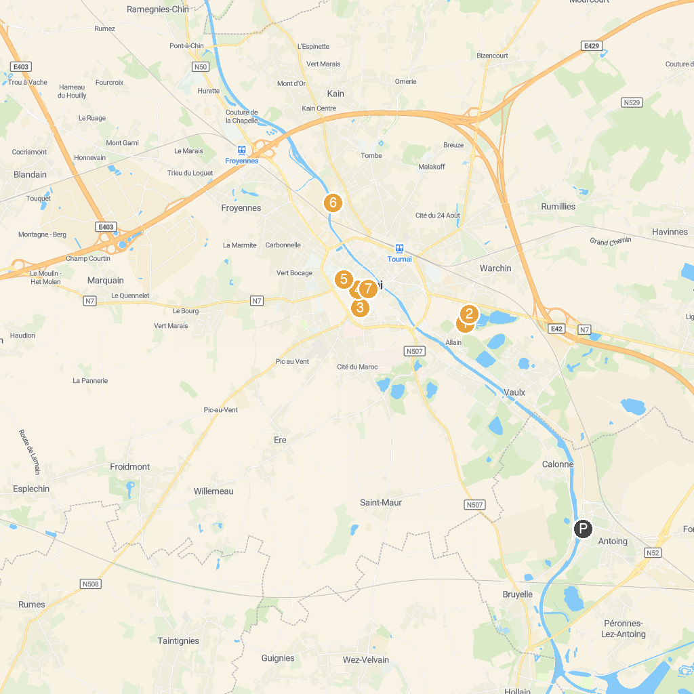
MAP KEY
1. Piscine communale de l'Orient | 5. Tournai Archaeology Museum
2. Ecopark Adventures Tournai | 6. Jungle City - Amusement park
3. Musée d'Histoire naturelle & Vivarium | 7. Cathedral of Notre-Dame of Tournai
4. Grand-Place de Tournai
P. Cruise port / terminal
Map © MapTiler © OpenStreetMap contributors · cruiseports.org

