Antofagasta, Chile
Antofagasta Port Guide
⚓ Port City · ⛏️ Mining Hub · 🌵 Desert Coast · 🇨🇱 Northern Chile
✍️ MY DAY IN PORT (FILL IN)
Ship / Date
In port | arrive ______ · all aboard ______
Booked excursion
Notes / meeting point
GETTING ASHORE
- Best Time: September to November
- Local Transport: Taxis and Colectivos
- Must-See: La Portada
- Vibe: Industrial and Coastal
GETTING AROUND
- 🚕 Taxi: $4–6 USD — Taxis wait outside the port gate (not permitted inside). City center is about 2–3 km away — a quick, affordable ride.
- 📱 Rideshare: ✅ Uber, Cabify
TOP THINGS TO DO
- La Portada and the Coastal Walk — Walk along the coastal promenade (Avenida Costanera) and visit La Portada, the iconic natural stone arch offering panoramic views…
- Huanchaca Ruins — Explore the 19th-century silver refinery ruins that tell the story of Antofagasta's mining boom and the region's nitrate and…
- Desert and Coast Exploration — Take a guided tour into the Atacama Desert, exploring the rugged terrain and the striking contrast between the arid desert and…
- City Center and Local Markets — Explore the downtown area, visiting local markets and tasting traditional Chilean seafood and northern delicacies.
BEST WALKS
- The Waterfront Promenade: Easy — A flat, scenic walk along the coast, perfect for watching the sunset and observing the local…
- Downtown Exploration: Moderate — A walk through the central business district, visiting local plazas and small shops.
- Hillside Lookout: Challenging — A climb up to the higher points of the city for a bird's-eye view of the port and the desert.
WEATHER · DAYLIGHT · MONEY
Month | High °F | Low °F | Rainy days
May | 67 | 58 | 0
Jul | 64 | 54 | 0
Sep | 65 | 55 | 0
Daylight: May 7:08AM–6:06PM · Jul 7:23AM–6:11PM · Sep 7:38AM–7:35PM
cruiseports.org/antofagasta · Confirm terminal & all-aboard time with your ship

Antofagasta, Chile — Port Map
Red = walkable sights · Amber = excursions farther out · P = cruise terminal
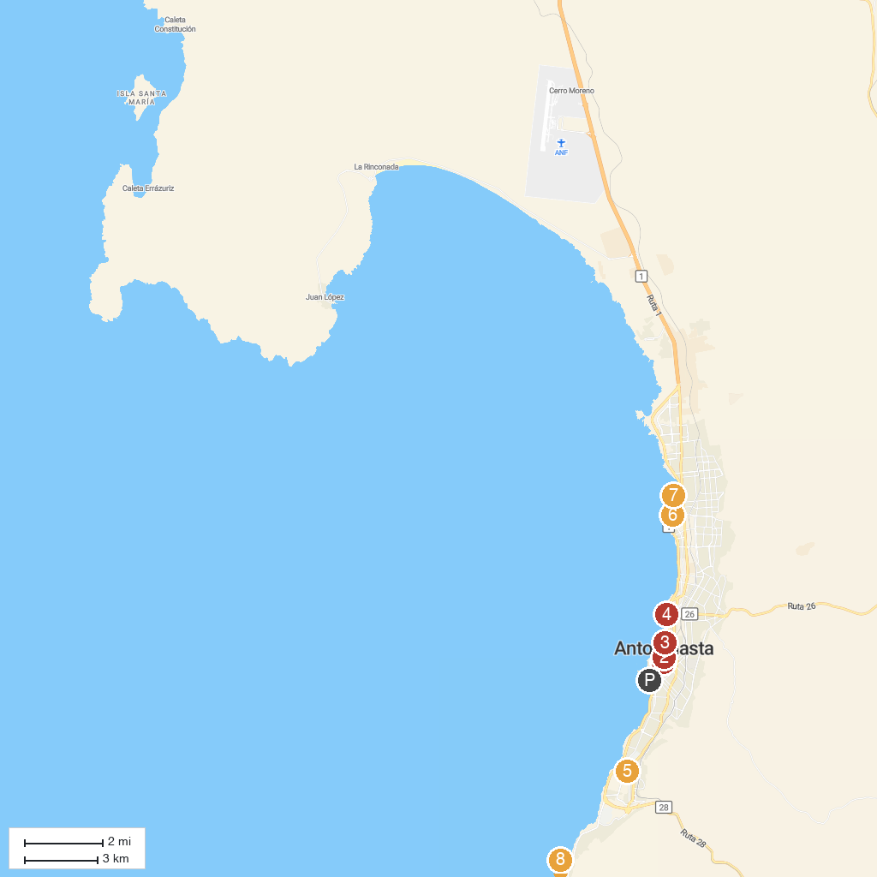
MAP KEY
1. Torre Reloj | 5. Huanchaca Ruins Museum
2. Museo Regional de Antofagasta | 6. Parque Nicolás Tirado
3. Playa Paraíso | 7. Playa Trocadero
4. Parque de los Eventos | 8. Balneario El Huáscar
P. Cruise port / terminal
Map © MapTiler © OpenStreetMap contributors · cruiseports.org

