Antilla, Holguín, Cuba
Tucked inside the vast, sheltered waters of Nipe Bay, Antilla is one of Cuba's most authentic eastern ports — a 1907 railway town that's the launching pad for Cayo Saetia, a private island reserve where zebras and ostriches roam white-sand beaches.
⚓ Docked (cement wharf, small ships only) · 🕒 Typical call: 7-9 hrs · 💵 Cuban Peso (CUP) / USD cash useful · 🗣️ Spanish — English very limited
✍️ MY DAY IN PORT (FILL IN)
Ship / Date
In port | arrive ______ · all aboard ______
Booked excursion
Notes / meeting point
GETTING ASHORE
- Docking: Small cement wharf inside Nipe Bay; only expedition and boutique cruise ships call here
- Walk to center: Town center is a short walk from the dock; limited shops and facilities
- Best For: Cayo Saetia safari, off-the-beaten-path Cuba, snorkeling, catamaran day trips
- Don't Miss: The catamaran excursion to Cayo Saetia — zebras on the beach is a genuinely surreal Cuban experience
GETTING AROUND
- 🚕 Taxi: $5–$20 USD — Government-operated tourist taxis wait at the dock; fares are negotiated in USD before boarding. Useful for reaching bea
- 📱 Rideshare: ❌ not available
TOP THINGS TO DO
- Cayo Saetia Safari & Beach Day — Board a catamaran across Nipe Bay to Cayo Saetia, a 42 km² private reserve where zebras, ostriches, antelopes, camels, and water…
- Nipe Bay Catamaran Cruise — Sail the sheltered turquoise waters of one of Cuba's largest bays, stopping at coral reefs for snorkeling.
- Antilla Town & Railway History Walk — Antilla was founded in 1907 as a sugar and lumber export terminal linked by rail to eastern Cuba's interior.
- Guardalavaca & Holguín Province — A bus transfer (~1 hr, ~50 km) takes you to the Guardalavaca resort area on Cuba's northern coast, where you can visit beaches…
BEST WALKS
- Antilla Town Center Stroll: 1-2 km · Easy · 30-45 min — From the wharf, walk into town past the central plaza, local market, and the old railway station.
WEATHER · DAYLIGHT · MONEY
Month | High °F | Low °F | Rainy days
May | 86 | 75 | 19
Jul | 89 | 79 | 12
Sep | 89 | 78 | 17
Daylight: May 6:25AM–7:33PM · Jul 6:30AM–7:46PM · Sep 6:50AM–7:05PM
cruiseports.org/antilla · Confirm terminal & all-aboard time with your ship

Antilla, Holguín, Cuba — Port Map
Red = walkable sights · Amber = excursions farther out · P = cruise terminal
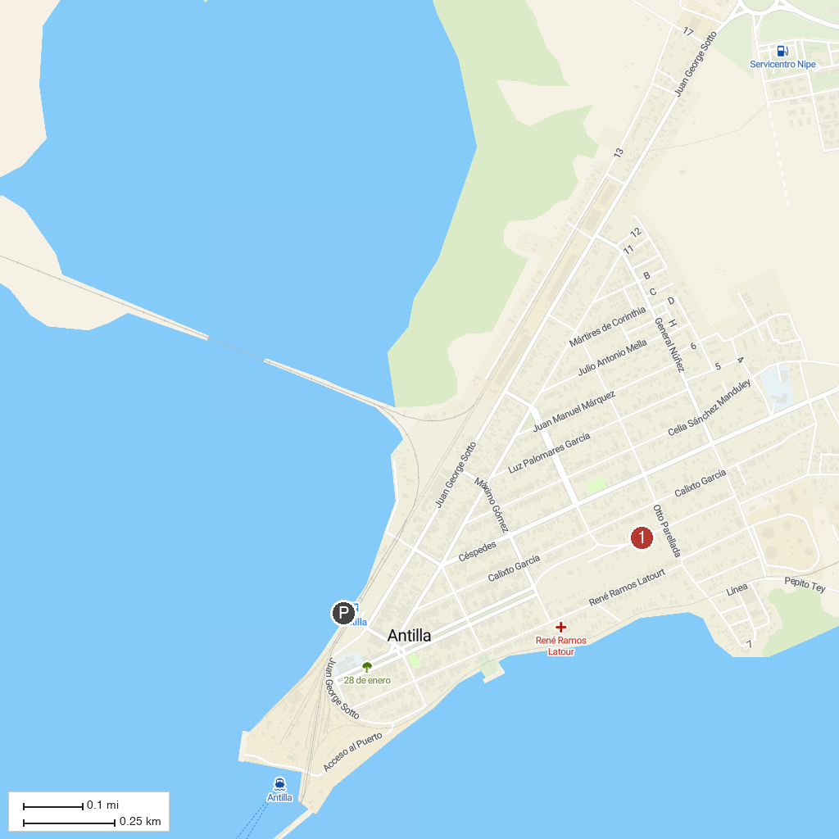
MAP KEY
1. Antilla Town Wharf | 2. Nipe Bay
P. Cruise port / terminal
Map © MapTiler © OpenStreetMap contributors · cruiseports.org

