Antarctic Peninsula, Antarctica
The last great wilderness on Earth. No ports, no piers, no crowds — just glaciers that calve into silence, penguin colonies that outnumber your ship, and the kind of quiet that changes you.
⚓ Zodiac landing (expedition) or scenic only (large ships) · 🕒 Voyage: 10–24 days from Ushuaia or Punta Arenas · 💵 USD on board · 🗣️ International crew · 🌡️ Season: November – March
✍️ MY DAY IN PORT (FILL IN)
Ship / Date
In port | arrive ______ · all aboard ______
Booked excursion
Notes / meeting point
GETTING ASHORE
- Ship Size Matters: Ships under 500 passengers can land via Zodiac. Larger ships cruise scenically only — no shore access under IAATO rules.
- Zodiac Landings: Max 100 passengers ashore at any one site at a time. Landings rotate in groups throughout the day.
- Getting There: Most voyages depart Ushuaia, Argentina (Drake Passage, 2 days each way) or fly-cruise from Punta Arenas to skip the Drake.
- Best Wildlife: Gentoo, chinstrap & Adélie penguins, humpback & minke whales, leopard seals, and vast seabird colonies.
GETTING AROUND
TOP THINGS TO DO
- Zodiac Landing — Penguin Colony — Step ashore at a working penguin rookery — gentoos, chinstraps, or Adélies depending on your location.
- Lemaire Channel & Iceberg Alley — The Lemaire Channel — 11km of water squeezed between towering cliffs and glaciers — is one of the most photographed passages on…
- Whale Watching from Zodiac — Humpback and minke whales feed in Antarctic waters throughout the season.
- Polar Plunge — A rite of passage on expedition ships — jump into Antarctic seawater (around 0°C/32°F) from the gangway or Zodiac platform.
- Port Lockroy — Penguin Post Office — A restored British research station from 1944 on Goudier Island, now run by the UK Antarctic Heritage Trust.
BEST WALKS
- Neko Harbour — Glacier Walk: Expedition landing · moderate · 1-2 hrs — One of the few places you can genuinely set foot on the Antarctic continent (not just the…
- Half Moon Island — Chinstrap Colony: Expedition landing · easy · 1-2 hrs — A crescent-shaped island in the South Shetlands with a dense chinstrap penguin colony and an…
WEATHER · DAYLIGHT · MONEY
Month | High °F | Low °F | Rainy days
May | 26 | 19 | 19
Jul | 22 | 13 | 16
Sep | 23 | 15 | 18
Daylight: May 10:02AM–4:13PM · Jul 10:46AM–3:50PM · Sep 7:23AM–6:52PM
cruiseports.org/antarctic-peninsula · Confirm terminal & all-aboard time with your ship

Antarctic Peninsula, Antarctica — Port Map
Red = walkable sights · Amber = excursions farther out · P = cruise terminal
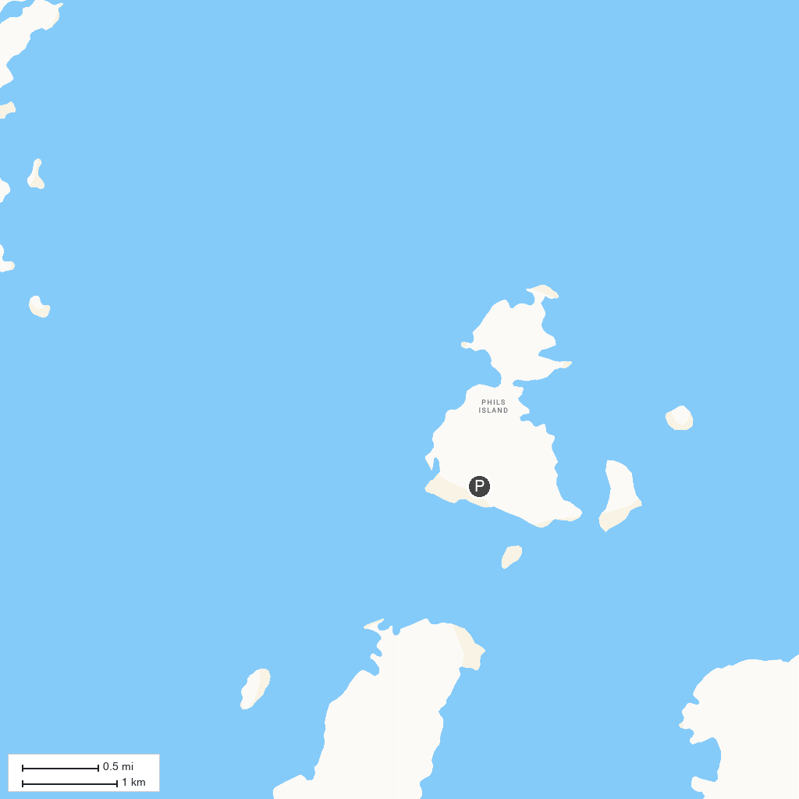
MAP KEY
1. Neko Harbour | 2. Cuverville Island
P. Cruise port / terminal
Map © MapTiler © OpenStreetMap contributors · cruiseports.org

