Antalya, Turkish Riviera, Turkey
Gateway to the Turkish Riviera, Antalya pairs one of Turkey's best-preserved Roman old towns with world-class ancient sites just a short drive away — all backed by dramatic mountain scenery.
⚓ Docked (Port Akdeniz) · 🕒 Typical call: 8-10 hrs · 💵 Turkish Lira (cards widely accepted) · 🗣️ Turkish (English common in tourist areas)
✍️ MY DAY IN PORT (FILL IN)
Ship / Date
In port | arrive ______ · all aboard ______
Booked excursion
Notes / meeting point
GETTING ASHORE
- Docking: Berthed at Port Akdeniz, ~10 km west of the city center
- Walk to center: Not walkable — shuttle, taxi, or public bus required
- Best For: Ancient Roman ruins, Kaleiçi Old Town, Mediterranean beaches
- Don't Miss: Hadrian's Gate and the Aspendos amphitheater
GETTING AROUND
- 🚕 Taxi: $20–$30 — Metered yellow taxis are plentiful at Port Akdeniz. The ride to Kaleiçi (Old Town) is about 10–15 km and takes roughly 2
- 📱 Rideshare: ✅ Uber
TOP THINGS TO DO
- Aspendos Roman Theater — One of the best-preserved Roman theaters on earth, Aspendos (47 km east) seats 15,000 and still hosts performances.
- Kaleiçi Old Town & Hadrian's Gate — Wander cobblestone lanes past Ottoman mansions, Byzantine walls, and the triple-arched Hadrian's Gate — built in 130 AD for…
- Ancient Perge & Antalya Museum — Perge's colonnaded Roman streets, grand gate, and stadium are about 25 km from port (18 km east of the city center).
- Düden Waterfalls Boat Trip — The Lower Düden Waterfall plunges directly into the Mediterranean — the only way to see it properly is from the sea.
- Konyaaltı Beach — Seven kilometres of pebble-and-sand beach just west of the city, with crystal-clear water and mountain backdrop.
BEST WALKS
- Kaleiçi Old Town Circuit: 2-3 km · 1.5 hrs · Easy — Enter through Hadrian's Gate, follow the ancient walls down toward the Roman Harbour, loop back…
- Karaalioglu Park & Cliffside Walk: 1.5 km · 45 min · Easy — Follow the clifftop park south of Kaleiçi for panoramic Mediterranean views and the Hidirlik Tower…
WEATHER · DAYLIGHT · MONEY
Month | High °F | Low °F | Rainy days
May | 79 | 59 | 7
Jul | 96 | 75 | 1
Sep | 89 | 69 | 2
Daylight: May 5:49AM–7:58PM · Jul 5:49AM–8:16PM · Sep 6:39AM–7:04PM
cruiseports.org/antalya · Confirm terminal & all-aboard time with your ship

Antalya, Turkish Riviera, Turkey — Port Map
Red = walkable sights · Amber = excursions farther out · P = cruise terminal
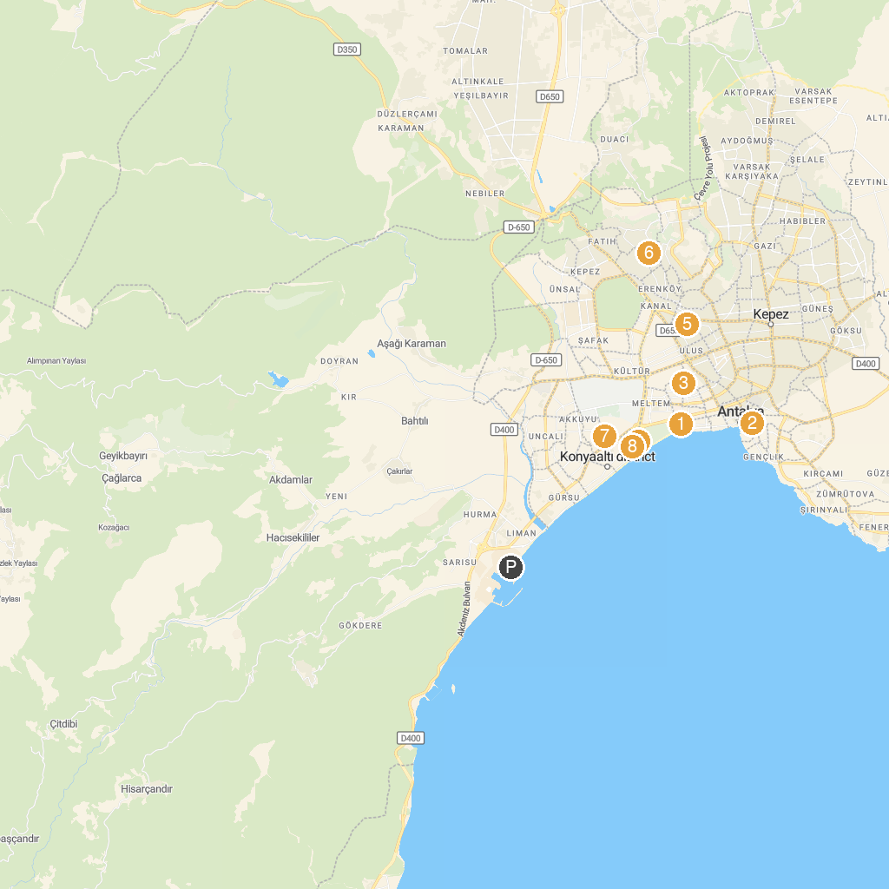
MAP KEY
1. Antalya Archaeology Museum | 5. İsmet İnönü Parkı
2. Say Antalya Tourism and Transport | 6. Selimiye Camii
3. Soğuksu Cami | 7. Kuba Cami
4. Waterhill | 8. Wild Park Antalya
P. Cruise port / terminal
Map © MapTiler © OpenStreetMap contributors · cruiseports.org

