Anguilla, Caribbean
Thirty-three world-class beaches and zero mega-ship crowds — Anguilla is the Caribbean's best-kept secret for small-ship cruisers seeking pristine sand, crystal water, and laid-back luxury.
⚓ Tender port (Road Bay / Sandy Ground) · 🕒 Typical call: 7-9 hrs · 💵 USD & Eastern Caribbean Dollar · 🗣️ English
✍️ MY DAY IN PORT (FILL IN)
Ship / Date
In port | arrive ______ · all aboard ______
Booked excursion
Notes / meeting point
GETTING ASHORE
- Docking: Tender to Road Bay pier at Sandy Ground village; no large cruise terminal
- Walk to center: Sandy Ground village is steps from the tender pier; The Valley is ~15 min by taxi
- Best For: Beach days, snorkeling, offshore cay tours, and upscale Caribbean dining
- Don't Miss: Shoal Bay East — consistently ranked among the world's best beaches
GETTING AROUND
- 🚕 Taxi: $25 USD for 2 passengers — Government-regulated fixed-fare taxis meet passengers at Blowing Point Ferry Terminal. The fare to The Valley (main town
- 📱 Rideshare: ❌ not available
TOP THINGS TO DO
- Shoal Bay East Beach Day — Anguilla's most celebrated beach — two miles of fine white sand with calm, clear water ideal for swimming.
- Sandy Island & Prickly Pear Cay Catamaran — Day-trip by catamaran to one of Anguilla's uninhabited offshore cays — pristine sand, excellent snorkeling, and an all-inclusive…
- Little Bay Snorkel Adventure — Reached by boat (or rope climb for the adventurous), Little Bay is a secluded cove with some of Anguilla's richest snorkeling…
- Island Heritage Tour — A guided taxi tour taking in Wallblake House (a restored 1787 plantation estate), the Heritage Collection Museum in East End, and…
- Culinary & Rum Tasting Tour — Anguilla punches well above its size in dining.
BEST WALKS
- Sandy Ground Village Stroll: ~1 km · Flat · 20-30 min — From the tender pier, walk the length of Sandy Ground Beach — the island's social hub — passing…
- Road Bay to Crocus Bay: ~2 km one-way · Easy coastal · 30-40 min — Head north from the Sandy Ground pier along the road toward Crocus Bay, a quieter beach with good…
WEATHER · DAYLIGHT · MONEY
Month | High °F | Low °F | Rainy days
May | 30 | 25 | 10
Jul | 31 | 26 | 11
Sep | 31 | 26 | 12
Daylight: May 5:27AM–8:14PM · Jul 5:25AM–8:35PM · Sep 6:34AM–7:04PM
cruiseports.org/anguilla-island · Confirm terminal & all-aboard time with your ship

Anguilla, Caribbean — Port Map
Red = walkable sights · Amber = excursions farther out · P = cruise terminal
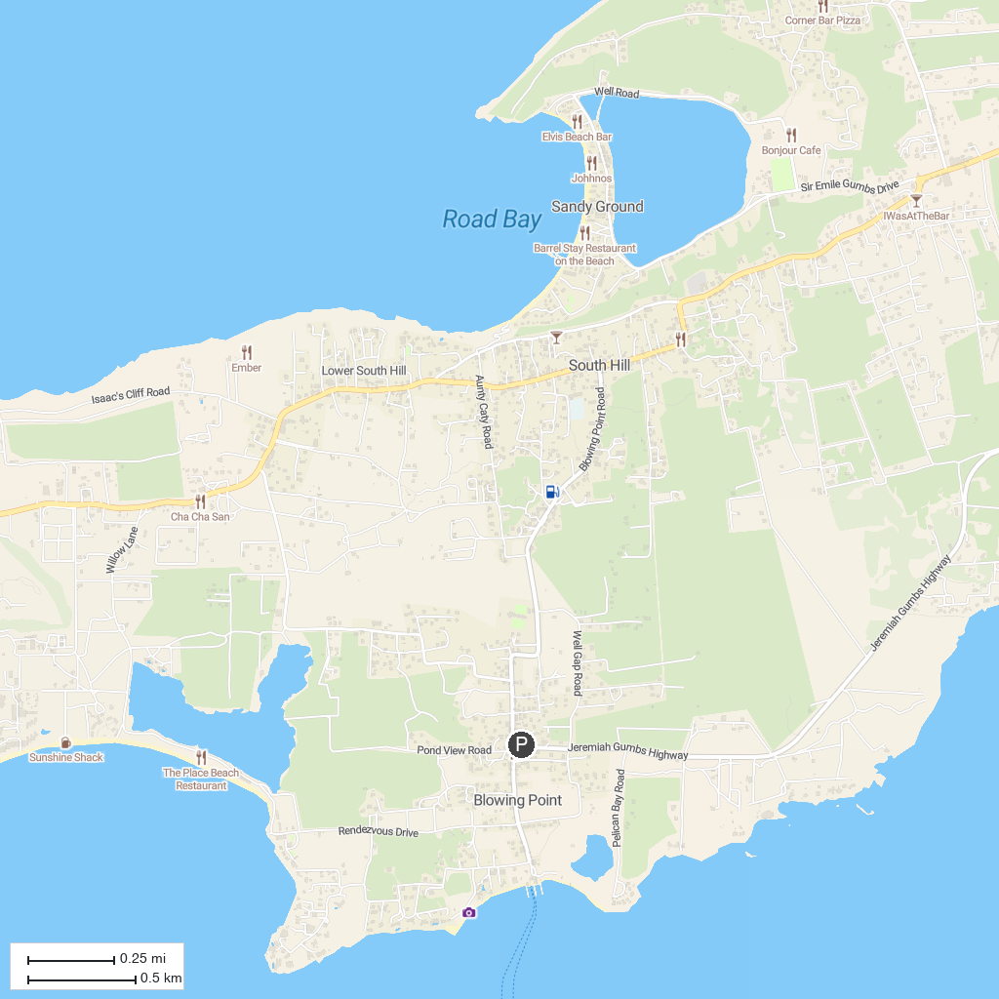
MAP KEY
1. The Butterfly Farm | 4. Seaside Ranch St. Maarten
2. Mary, Star of the Sea Catholic Church | 5. Fort Amsterdam
3. Diamond Casino SXM | 6. Starz City Casino
P. Cruise port / terminal
Map © MapTiler © OpenStreetMap contributors · cruiseports.org

