Angra dos Reis, Rio de Janeiro, Brazil
Ringed by 365 islands and 2,000 beaches along Brazil's Costa Verde, Angra dos Reis rewards cruisers with island-hopping schooner tours, crystal snorkeling waters, and a well-preserved colonial center all within tender range.
⚓ Tender port · 🕒 Typical call: 8-10 hrs · 💵 Brazilian Real (BRL) · 🗣️ Portuguese
✍️ MY DAY IN PORT (FILL IN)
Ship / Date
In port | arrive ______ · all aboard ______
Booked excursion
Notes / meeting point
GETTING ASHORE
- Docking: Tender to Estação Santa Luzia pier, city center
- Walk to center: 0 min — tender drops at the heart of town
- Best For: Island schooner tours, snorkeling, colonial sightseeing
- Don't Miss: Lagoa Azul snorkel stop and Igreja de Santa Luzia
GETTING AROUND
- 🚕 Taxi: Agree fare before riding — Taxis and private transfers are useful for beaches, hotels, or longer runs outside the compact center. Published 2025 ta
- 📱 Rideshare: ✅ Uber
TOP THINGS TO DO
- Schooner Island Cruise — The classic Angra experience: a schooner loops the archipelago with stops at Lagoa Azul (a natural snorkel pool packed with…
- Ilha Grande Day Trip — Speedboat across to Ilha Grande — Brazil's largest protected island — for beaches, trails, and the turquoise calm of Abraão bay.
- Praia do Dentista Beach Stop — Gipóia Island's famous Praia do Dentista — a sheltered white-sand cove with calm, blue-green water — is a regular stop on…
- Colonial Historic Center Walk — From the tender pier, stroll Rua do Comércio past Igreja de Santa Luzia (1632) and the baroque Convento do Carmo — both national…
- Day Trip to Paraty — About 90 minutes by road, the UNESCO-listed colonial town of Paraty offers cobblestone streets, whitewashed Portuguese buildings…
BEST WALKS
- Historic Center Stroll: 1-2 km · 30-45 min · Easy — From Estação Santa Luzia pier, walk northwest along Rua do Comércio to Igreja de Santa Luzia, then…
- Waterfront to Praia Grande: ~3 km one way · 45-60 min · Easy — Head east along the waterfront from the pier past the naval academy complex (Colégio Naval) toward…
WEATHER · DAYLIGHT · MONEY
Month | High °F | Low °F | Rainy days
May | 77 | 66 | 12
Jul | 76 | 62 | 8
Sep | 79 | 67 | 14
Daylight: May 6:23AM–5:23PM · Jul 6:37AM–5:28PM · Sep 5:53AM–5:51PM
cruiseports.org/angra-dos-reis · Confirm terminal & all-aboard time with your ship

Angra dos Reis, Rio de Janeiro, Brazil — Port Map
Red = walkable sights · Amber = excursions farther out · P = cruise terminal
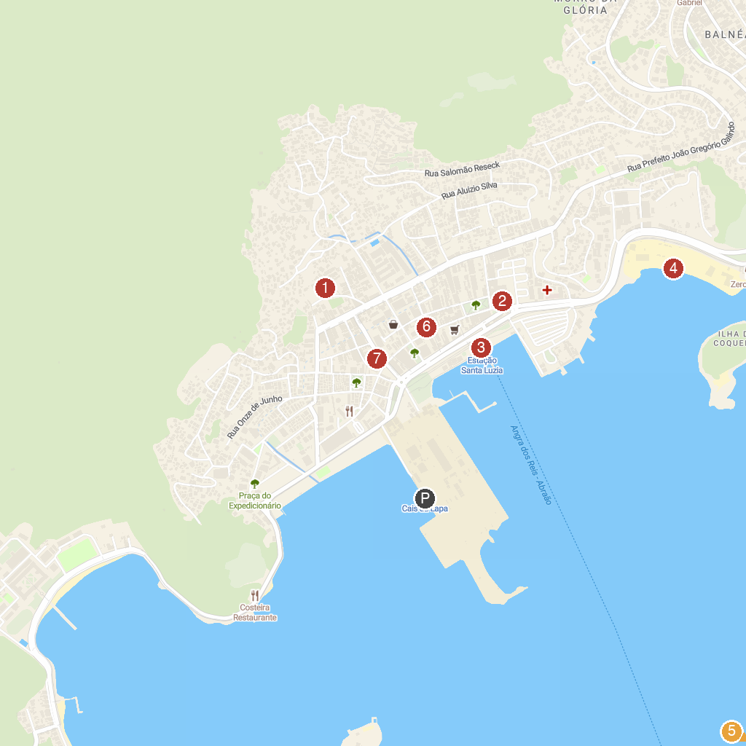
MAP KEY
1. São Bernardino de Sena Convent | 5. Praia do Leme
2. Convento do Carmo | 6. Igreja da Freguesia de Santana
3. Pier Santa Luzia | 7. Church of Santa Luzia
4. Angra Azzure | 8. Praça General Silvestre Travassos odontocompany
P. Cruise port / terminal
Map © MapTiler © OpenStreetMap contributors · cruiseports.org

