Angkor Ban, Kampong Cham Province, Cambodia
A living time capsule on the Mekong — Angkor Ban's century-old wooden houses and unhurried village rhythms survived war, revolution, and floods. It's one of the most authentic stops on any river cruise.
⚓ Tender (small local boats) · 🕒 Typical call: 3–5 hrs · 💵 USD & Cambodian Riel · 🗣️ Khmer · 🌴 Rural village — no tourist shops
✍️ MY DAY IN PORT (FILL IN)
Ship / Date
In port | arrive ______ · all aboard ______
Booked excursion
Notes / meeting point
GETTING ASHORE
- Docking: Tender only — small local boats from river ship to simple village landing
- Walk to center: Immediate — village begins at the landing
- Best For: Cultural immersion, village life, Buddhist temples, photography
- Don't Miss: The stilted wooden houses with blue doors and the village Buddhist temple with murals
GETTING AROUND
TOP THINGS TO DO
- Village Walking Tour — A guided stroll through Angkor Ban's lanes, past century-old wooden houses built on stilts with distinctive blue doors, while…
- Buddhist Temple & Monk Blessing — Visit the village's colorful Buddhist temple, admire traditional Khmer murals, and — if timing allows — receive a monk's blessing…
- Village School & Community Visit — Some itineraries include a stop at the local school, where passengers meet children and teachers and donate school supplies.
- Mekong Riverbank & Rice Paddy Walk — Wander the village edges to watch fishermen cast nets on the Mekong, farmers tending rice paddies, and the slow waterway life…
BEST WALKS
- Village Loop Walk: 1.5 km · Easy · ~45 min — From the landing, walk through the main village lane past stilted wooden houses, past the Buddhist…
WEATHER · DAYLIGHT · MONEY
Month | High °F | Low °F | Rainy days
May | 90 | 76 | 25
Jul | 86 | 76 | 27
Sep | 85 | 74 | 27
Daylight: May 5:44AM–6:29PM · Jul 5:51AM–6:41PM · Sep 5:59AM–6:11PM
cruiseports.org/angkor-ban · Confirm terminal & all-aboard time with your ship

Angkor Ban, Kampong Cham Province, Cambodia — Port Map
Red = walkable sights · Amber = excursions farther out · P = cruise terminal
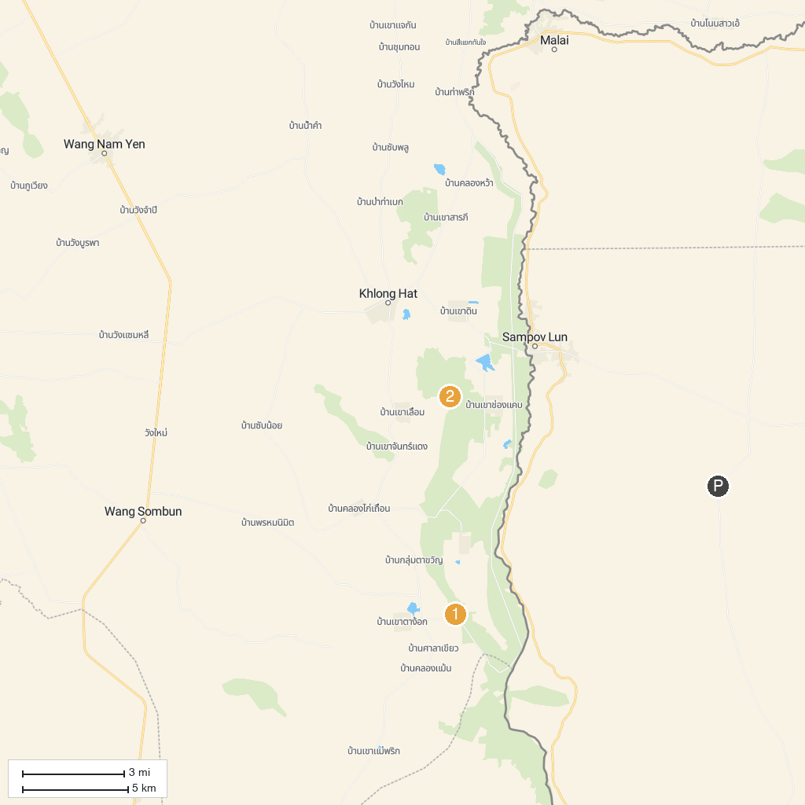
MAP KEY
1. Khao Siwa Water Cave | 2. Tham Phet Pho Thong
P. Cruise port / terminal
Map © MapTiler © OpenStreetMap contributors · cruiseports.org

