Angers, Loire Valley, France
A compact medieval city punching well above its weight: an enormous 13th-century fortress, the largest surviving medieval tapestry on earth, and the birthplace of Cointreau — all within easy walking distance of the quay.
⚓ River docked (Maine River quayside) · 🕒 Typical call: 7-10 hrs · 💶 Currency: Euro · 🗣️ Language: French · 🏰 Historic city center
✍️ MY DAY IN PORT (FILL IN)
Ship / Date
In port | arrive ______ · all aboard ______
Booked excursion
Notes / meeting point
GETTING ASHORE
- Docking: River cruise ships dock along the Maine River quayside, a short walk from the city center
- Walk to center: 5-10 min on foot to Château d'Angers and the old town
- Best For: Medieval history, the Apocalypse Tapestry, Loire wines, and an unhurried French city vibe
- Don't Miss: The Apocalypse Tapestry inside Château d'Angers — 14th-century, around 100 metres of it surviving (originally ~140 m), utterly extraordinary
GETTING AROUND
- 🚕 Taxi: €5–€15 — Angers is a river cruise port with docking areas close to the city center, so taxi rides are short. Licensed taxis charg
- 📱 Rideshare: ✅ Uber, Bolt
TOP THINGS TO DO
- Château d'Angers & the Apocalypse Tapestry — This 13th-century fortress with 17 drum towers houses the Tapisserie de l'Apocalypse — a 14th-century masterpiece woven…
- Old Town & Maison d'Adam — Wander the historic Quartier de la Doutre and the old town around Place Sainte-Croix.
- David d'Angers Gallery & Musée des Beaux-Arts — The David d'Angers Gallery (in restored Toussaint Abbey) showcases monumental plaster casts by Angers' most famous sculptor.
- Cointreau Distillery Tour — Angers is the birthplace of Cointreau, the orange liqueur invented here in 1875.
- Loire Valley Vineyard & Château Day — The Anjou appellation produces some of France's finest whites (Savennières, Chenin Blanc) and rosés.
BEST WALKS
- Quay to Château & Cathedral Circuit: 2.5 km · ~45-60 min walking · mostly flat — From the Maine River quay, walk uphill to the Château d'Angers entrance on Boulevard du Roi René…
- Old Town & Maison d'Adam Stroll: 1.5 km · ~30 min · flat — Cross into the heart of the old town via Rue Saint-Laud, find the Maison d'Adam on Place…
WEATHER · DAYLIGHT · MONEY
Month | High °F | Low °F | Rainy days
May | 67 | 50 | 10
Jul | 78 | 60 | 7
Sep | 73 | 56 | 8
Daylight: May 6:25AM–9:32PM · Jul 6:20AM–9:54PM · Sep 7:40AM–8:13PM
cruiseports.org/angers · Confirm terminal & all-aboard time with your ship

Angers, Loire Valley, France — Port Map
Red = walkable sights · Amber = excursions farther out · P = cruise terminal
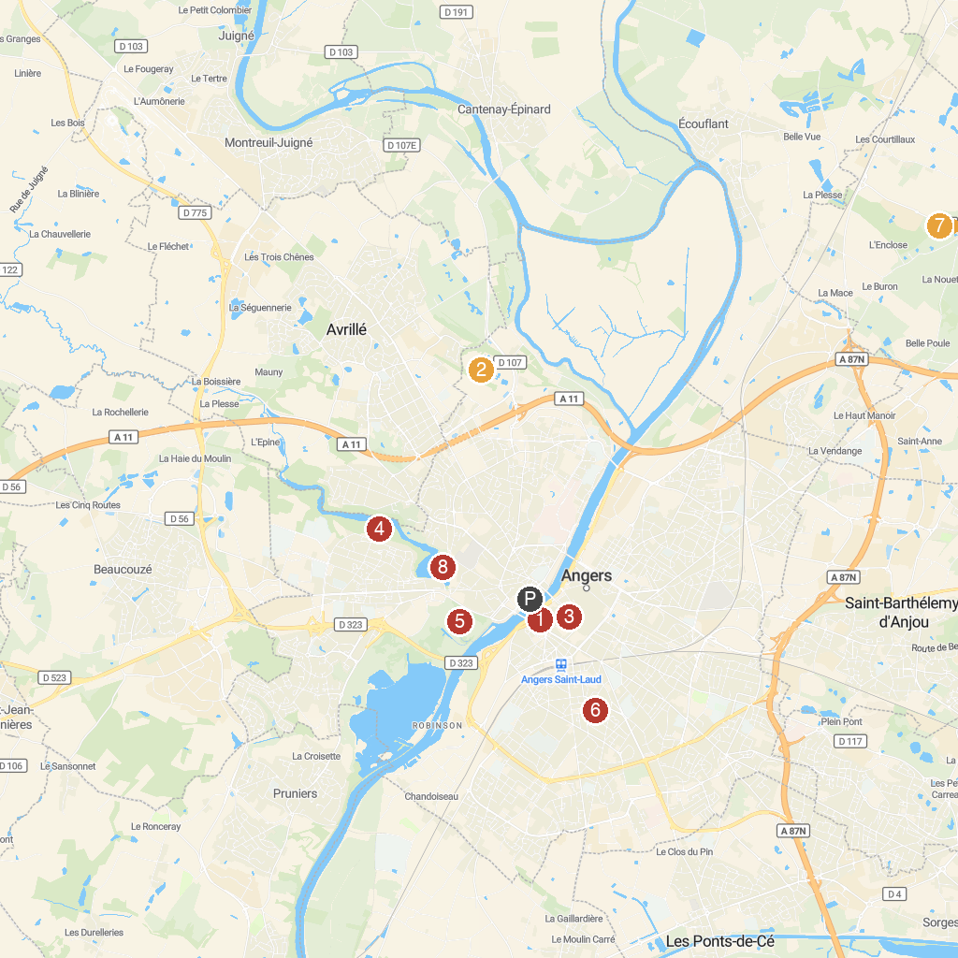
MAP KEY
1. Château d'Angers | 5. Balzac Park
2. Terra Botanica | 6. Parc du Pin (Rue du Pin)
3. Cathédrale Saint-Maurice d'Angers | 7. Château à Motte de Verrières en Anjou
4. Saint Nicolas park | 8. Parc de la Garenne
P. Cruise port / terminal
Map © MapTiler © OpenStreetMap contributors · cruiseports.org

