Andros Island, Cyclades, Greece
The greenest, least-crowded Cycladic island — Andros delivers dramatic hiking trails, a genuine art-museum scene, and turquoise coves, all within easy reach of Gavrio's working harbour.
⚓ Docked (Gavrio pier) · 🕒 Typical call: 8-10 hrs · 💶 Euro · 🗣️ Greek
✍️ MY DAY IN PORT (FILL IN)
Ship / Date
In port | arrive ______ · all aboard ______
Booked excursion
Notes / meeting point
GETTING ASHORE
- Docking: Ships berth at Gavrio pier on the northwest coast; no tendering required for most vessels
- Walk to Center: Gavrio village is 5 min on foot; Batsi resort town is 7 km; Chora (capital) is 35 km
- Best For: Hiking, beaches, contemporary art, authentic Cycladic villages
- Don't Miss: Goulandris Museum of Contemporary Art in Chora and the Pithara Waterfalls near Apikia
GETTING AROUND
- 🚕 Taxi: €28–€40 — Taxis are available at Gavrio port. The ride to Chora (Andros Town) takes about 50–55 minutes and costs roughly €28–€40;
TOP THINGS TO DO
- Chora & Goulandris Museum of Contemporary Art — Andros Town (Chora) is one of the most elegant capitals in the Cyclades — neoclassical mansions, marble-paved lanes, and sea-view…
- Pithara Waterfalls Hike — A short, shaded walk near Apikia village leads to a lush cascade of waterfalls surrounded by ferns and plane trees — a cool…
- Andros Hiking Trails — Andros has a network of over 300 km of restored trails, anchored by the 100 km 'Andros Route' — certified in 2015 as a Leading…
- Chryssi Ammos & Agios Petros Beach — Chryssi Ammos (Golden Sand) is a sheltered bay with fine sand and Caribbean-blue water just minutes from Gavrio.
- Venetian Castle & Maritime Museum in Chora — The medieval Venetian castle sits on a rocky promontory connected to Chora's old town by a narrow bridge.
BEST WALKS
- Gavrio Waterfront & Tower of Agios Petros: 2 km · 45 min · Easy — From the pier, stroll the Gavrio waterfront past fish tavernas and cafes, then follow signs inland…
- Chora Old Town Walk: 1.5 km loop · 1-2 hrs · Easy — Walk the marble-paved main street of Andros Town past neoclassical mansions and through archways to…
WEATHER · DAYLIGHT · MONEY
Month | High °F | Low °F | Rainy days
May | 70 | 63 | 4
Jul | 82 | 75 | 1
Sep | 78 | 72 | 3
Daylight: May 6:11AM–8:24PM · Jul 6:11AM–8:42PM · Sep 7:03AM–7:28PM
cruiseports.org/andros-island-greece · Confirm terminal & all-aboard time with your ship

Andros Island, Cyclades, Greece — Port Map
Red = walkable sights · Amber = excursions farther out · P = cruise terminal
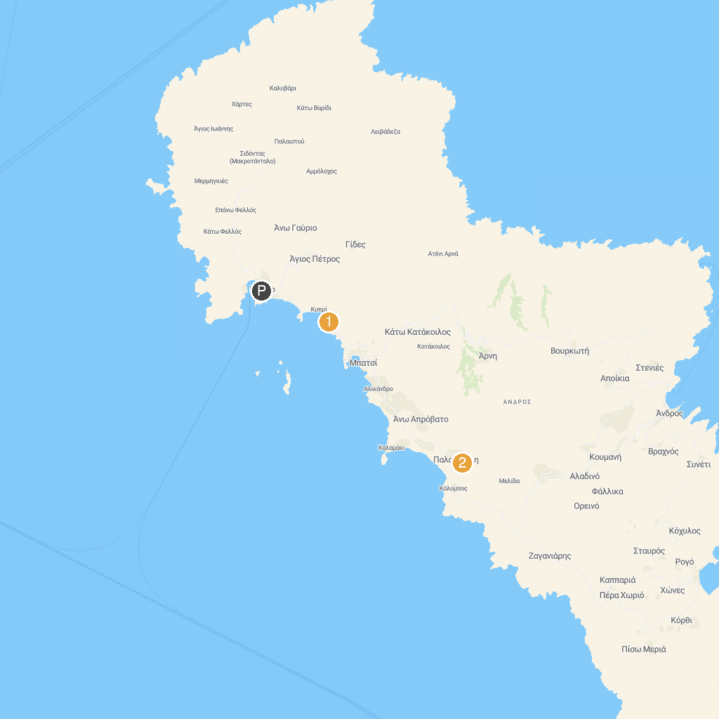
MAP KEY
1. Agios Kyprianos | 2. Archaeological Museum of Paleopolis
P. Cruise port / terminal
Map © MapTiler © OpenStreetMap contributors · cruiseports.org

