Andernach, Rhineland-Palatinate, Germany
One of Germany's oldest cities, Andernach packs medieval walls, the world's tallest cold-water geyser, and a landmark 16th-century stone crane into a compact Rhine riverfront — and Koblenz is just 20 minutes away.
⚓ Docked — Rhine riverbank quay · 🕒 Typical call: 6–8 hrs · 💶 Euro (EUR) · 🗣️ German
✍️ MY DAY IN PORT (FILL IN)
Ship / Date
In port | arrive ______ · all aboard ______
Booked excursion
Notes / meeting point
GETTING ASHORE
- Docking: River cruise ships dock at the Rhine quay (Rheinpromenade) — no tender, town center is a 5-minute walk
- Walk to center: ~5 min on foot from the dock to the Alter Kran and Old Town
- Best For: Medieval architecture, the Geysir Andernach boat excursion, day trip to Koblenz
- Don't Miss: The Geysir Andernach — CO₂-driven cold-water geyser erupts up to ~60 m skyward from a Rhine peninsula; boats run roughly every 1.5–2 hours
GETTING AROUND
- 🚕 Taxi: ~€8–€15 for short local rides — Standard local taxis are the practical choice for short hops beyond the center. Published taxi calculators list a base f
TOP THINGS TO DO
- Geysir Andernach Boat Trip — Board an excursion boat from the Andernach waterfront to the Namedyer Werth river peninsula, where a CO₂-driven cold-water geyser…
- Runder Turm & Medieval City Walls — The Runder Turm (Round Tower) is one of the largest and best-preserved medieval defensive towers in Germany, built in the…
- Alter Kran (Old Crane) — This 16th-century stone treadwheel crane (built 1554–1561, replacing an earlier wooden one) on the Rhine riverbank is one of the…
- Liebfrauenkirche & Market Square — The Church of Our Lady (Liebfrauenkirche) is a handsome late Romanesque and Gothic parish church in the center of the Old Town.
- Day Trip to Koblenz — Koblenz, just ~18 km south, sits at the confluence of the Rhine and Moselle rivers.
BEST WALKS
- Old Town & Waterfront Loop: ~2 km | 45–60 min | Easy | All paved — From the dock, walk to the Alter Kran on the riverbank, then follow the Rhine promenade north…
WEATHER · DAYLIGHT · MONEY
Month | High °F | Low °F | Rainy days
May | 65 | 48 | 11
Jul | 76 | 59 | 11
Sep | 69 | 53 | 9
Daylight: May 5:42AM–9:11PM · Jul 5:36AM–9:35PM · Sep 7:06AM–7:43PM
cruiseports.org/andernach · Confirm terminal & all-aboard time with your ship

Andernach, Rhineland-Palatinate, Germany — Port Map
Red = walkable sights · Amber = excursions farther out · P = cruise terminal
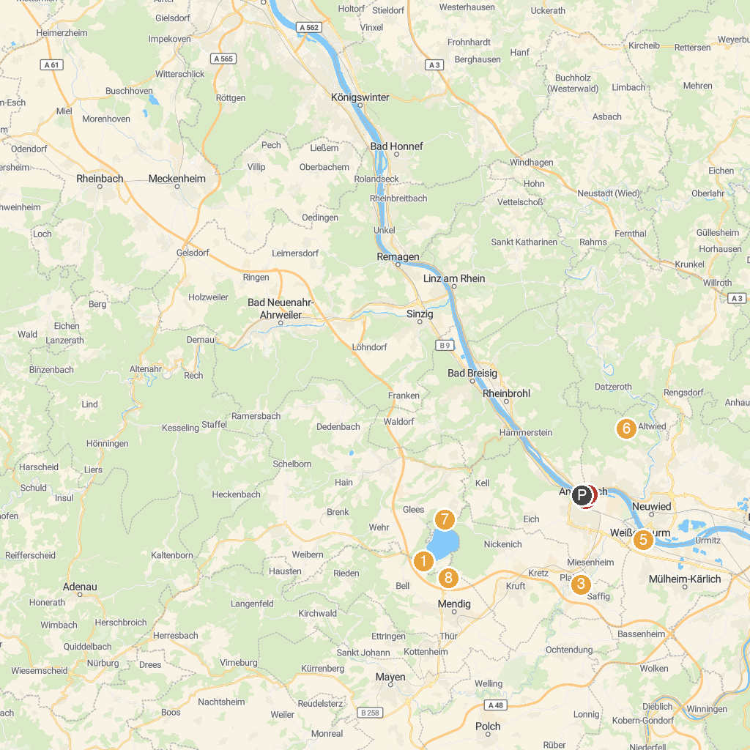
MAP KEY
1. Maria Laach Abbey | 5. Weißer Turm
2. Schlossgarten | 6. Monrepos
3. Rauscher Park | 7. Lydiaturm
4. Andernach Bollwerk | 8. Wingertsbergwand
P. Cruise port / terminal
Map © MapTiler © OpenStreetMap contributors · cruiseports.org

