Andenes, Vesterålen, Norway
Perched at the northern tip of Andøya island, Andenes is Norway's undisputed whale capital — sperm whales feed year-round in the deep Bleik Canyon just offshore, while a 40-metre red lighthouse watches over a compact fishing village where the midnight sun never quite sets.
⚓ Docked (quay, central harbor) · 🕒 Typical call: 6-8 hrs · 💵 Norwegian Krone (NOK) · 🗣️ Norwegian (English widely spoken)
✍️ MY DAY IN PORT (FILL IN)
Ship / Date
In port | arrive ______ · all aboard ______
Booked excursion
Notes / meeting point
GETTING ASHORE
- Docking: Quay alongside in Andenes harbor (Østre Havn); town center is a short walk
- Walk to center: 5-10 min on foot to Whale Center, lighthouse, and restaurants
- Best For: Whale watching, birdlife (puffins, eagles), Midnight Sun photography
- Don't Miss: Whale safari on the Bleik Canyon — sperm whales sighted on almost every trip
GETTING AROUND
- 🚕 Taxi: NOK 130–170 (short trips) — Andøy Taxi (+47 76 14 12 00) is the primary local provider. The port and town center are close; short rides run NOK 130–
- 📱 Rideshare: ❌ not available
TOP THINGS TO DO
- Sperm Whale Safari — Board a purpose-built whale-watch vessel and head out over the Bleik Canyon, one of the deepest submarine troughs off Norway's…
- Puffin & Seabird Safari to Bleiksøya — The sea stack of Bleiksøya, visible from Bleik Beach a short drive south, hosts around 80,000 puffins during the breeding season…
- Andenes Lighthouse Climb — The 40-metre red cast-iron lighthouse (1859) is one of Norway's tallest.
- Scenic Drive: Norwegian Scenic Route Andøya — The designated National Tourist Route hugs Andøya's western coast past Bleik Beach (one of North Norway's longest white-sand…
- Andenes Whale Center & Exhibition — The harbour-front Whale Center houses a full whale exhibition covering marine mammal anatomy, deep-sea ecology, and the Bleik…
BEST WALKS
- Harbor to Lighthouse Loop: 1.5 km · Easy · 30-45 min — A flat waterfront walk from the cruise quay along Hamnegata past the Whale Center, through the…
- Bleik Beach Walk: ~10 min drive south + 1 km walk · Easy · 45 min on beach — Bleik Beach is one of Norway's finest Arctic beaches — a long white-sand crescent backed by the…
WEATHER · DAYLIGHT · MONEY
Month | High °F | Low °F | Rainy days
May | 45 | 39 | 16
Jul | 57 | 50 | 10
Sep | 52 | 47 | 15
Daylight: Sep 6:10AM–7:28PM
cruiseports.org/andenes · Confirm terminal & all-aboard time with your ship

Andenes, Vesterålen, Norway — Port Map
Red = walkable sights · Amber = excursions farther out · P = cruise terminal
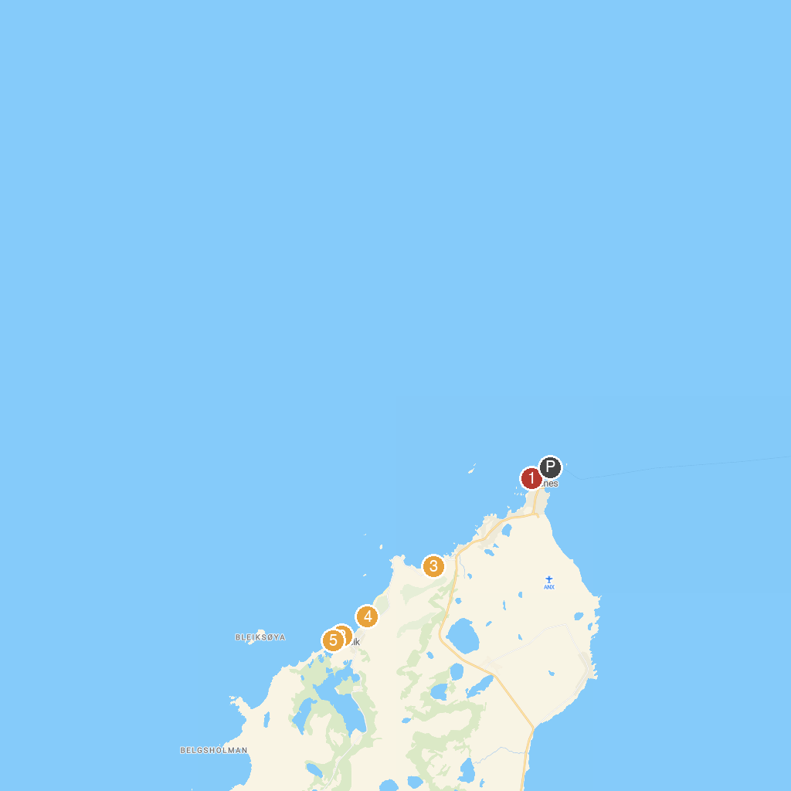
MAP KEY
1. Andøymuseet | 4. Bleik sandstrand
2. Puffin Safari AS | 5. Bleik, Vesteralen
3. Spaceship Aurora
P. Cruise port / terminal
Map © MapTiler © OpenStreetMap contributors · cruiseports.org

