Åndalsnes, Møre og Romsdal, Norway
Where the Romsdal Alps plunge straight into the fjord, Åndalsnes packs spectacular scenery into a single shore day — a gondola at the dock, hairpin mountain roads, and one of Europe's most beautiful rail journeys.
⚓ Pier (Tindekaia — no tender) · 🕒 Typical call: 6–10 hrs · 💵 Norwegian Krone (NOK) · 🗣️ Norwegian (English widely spoken)
✍️ MY DAY IN PORT (FILL IN)
Ship / Date
In port | arrive ______ · all aboard ______
Booked excursion
Notes / meeting point
GETTING ASHORE
- Docking: Direct at Tindekaia pier, town center; up to 330 m vessels
- Walk to center: ~500 m from gangway to main street
- Best For: Mountain scenery, scenic railways, fjord hiking
- Don't Miss: Romsdalen Gondola or the Rauma Railway round-trip
GETTING AROUND
- 🚕 Taxi: ~100 NOK base + 15 NOK/km — Rauma Taxi serves the area. Short town trips are close to the base fare; longer rides to Trollveggen or Trollstigen will
TOP THINGS TO DO
- Trollstigen Mountain Road — Eleven hairpin bends zig-zag up a near-vertical cliff face alongside a thundering waterfall.
- Romsdalen Gondola — An electric cable car departs from a base station 5 minutes' walk from the pier, rising to the Nesaksla summit (708 m) with 360°…
- Rauma Railway Scenic Round-Trip — Ranked among Europe's most beautiful rail journeys, this scenic round-trip (about 2.5 hrs) through Romsdalen valley passes the…
- Norwegian Mountaineering Centre — A sleek museum at the water's edge chronicles Norway's rich climbing history with interactive exhibits, Norway's tallest indoor…
- Full-Day Geiranger & Eagle Road — The longest day-trip combines Trollstigen with a drive over the Eagle Road (Ørnevegen) to Geiranger village and the UNESCO-listed…
BEST WALKS
- Pier to Gondola & Town Loop: 1.5 km | Flat | 20–30 min — From Tindekaia pier walk along the waterfront to the Romsdalen Gondola base station, then continue…
- Rampestreken Viewpoint (via Gondola): 1.5 km ridge walk from gondola top | Moderate | 45–60 min each way — Ride the gondola to Nesaksla summit, then follow the signed path along the ridge to Rampestreken…
WEATHER · DAYLIGHT · MONEY
Month | High °F | Low °F | Rainy days
May | 55 | 40 | 16
Jul | 65 | 53 | 20
Sep | 60 | 47 | 18
Daylight: May 4:30AM–10:22PM · Sep 6:54AM–7:52PM
cruiseports.org/andalsnes · Confirm terminal & all-aboard time with your ship

Åndalsnes, Møre og Romsdal, Norway — Port Map
Red = walkable sights · Amber = excursions farther out · P = cruise terminal
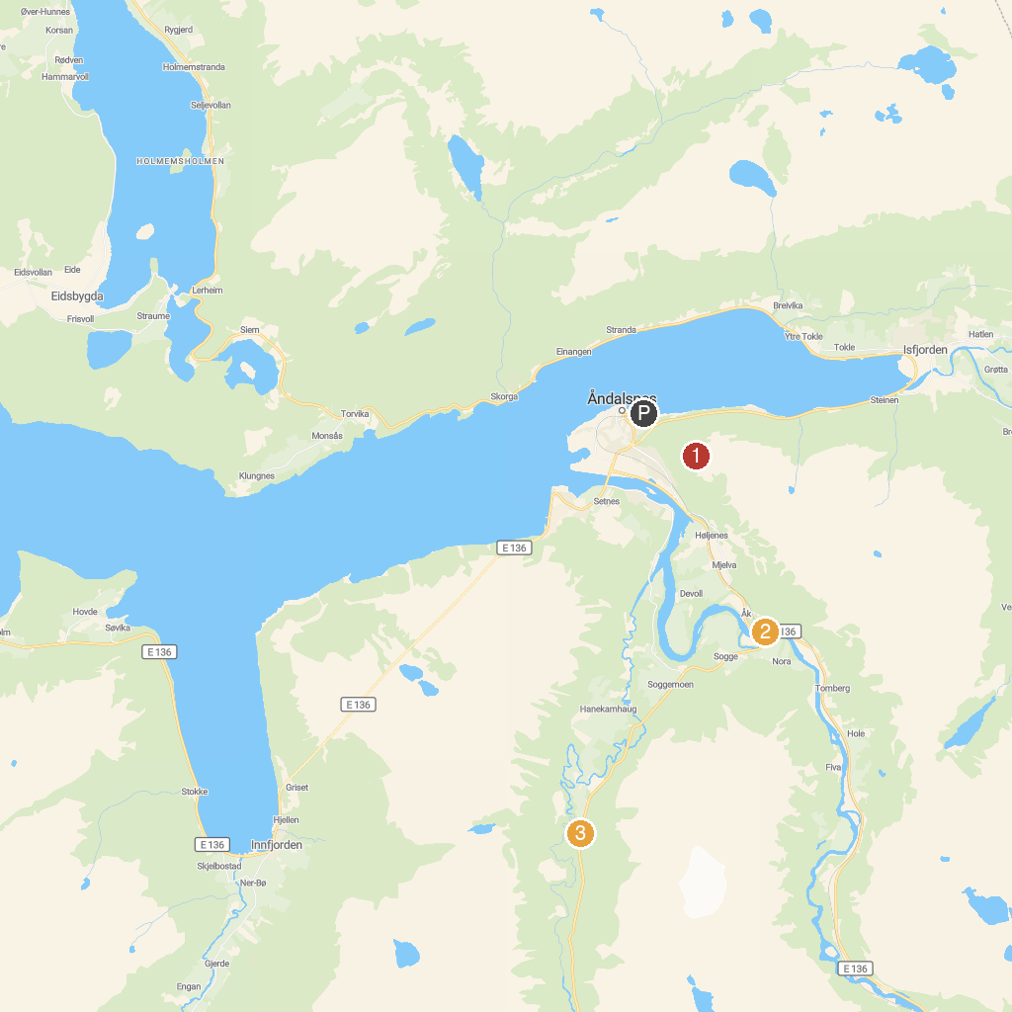
MAP KEY
1. Stigfossbrua | 3. Sogge Bru
2. Rampestreken | 4. Trollstigen Gjestgård
P. Cruise port / terminal
Map © MapTiler © OpenStreetMap contributors · cruiseports.org

