Anchorage, Alaska, USA
Alaska's biggest city sits between the Chugach Mountains and Cook Inlet, giving cruise passengers direct access to glaciers, wildlife sanctuaries, and Alaska Native heritage — all on an easy shore day.
⚓ Docked — Port of Anchorage · 🕒 Typical call: 8-10 hrs (often embark/debark day) · 💵 USD · 🗣️ English
✍️ MY DAY IN PORT (FILL IN)
Ship / Date
In port | arrive ______ · all aboard ______
Booked excursion
Notes / meeting point
GETTING ASHORE
- Docking: Port of Anchorage (cargo/passenger berths); many itineraries use bus transfer from Seward or Whittier
- Walk to center: ~1 mile from port to downtown Ship Creek area; free shuttle sometimes provided
- Best For: Glacier day trips, Alaska Native culture, wildlife viewing, scenic hikes
- Don't Miss: Alaska Wildlife Conservation Center (Portage Valley) and Tony Knowles Coastal Trail
GETTING AROUND
- 🚕 Taxi: $10–$20 — Alaska Yellow Dispatch and other local cabs serve the port. Rates from $3.00/mile as of 2025; short downtown runs are af
- 📱 Rideshare: ✅ Uber, Lyft
TOP THINGS TO DO
- Portage Glacier Cruise — Board the MV Ptarmigan at Portage Lake for a close-up look at Portage Glacier — one of Alaska's most accessible glaciers, calving…
- Alaska Wildlife Conservation Center — Drive-through sanctuary in Portage Valley with resident brown bears, moose, caribou, musk ox, bison, and lynx — rescued animals…
- Matanuska Glacier Hike — Guided hike on the surface of Matanuska Glacier — Alaska's largest road-accessible glacier in the Matanuska-Susitna Valley, about…
- Alaska Native Heritage Center — Immersive cultural center in Anchorage featuring authentic Alaska Native village replicas, traditional dance performances…
- Flightseeing over Denali or Knik Glacier — Small-plane or helicopter tours departing from Anchorage's Lake Hood Seaplane Base — the world's busiest floatplane base — with…
BEST WALKS
- Tony Knowles Coastal Trail: 11 miles one-way | Paved | Easy to moderate | Bike or walk — A paved multi-use trail hugging the Cook Inlet shoreline from downtown Anchorage to Kincaid Park.
- Downtown Anchorage Loop: 1-2 miles | Flat | Easy | 45-60 min — Walk from the Ship Creek overlook along 4th Avenue to the Anchorage Museum, through Town Square…
WEATHER · DAYLIGHT · MONEY
Month | High °F | Low °F | Rainy days
May | 57 | 41 | 11
Jul | 67 | 54 | 13
Sep | 55 | 44 | 17
Daylight: May 5:11AM–10:42PM · Jul 4:52AM–11:16PM · Sep 7:27AM–8:19PM
cruiseports.org/anchorage-ak · Confirm terminal & all-aboard time with your ship

Anchorage, Alaska, USA — Port Map
Red = walkable sights · Amber = excursions farther out · P = cruise terminal
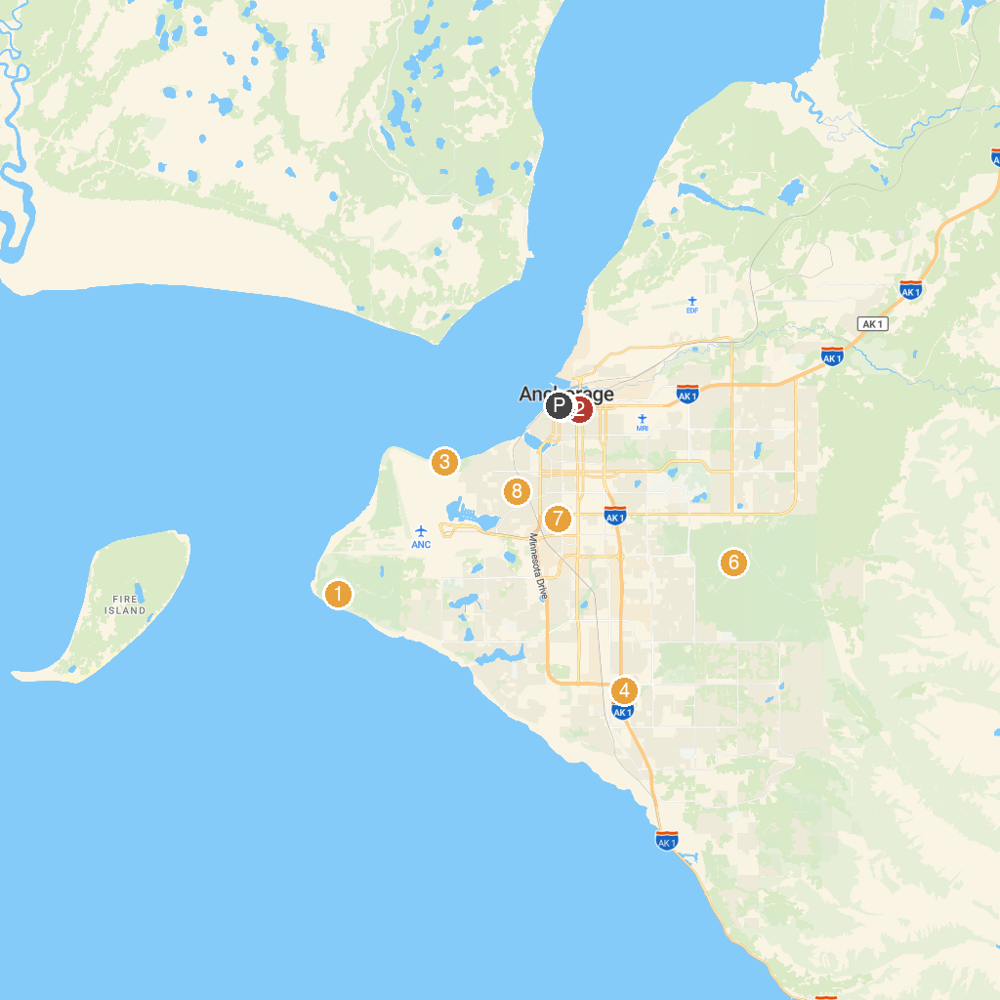
MAP KEY
1. Kincaid Park | 5. Holy Family Catholic Church
2. Anchorage Museum | 6. Campbell Creek Science Center
3. Earthquake Park | 7. Pop Carr Memorial Park
4. H2Oasis Indoor Waterpark | 8. Woodland Park
P. Cruise port / terminal
Map © MapTiler © OpenStreetMap contributors · cruiseports.org

