Anadyr, Chukotka, Russia
At the far eastern tip of Russia, Anadyr bursts with color against a backdrop of tundra and frozen sea — a remote Arctic capital where Chukchi traditions, bold Soviet murals, and beluga whales all share the same estuary.
⚓ Tender (no cruise pier) · 🕒 Typical call: 6-8 hrs · 💵 Russian Ruble · 🗣️ Russian / Chukchi · 🛂 Border permit required in advance
✍️ MY DAY IN PORT (FILL IN)
Ship / Date
In port | arrive ______ · all aboard ______
Booked excursion
Notes / meeting point
GETTING ASHORE
- Docking: Tender only — ships anchor in Anadyr Bay; Zodiac or ship's tender to town quay
- Walk to center: 5-10 min on foot from the landing quay to the town center
- Best For: Indigenous culture, remote Arctic atmosphere, unique architecture
- Don't Miss: Heritage of Chukotka Museum and the St Nicholas statue on the cliff
GETTING AROUND
- 🚕 Taxi: Varies — negotiate locally — Local taxis are available within the city. Prices are not standardized; agree on a fare before boarding. Your cruise lin
TOP THINGS TO DO
- Heritage of Chukotka Museum — One of the finest museums in the Russian Far East, built to resemble a polar bear.
- Holy Trinity Cathedral — Consecrated in 2005, this is one of the largest wooden Orthodox churches in the world built on permafrost.
- Statue of Saint Nicholas & Estuary Views — A 10-metre bronze monument on a rocky cliff overlooking the Anadyr Estuary — the largest statue of the patron saint of travellers…
- Beluga Whale Watching in the Estuary — During summer months (July–September), beluga whales regularly feed in the Anadyr Estuary.
- Camel Hill & City Murals Walk — Anadyr's highest point is topped by a large Orthodox cross and offers sweeping tundra views.
BEST WALKS
- Anadyr Town Centre Loop: ~2 km · 2 hrs · Easy — From the port quay, walk uphill into the city centre to the Holy Trinity Cathedral, then continue…
WEATHER · DAYLIGHT · MONEY
Month | High °F | Low °F | Rainy days
May | 35 | 26 | 5
Jul | 56 | 47 | 11
Sep | 47 | 40 | 11
Daylight: May 2:50AM–9:25PM · Sep 5:31AM–6:37PM
cruiseports.org/anadyr · Confirm terminal & all-aboard time with your ship

Anadyr, Chukotka, Russia — Port Map
Red = walkable sights · Amber = excursions farther out · P = cruise terminal
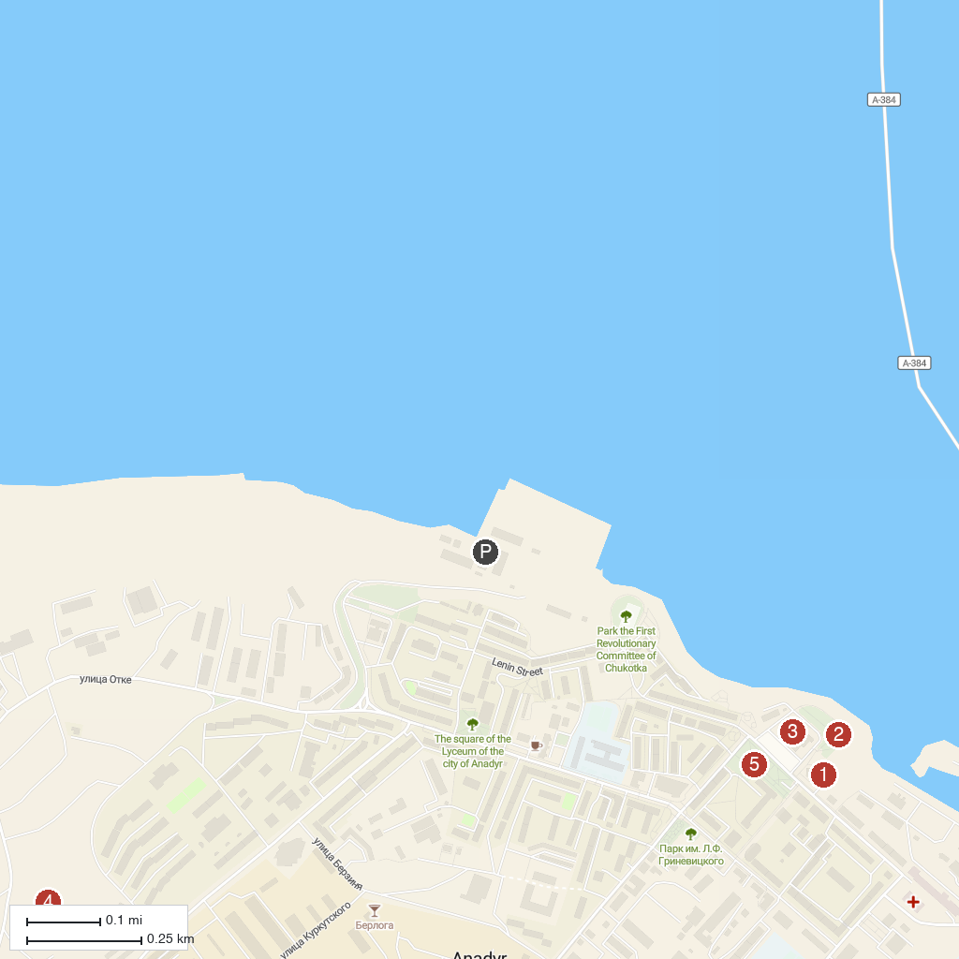
MAP KEY
1. Holy Trinity Cathedral, Anadyr | 4. Camel Hill (Gora Verblyuzhka)
2. Monument to St. Nicholas the Wonderworker | 5. Monument to Yuri Rytkheu
3. Museum Center Heritage of Chukotka
P. Cruise port / terminal
Map © MapTiler © OpenStreetMap contributors · cruiseports.org

