Amsterdam, North Holland, Netherlands
A city built on 90 islands and 1,500 bridges, Amsterdam rewards cruise visitors with iconic canals, Golden Age masterpieces, world-famous museums, and a cycling culture unlike anywhere else in Europe.
⚓ Docked (PTA or Felison/IJmuiden) · 🕒 Typical call: 8–10 hrs · 💶 Euro (€) — nearly cashless city · 🗣️ Dutch (English universally spoken)
✍️ MY DAY IN PORT (FILL IN)
Ship / Date
In port | arrive ______ · all aboard ______
Booked excursion
Notes / meeting point
GETTING ASHORE
- Docking: Passenger Terminal Amsterdam (PTA), Piet Heinkade 27 — 10-min walk to Centraal Station; or Felison Terminal in IJmuiden, ~45–60 min from city by shuttle
- Walk to Centre: 10–15 min from PTA to Centraal Station; ~35 min to Museumplein on foot or 15 min by Tram 2/12
- Best For: Art lovers, canal cruises, cycling, day trips to Zaanse Schans windmills
- Don't Miss: Book Anne Frank House & Rijksmuseum tickets weeks in advance — they sell out; same-day entry is nearly impossible
GETTING AROUND
- 🚕 Taxi: €10–€20 — Official taxis are available at the terminal. The ride to Centraal or the main city center takes under 10 minutes. Note:
- 📱 Rideshare: ✅ Uber, Bolt
- 🚌 Hop-on hop-off: ✅
TOP THINGS TO DO
- Amsterdam Canal Cruise — See the UNESCO-listed canal ring from the water, gliding past 17th-century merchant houses, wooden houseboats, and stone bridges.
- Rijksmuseum & Museumplein — The Dutch national museum holds Rembrandt’s Night Watch, Vermeer’s Milkmaid, and a vast Delftware collection.
- Anne Frank House — The canal house where Anne Frank hid with her family during WWII is one of Amsterdam’s most affecting experiences.
- Zaanse Schans Windmills & Village — A 20-min train from Centraal (or 30-min via tour bus) brings you to this preserved windmill village where you can step inside…
- Our Lord in the Attic (Ons’ Lieve Heer op Solder) — A perfectly preserved 17th-century canal house with a secret, fully functioning Catholic church hidden in its top three floors…
BEST WALKS
- PTA to the Canal Ring & Jordaan: 2.5 km · ~35 min one way · Flat — Walk west from PTA along Piet Heinkade, cross De Ruijterkade past Centraal Station, and enter the…
- Centraal Station to Museumplein: 3 km · ~40 min one way · Flat (or 15 min by Tram 2 or 12) — From Centraal, walk south along Damrak to Dam Square and the Royal Palace, then continue via…
WEATHER · DAYLIGHT · MONEY
Month | High °F | Low °F | Rainy days
May | 62 | 48 | 11
Jul | 71 | 58 | 14
Sep | 67 | 54 | 12
Daylight: May 5:45AM–9:29PM · Jul 5:37AM–9:55PM · Sep 7:15AM–7:54PM
cruiseports.org/amsterdam · Confirm terminal & all-aboard time with your ship

Amsterdam, North Holland, Netherlands — Port Map
Red = walkable sights · Amber = excursions farther out · P = cruise terminal
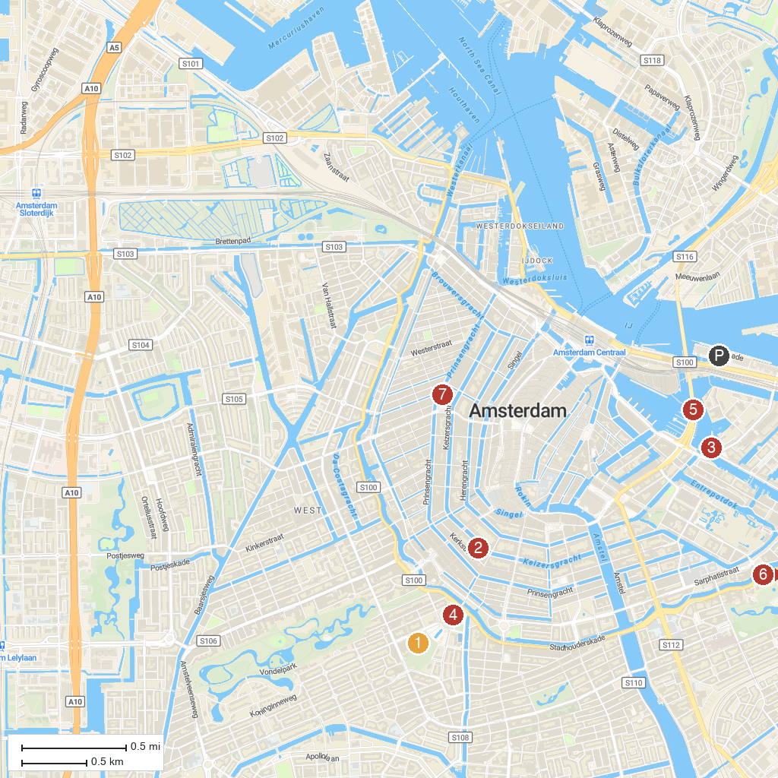
MAP KEY
1. Van Gogh Museum | 5. NEMO Science Museum
2. Keizersgrachtkerk | 6. Wereldmuseum Amsterdam
3. National Maritime Museum | 7. Anne Frank House
4. Rijksmuseum
P. Cruise port / terminal
Map © MapTiler © OpenStreetMap contributors · cruiseports.org

