Amorgos Island, Cyclades, Greece
One of the wildest islands in the Cyclades, Amorgos rewards intrepid cruisers with a vertiginous 11th-century cliff monastery, the turquoise coves that starred in The Big Blue, and footpaths threading between hilltop villages untouched by mass tourism.
⚓ Tender port (both Katapola & Aegiali) · 🕒 Typical call: 6-8 hrs · 💶 Euro (€) · 🗣️ Greek
✍️ MY DAY IN PORT (FILL IN)
Ship / Date
In port | arrive ______ · all aboard ______
Booked excursion
Notes / meeting point
GETTING ASHORE
- Docking: Tender only — ships anchor offshore at Katapola (west) or Aegiali (north); tenders drop at the village quay
- Walk to center: Katapola village is steps from the tender dock; Chora (capital) is about 5 km by bus or taxi
- Best For: Hiking, monastery visits, authentic Cycladic atmosphere, swimming
- Don't Miss: Monastery of Panagia Hozoviotissa — one of Greece's most extraordinary sights
GETTING AROUND
- 🚕 Taxi: €10–€22 — Taxis are scarce but available. Katapola to Chora is roughly €10 (5.5 km); Aegiali to Chora is roughly €22 (15 km). Fare
- 📱 Rideshare: ❌ not available
TOP THINGS TO DO
- Monastery of Panagia Hozoviotissa — Founded in 1088, this dazzling white monastery is wedged into a sheer 300-meter cliff above the sea.
- Ancient Minoa & Chora Village — Above Katapola sit the scant but evocative ruins of ancient Minoa — an acropolis with sea views.
- Agia Anna Beach & The Big Blue — This small rocky cove on the south coast was immortalized in Luc Besson's 1988 film The Big Blue.
- Chora to Katapola Hiking Trail (Route 2) — A well-marked ancient footpath descends from Chora back to Katapola — roughly 4 km through terraced hillsides with sweeping sea…
- Boat Trip to Secluded Coves & Sea Caves — Small-boat excursions circle the island to reach sea caves, hidden swimming bays, and the rusting wreck of the Olympia in Liveros…
BEST WALKS
- Katapola Village & Ancient Minoa Loop: 2.5 km | Easy | 1-1.5 hrs — From the tender quay, stroll through Katapola's harbor front, then follow signs uphill to the…
- Chora Village Wander: 1-2 km | Easy | 1 hr (plus bus/taxi each way) — Take the bus or taxi to Chora, then wander freely through the maze of narrow lanes past whitewashed…
WEATHER · DAYLIGHT · MONEY
Month | High °F | Low °F | Rainy days
May | 73 | 64 | 3
Jul | 82 | 75 | 0
Sep | 79 | 72 | 2
Daylight: May 6:09AM–8:17PM · Jul 6:09AM–8:35PM · Sep 6:59AM–7:23PM
cruiseports.org/amorgos-island · Confirm terminal & all-aboard time with your ship

Amorgos Island, Cyclades, Greece — Port Map
Red = walkable sights · Amber = excursions farther out · P = cruise terminal
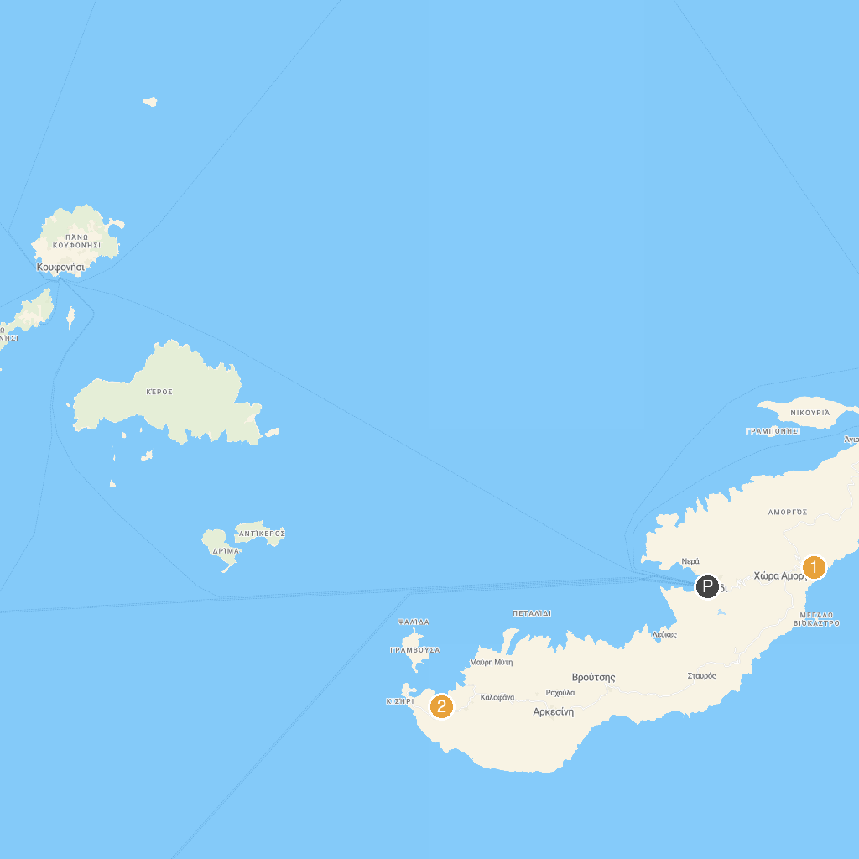
MAP KEY
1. Holy Monastery of the Virgin Mary Chozoviotissa | 3. Psili Ammos Beach
2. Shipwreck of Olympia
P. Cruise port / terminal
Map © MapTiler © OpenStreetMap contributors · cruiseports.org

