Ambrym Island, Malampa, Vanuatu
One of the Pacific's rawest adventure stops — two active volcanic cones, a vast volcanic caldera, and living traditions that have survived untouched for centuries. Ambrym rewards the curious and the intrepid.
⚓ Tender port (anchor offshore) · 🕒 Typical call: 6–8 hrs · 💵 Vanuatu Vatu (USD widely accepted) · 🗣️ Bislama, English, French
✍️ MY DAY IN PORT (FILL IN)
Ship / Date
In port | arrive ______ · all aboard ______
Booked excursion
Notes / meeting point
GETTING ASHORE
- Docking: Tender only — ships anchor offshore, Zodiacs or tenders ferry to Port Vato village landing
- Walk to centre: Port Vato village is steps from the tender landing; volcano treks are 4–5 hrs each way by foot
- Best For: Volcano adventurers, cultural immersion, photography, off-the-beaten-track travellers
- Don't Miss: Marum and Benbow volcanic craters, the Rom masked dance, Ambrym sand drawings
GETTING AROUND
- 📱 Rideshare: ❌ not available
TOP THINGS TO DO
- Volcano Trek to Mount Marum & Mount Benbow — Hike across the vast ash plain to the rim of one — or both — of Ambrym's legendary craters.
- Rom Dance & Black Magic Ceremony — In villages like Fanla and Ranon, masked Rom dancers perform one of Vanuatu's most sacred rituals.
- Sand Drawing & Traditional Carving Villages — Ambrym sand drawing is UNESCO-recognised intangible heritage.
- Lonwok Crater Lake — A deep crater lake formed by the catastrophic 1913 eruption — once a sheltered lagoon, it was sealed off into a lake by the blast.
- Zodiac & Snorkel Along the Coast — Some expedition lines offer Zodiac cruises along Ambrym's volcanic coastline, with snorkelling in clear, warm waters.
BEST WALKS
- Port Vato Village Stroll: 30–45 min · Flat · No guide needed — From the tender landing, a short walk through Port Vato village lets you meet locals, browse…
- Coastal Path to Neighbouring Village: 1–1.5 hrs · Easy · Informal track — A rough coastal track leads north from Port Vato toward smaller hamlets.
WEATHER · DAYLIGHT · MONEY
Month | High °F | Low °F | Rainy days
May | 69 | 62 | 19
Jul | 67 | 60 | 18
Sep | 67 | 61 | 19
Daylight: May 6:03AM–5:24PM · Jul 6:16AM–5:30PM · Sep 5:43AM–5:42PM
cruiseports.org/ambrym-island-vanuatu · Confirm terminal & all-aboard time with your ship

Ambrym Island, Malampa, Vanuatu — Port Map
Red = walkable sights · Amber = excursions farther out · P = cruise terminal
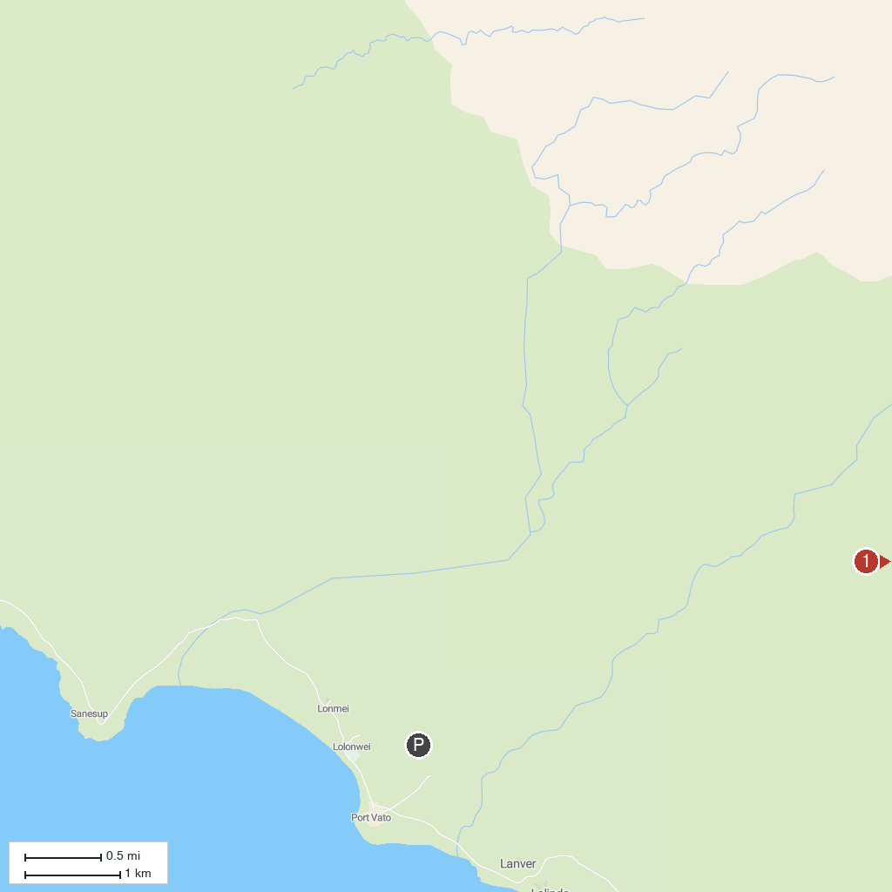
MAP KEY
1. Mount Marum | 2. Rom Dance villages, Ambrym
P. Cruise port / terminal
Map © MapTiler © OpenStreetMap contributors · cruiseports.org

