Amasra, Bartın, Turkey
Amasra is a rare Black Sea port where Roman walls, Byzantine churches, and Genoese towers all crowd a single rocky peninsula — and the seafood is outstanding. Most ships call just long enough to walk the whole thing.
⚓ Docked (new cruise pier) or Tendered · 🕒 Typical call: 6–8 hrs · 💵 Turkish Lira (TRY); some tourist spots accept EUR/USD · 🗣️ Turkish; limited English in tourist areas
✍️ MY DAY IN PORT (FILL IN)
Ship / Date
In port | arrive ______ · all aboard ______
Booked excursion
Notes / meeting point
GETTING ASHORE
- Docking: New 193-m harbor pier for most cruise ships; some expedition vessels tender
- Walk to center: 5 min from pier to Büyük Liman beach & castle gate
- Best For: Walkable history, Black Sea boat tours, Byzantine & Genoese ruins
- Don't Miss: Amasra Castle panorama, the museum's Hellenistic finds, a harbor boat tour
GETTING AROUND
- 🚕 Taxi: ₺50–150 in town / ₺400–500 to Bartın — Local taxis wait near the port. Short in-town trips are inexpensive; the 17 km ride to Bartın city center costs roughly
- 📱 Rideshare: ❌ not available
TOP THINGS TO DO
- Amasra Castle & Byzantine Quarter — The castle crowns a rocky peninsula and encompasses Roman foundations, Byzantine walls, Genoese towers, and an Ottoman mosque…
- Amasra Museum — A well-curated collection spanning 5,000 years — Hellenistic statues, Roman reliefs, Byzantine icons, Genoese coats-of-arms, and…
- Harbor Boat Tour & Rabbit Island — Short (30–60 min) wooden-boat tours depart from the harbor and circle Amasra's peninsula, pass beneath the castle walls, and…
- Güzelcehisar Lava Columns — About 40 minutes by taxi, these 80-million-year-old basalt columns rise dramatically from the Black Sea shoreline.
- Safranbolu UNESCO Day Trip — Turkey's best-preserved Ottoman town sits about 1.75–2 hrs inland.
BEST WALKS
- Old Town & Castle Loop: 2–3 km | 1–1.5 hrs | Easy–Moderate — Start at Büyük Liman (Big Harbour), walk along the waterfront to the Kemere Bridge, cross to…
- Harbor & Küçük Liman Stroll: 1 km | 30 min | Easy — A flat, relaxed walk from the cruise pier along the harbor front to Küçük Liman (Small Harbour)…
WEATHER · DAYLIGHT · MONEY
Month | High °F | Low °F | Rainy days
May | 68 | 56 | 10
Jul | 80 | 68 | 7
Sep | 76 | 64 | 7
Daylight: May 5:30AM–8:03PM · Jul 5:29AM–8:23PM · Sep 6:30AM–6:59PM
cruiseports.org/amasra-bartin · Confirm terminal & all-aboard time with your ship

Amasra, Bartın, Turkey — Port Map
Red = walkable sights · Amber = excursions farther out · P = cruise terminal
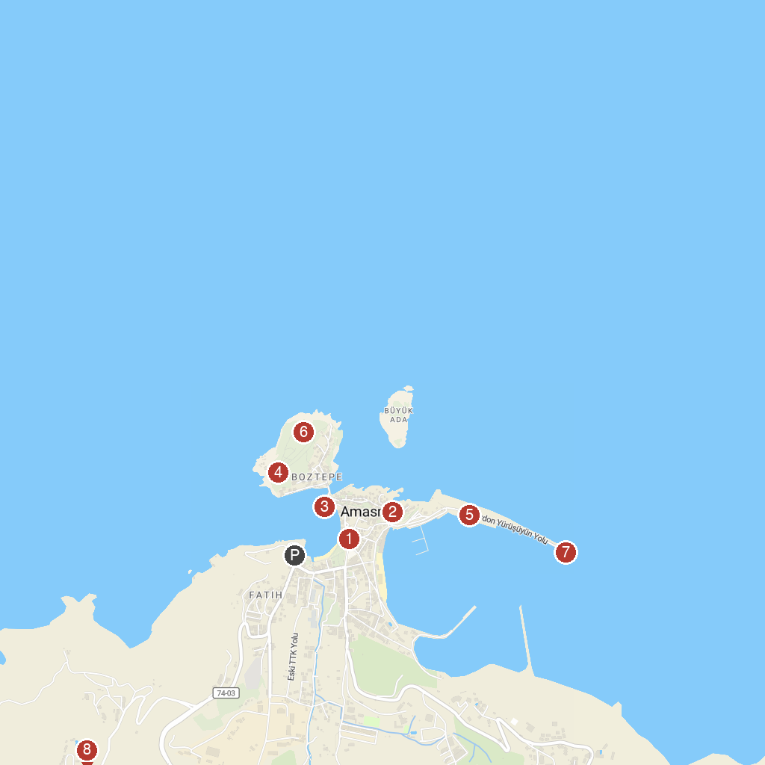
MAP KEY
1. Barış Akarsu Park | 5. Mendirek
2. Kilise | 6. Amasra Deniz Feneri
3. Direkli Kaya | 7. Deniz feneri
4. Amasra Lookout | 8. Amasra Seyir Noktası
P. Cruise port / terminal
Map © MapTiler © OpenStreetMap contributors · cruiseports.org

