Amarapura, Mandalay Region, Myanmar
A former Burmese royal capital where monks cross a legendary teakwood bridge at dawn and ancient pagodas rise from riverside mist — one of the Irrawaddy's most atmospheric stops.
⚓ Dock at Mandalay jetty; Amarapura ~11 km by road · 🕒 Typical call: 4-6 hrs · 💵 Myanmar Kyat (limited USD use) · 🗣️ Burmese
✍️ MY DAY IN PORT (FILL IN)
Ship / Date
In port | arrive ______ · all aboard ______
Booked excursion
Notes / meeting point
GETTING ASHORE
- Docking: Irrawaddy river-cruise jetty in the Mandalay area (e.g. Gawein or Shwe Kyet Yet)
- To Amarapura: Amarapura is ~11 km south of Mandalay; reached by tour coach, taxi or tuk-tuk
- Best For: Photography, Buddhist culture, authentic local life
- Don't Miss: U Bein Bridge at sunset and morning almsgiving at Mahagandayon
GETTING AROUND
- 🚕 Taxi: $10–15 USD — Negotiated taxis are the most common way to get around. The ~10 km ride between the river jetty and main sights like U B
- 📱 Rideshare: ✅ Grab
TOP THINGS TO DO
- U Bein Bridge at Sunset — Walk (or take a boat ride beneath) the world's longest teakwood bridge, stretching 1.2 km across Taungthaman Lake.
- Mahagandayon Monastery Almsgiving — One of Myanmar's largest teaching monasteries, housing over a thousand monks.
- Amarapura Palace Ruins & Ancient City — Explore the remnants of the 19th-century royal capital: the treasury building, old watchtower, corner pagodas, and the tombs of…
- Traditional Craft Workshops — Amarapura is a living center of Burmese craftsmanship.
- Kyauktawgyi Pagoda — Built in 1847, this pagoda houses a massive Buddha image carved from a single block of Sagyin marble.
BEST WALKS
- U Bein Bridge Walk: 1.2 km one-way | Easy | Allow 45 min return — Walk the full length of the world's longest teakwood bridge from the Amarapura lakeside pavilion to…
- Mahagandayon to Palace Ruins: ~1.5 km | Easy | Allow 1 hr with stops — A short walk between two of Amarapura's most significant sites: the great monastery and the remnant…
WEATHER · DAYLIGHT · MONEY
Month | High °F | Low °F | Rainy days
May | 96 | 81 | 13
Jul | 91 | 79 | 23
Sep | 90 | 78 | 23
Daylight: May 5:26AM–6:37PM · Jul 5:31AM–6:51PM · Sep 5:52AM–6:08PM
cruiseports.org/amarapura · Confirm terminal & all-aboard time with your ship

Amarapura, Mandalay Region, Myanmar — Port Map
Red = walkable sights · Amber = excursions farther out · P = cruise terminal
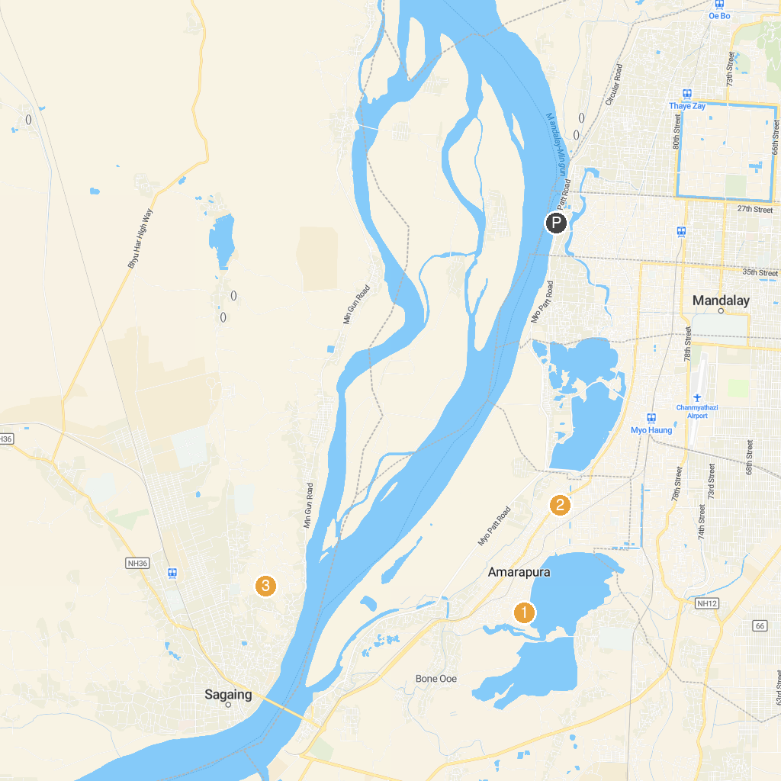
MAP KEY
1. Sandamuni Pagoda | 3. Bagaya Monastery
2. မဟာဂန္ဓာရုံကျောင်းတိုက် | 4. Soon Oo Pon Nya Shin Pagoda
P. Cruise port / terminal
Map © MapTiler © OpenStreetMap contributors · cruiseports.org

