Amami Oshima, Kagoshima, Japan
A subtropical island between Kyushu and Okinawa, Amami Oshima packs UNESCO-listed jungle, Japan's second-largest mangrove forest, and pristine coral-fringed beaches into one unhurried cruise call.
⚓ Docked at Naze Port (Nagahama berth) · 🕒 Typical call: 8–10 hrs · 💴 Japanese Yen (JPY) — carry cash outside city · 🗣️ Japanese (English limited outside port) · 🌿 UNESCO World Natural Heritage
✍️ MY DAY IN PORT (FILL IN)
Ship / Date
In port | arrive ______ · all aboard ______
Booked excursion
Notes / meeting point
GETTING ASHORE
- Docking: Berthed at Naze Port (Nagahama berth, up to 80,000 GT); occasional tender for larger ships
- Walk to center: 15–20 min walk to downtown Naze; shuttle buses often provided
- Best For: Mangrove kayaking, tropical beaches, Oshima Tsumugi silk, subtropical hiking
- Don't Miss: Keihan chicken rice — Amami's beloved local soul food
GETTING AROUND
- 🚕 Taxi: ¥500–¥800 to city center; ~¥6,500–¥7,500 to Mangrove Park (one-way) — Taxis queue at the pier and are the most flexible option. The ride to town takes about 3 minutes. For longer island trip
TOP THINGS TO DO
- Kuroshio no Mori Mangrove Kayak — Paddle through Japan's second-largest mangrove forest at Kuroshio no Mori Mangrove Park, about 30 minutes from Naze.
- Oshima Tsumugi Silk Weaving Workshop — Oshima Tsumugi is one of Japan's finest silks, hand-woven on Amami Oshima for over 1,300 years using a traditional mud-dyeing…
- Kinsakubaru Virgin Forest Walk — Hike through one of Japan's last surviving subtropical evergreen forests, home to Amami rabbits, Lidth's jays, and giant ferns…
- Tomori Beach & Snorkeling — Often ranked Amami's finest beach, Tomori Beach offers white sand, calm turquoise water, and healthy coral reefs in the island's…
- Tanaka Isson Memorial Museum of Art — Set within Amami Park, this museum celebrates the painter Tanaka Isson, who moved to Amami Oshima in 1958 and spent 20 years…
BEST WALKS
- Naze Port to Downtown & Nazemachi Shopping Street: 1.5 km · 20 min · Flat — An easy stroll from the Nagahama berth along the waterfront brings you to downtown Naze and…
- Ogamiyama Park Hilltop Viewpoint: 1 km uphill · 20 min · Easy–Moderate — A short climb from downtown Naze leads to Ogamiyama Park, which crowns a forested knoll with…
WEATHER · DAYLIGHT · MONEY
Month | High °F | Low °F | Rainy days
May | 75 | 67 | 18
Jul | 84 | 78 | 19
Sep | 83 | 76 | 21
Daylight: May 5:32AM–7:05PM · Jul 5:34AM–7:21PM · Sep 6:07AM–6:27PM
cruiseports.org/amami-oshima-island-japan · Confirm terminal & all-aboard time with your ship

Amami Oshima, Kagoshima, Japan — Port Map
Red = walkable sights · Amber = excursions farther out · P = cruise terminal
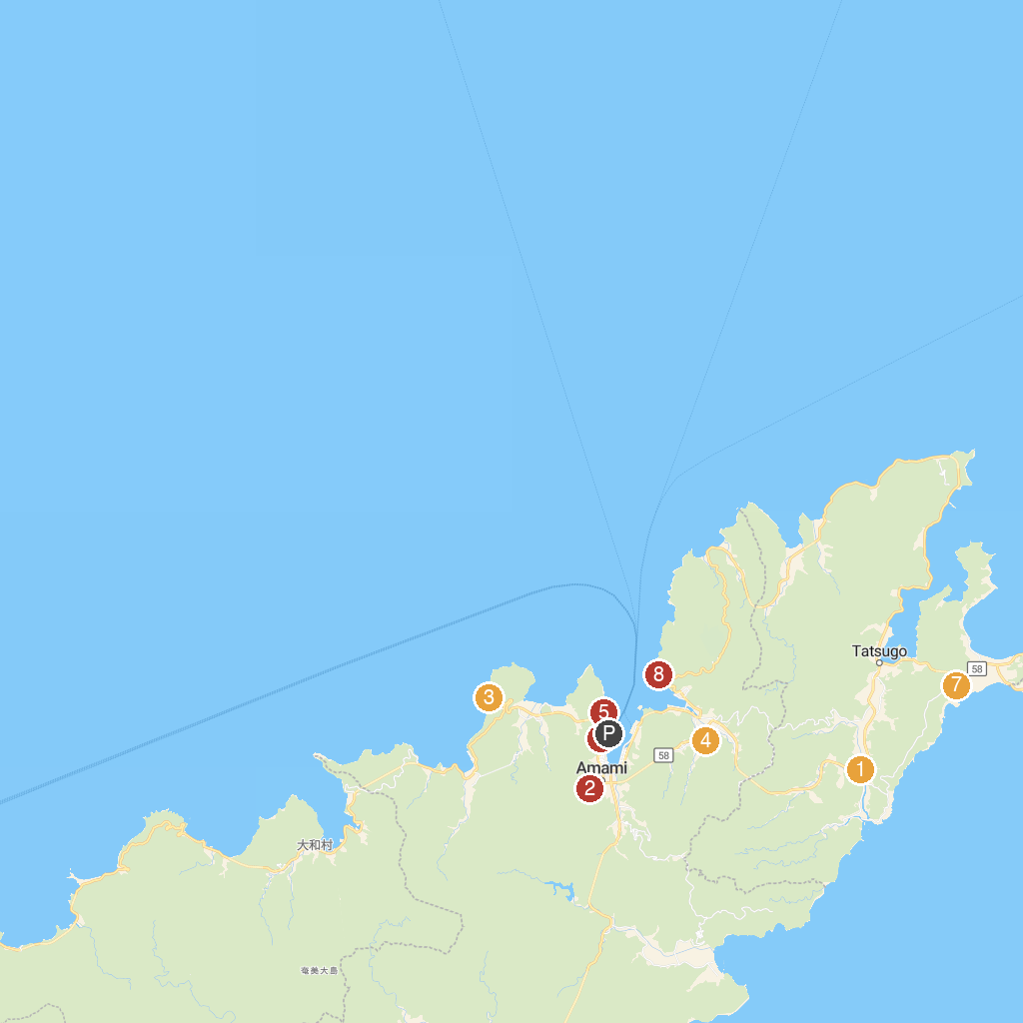
MAP KEY
1. Full Fula Garden | 5. Amami City Amami Museum
2. Takachiho Shrine | 6. Amami Tourism Habu Center.
3. Amami Marine Aquarium & Museum | 7. Amami Oshima Tsumugi Village
4. Tanaka Isson former residence | 8. Daikuma Observatory Point.
P. Cruise port / terminal
Map © MapTiler © OpenStreetMap contributors · cruiseports.org

