Alton, Illinois, USA
Perched on limestone bluffs above the mighty Mississippi, Alton punches well above its size — abolitionist history, the world's tallest man, and bald eagles soaring the confluence make this small river town a surprisingly rich shore-day stop.
⚓ Docked (river pier) · 🕒 Typical call: 6-8 hrs · 💵 USD · 🗣️ English · 🦅 Eagle watching Nov–Mar
✍️ MY DAY IN PORT (FILL IN)
Ship / Date
In port | arrive ______ · all aboard ______
Booked excursion
Notes / meeting point
GETTING ASHORE
- Docking: Alongside at Alton Marina / National Great Rivers Museum dock, adjacent to Clark Bridge
- Walk to center: 5–10 min walk to Historic Downtown Alton
- Best For: History buffs, eagle watchers, antique hunters, scenic river drives
- Don't Miss: Robert Wadlow statue, National Great Rivers Museum (free), Piasa Bird bluff painting
GETTING AROUND
- 🚕 Taxi: Metered (varies) — Local taxi services operate in Alton. Ask your cruise ship staff for recommended local cab companies, as there is no maj
- 📱 Rideshare: ✅ Uber
TOP THINGS TO DO
- Alton Museum of History & Art — Explore exhibits on abolitionist Elijah Lovejoy, jazz legend Miles Davis, and Robert Wadlow — the 8 ft 11 in tallest man in…
- Lewis & Clark Confluence Tower — A few miles north of Alton, this tower overlooks the dramatic confluence of the Mississippi and Missouri Rivers — the very spot…
- Pere Marquette State Park — Illinois' largest state park sits 20 minutes west of Alton at the confluence of the Illinois and Mississippi Rivers.
- National Great Rivers Museum (Free) — Right at the dock, this free Smithsonian-affiliated museum covers the ecology and commerce of the Mississippi through hands-on…
- Cahokia Mounds State Historic Site — A UNESCO World Heritage Site just 30 minutes from Alton, Cahokia Mounds preserves the largest pre-Columbian settlement north of…
BEST WALKS
- Riverfront to Downtown History Walk: 1.5 miles • Easy • 45–60 min — From the dock, stroll along the Mississippi riverfront past the Clark Bridge, then head into…
- Piasa Bird Bluff Drive / Walk: Short scenic drive or bike • 3 miles north of downtown — Head north on the Great River Road (IL-100) to see the Piasa Bird — a large Native American…
WEATHER · DAYLIGHT · MONEY
Month | High °F | Low °F | Rainy days
May | 76 | 58 | 13
Jul | 89 | 71 | 11
Sep | 83 | 64 | 6
Daylight: May 5:58AM–8:06PM · Jul 5:59AM–8:23PM · Sep 6:48AM–7:12PM
cruiseports.org/alton-il · Confirm terminal & all-aboard time with your ship

Alton, Illinois, USA — Port Map
Red = walkable sights · Amber = excursions farther out · P = cruise terminal
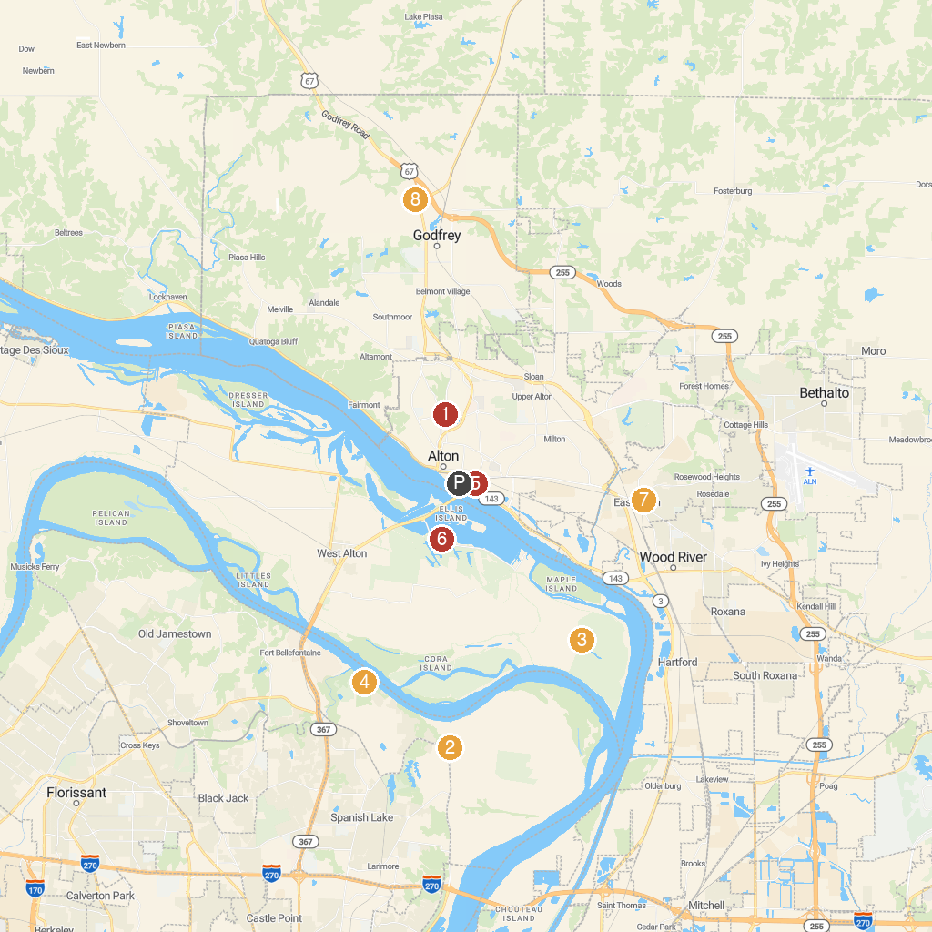
MAP KEY
1. McPike Mansion | 5. Russell Commons Park
2. Columbia Bottom Conservation Area | 6. Audubon Center at Riverlands
3. Edward "Ted" and Pat Jones-Confluence Point State Park | 7. Van Preter Park
4. Fort Belle Fontaine | 8. Village of Godfrey Parks and Recreation Department
P. Cruise port / terminal
Map © MapTiler © OpenStreetMap contributors · cruiseports.org

